WREXHAM MUSEUM – PLANNING/LBC CHANGES

The amendments to the scheme can be summarised as followed:
Ground floor
- G23 furniture store - the layout has been amended to retain the chimney breast and the section of wall running to the South elevation (although the door opening has been widened). This will maximise the retention of historic fabric in this room and reduced construction risk.
- The existing modern partition in G34 catering kitchen area is now to be retained.
- The form of the inserted partition between G41 and G42 in the annex has been amended.
- G57 becomes a cleaner’s store with a sink to take advantage of the available hot and cold water supplies and above ground drainage.
- The layout of G11 (the exercise yard extension at ground floor level) has been amended to incorporate an exhibition store.
- The doors have been omitted from the new opening between G11 and G12 to meet fire safety requirements.
- G53 has been amended to be an electrical cupboard as there is no local hot and cold water or drainage in this area.
- G05 staff mess - the extent of the staff tea kitchen has now been identified.
- The gable wall to the bin store (G58) has been amended from timber posts, cladding rails and timber cladding to 100 mm dense blockwork with timber cladding to meet the one hour fire resistance required by Building Control. (Please note that the roof form and materiality remains as per the approved scheme.)
- The piers to the folding partition In G23/ G24 and docking arrangement have been amended slightly to comply with the manufacturer's requirements and the acoustician's recommendations.

First floor
- The partition arrangement between 1.19 and 1.21 will be retained as existing to facilitate the fire safety requirements, compared with the demolition of the partition and blocking of openings in the approved scheme. However, the remaining door leaf will have to be removed as per the approved scheme.
- In the corridor 1.16 we have had to add a fire door to create a protected lobby for the landing of the drop down ladder to 2nd floor plant room access hatch, to meet the requirements of Building Control.
Since our meeting we have had further consultation with Building Control and it is likely that we will require an additional hatch from the courtyard roof valley into the plant room at 2nd floor level. This will only impact the detailing of the extension and not the existing fabric, and we therefore assume this can be dealt with via the detailing to be submitted to discharge the condition attached to the LBC consent.
- The original courtroom doors between 1.04 and 1.05 were due to be removed in the approved scheme, however, we have agreed a derogation with Building Control to enable the doors to be retained but turned to open into 1.05 and a fire door swinging in the opposite direction into 1.04. This will therefore retain more of the historic fabric.
- There are areas where the existing floor levels are raised to provide level access throughout the Wrexham gallery and a wheelchair refuge on the means of escape from the football gallery. The new floors consist of 142 X 50 mm joists with 18mm ply over, which sit over the existing floor constructions without loss of existing fabric.
- We have provided new piers to the new openings between the football gallery spaces 1.01 and 1.22.

roof plan
- The extent of the valley gutters have been more accurately indicated on the updated roof layouts but generally are the same design intent.
- The roof form of the exercise yard extension has been amended to facilitate rainwater discharge and protect the historic fabric there is also an opportunity to discharge the rainwater in the area to relieve the impact on historic fabric. Currently the water from the valley discharges a relatively large area of roof into the end of the gutter and clearly spills over a large area of the masonry causing damage. Please refer to the screenshot below.

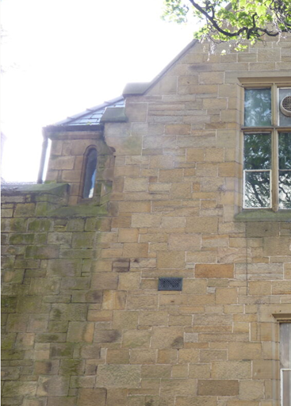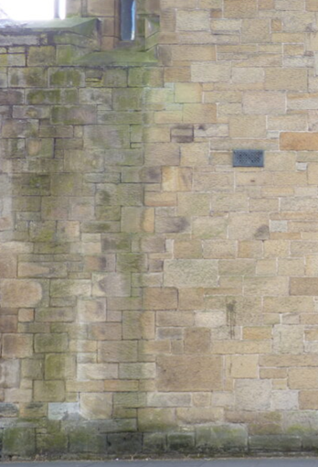

Elevations
- The amended form of the exercise yard extension roof identified above is indicated on elevation. It has also been necessary to raise the ridge by 430 mm to enable the valley gutter arrangement to work.
- Having reviewed the bin store details, we can confirm that the new bin store retains the form and materiality of the approved scheme. The amendment to the construction of the gable wall for fire protection is captured in the ground floor amendments but the external appearance will remain the same.
- The requirement for manifestation on the structural glass on the north elevation has been identified.

Sections
- Details of the passive roof vents have been added to the section.
- The need to build up the masonry of the courtyard wall to support the second floor plant room wall has been identified.

