Preliminary Bat Roost Assessment (PRA) Report

Project: Ty Gaffney Brynisa Road, Brynteg, Wrexham, LL11 6NS

Client: Mr. Robert P Jones

Date: May 2024

Reference: 170524MM
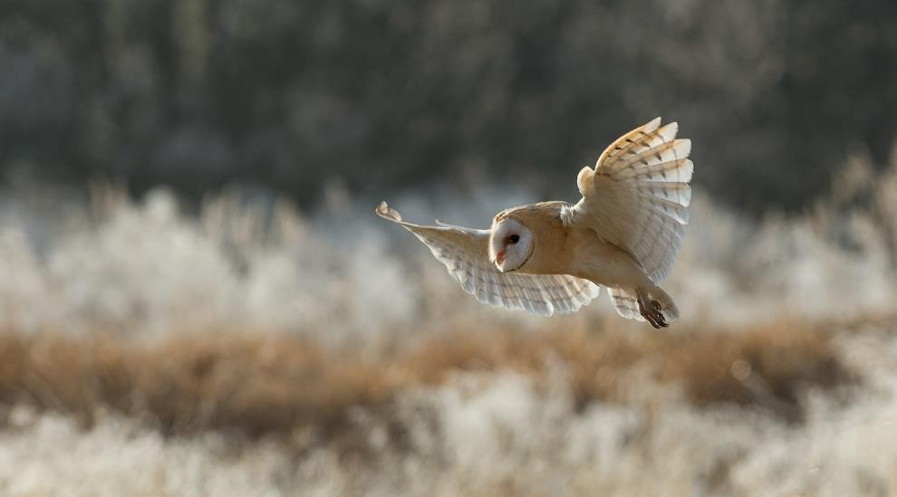


CONTACT DETAILS
Pearce Environment Ltd  Cedar Lodge  Wilcott Marsh  Shrewsbury  SY4 1AR | T: 01743 741 421  M: 07811 113 250  E: info@pearce-environment.co.uk  W: www.pearce-environment.co.uk

Pearce Environment Ltd. is registered in England and Wales: No. 5175771
REPORT DETAILS
Reference no. | 170524MM
Version | 001
Status | FINAL
QUALITY ASSURANCE
Author(s) | Mark Morgan BSc (Hons)
Technical reviewer(s) | Tristam Pearce MCIEEM MRSB
Proofed by | Charlotte Pearce
Date of review | 17th May 2024
DISCLAIMER
The contents of this report are confidential and may contain information regarding protected species of a sensitive nature.

This report has been prepared by Pearce Environment Ltd. for the sole use of the client and in connection with the development project described – this report cannot be relied upon by any third party without express written consent by both Pearce Environment Ltd. and the client.

The findings of this report are valid for a maximum of two years from the final review date.

This is a technical report and does not represent legal advice/ opinion.

This report remains Pearce Environment Ltd. property and cannot be relied upon until full payment has been made.
Pearce Environment Ltd. retain the right to re-publish data obtained and submit those species records produced during all ecological studies to the local recording centre.
COPYRIGHT © This report is the copyright of Pearce Environment Ltd. Any unauthorised reproduction or usage of material from this report is prohibited.

CONTENTS

EXECUTIVE SUMMARY…..……………………………………………………………….......1

BAT LEGISLATION …..……………………………………..……………………….…….......2

Section 1 Introduction .......................................................................................... 3
1.1 Commission and Proposals. .......................... ......................................... 3
1.2 Aims ....................................................................................................... 3
1.3 Background ............................................................................................ 3

Section 2 Methodology..................................................... .................................... 4
2.1 Badger Survey .............................................. ........................................ 4
2.3 Limitations .............................................................................................. 5

Section 3 Results and Recommendations ................................. ......................... 6
3.1 Site Description ................................................................ ..................... 6
3.2 Broad habitats .......................................................... ........................... 7
3.3 Species Records .................................................................................... 9
3.4 Preliminary Roost Assessment (PRA) .................................................... 9

Section 4 Conclusions.…….……………………...….………..……….……….........13
4.1 Status of Bats on the Site ..................................................................... 13
4.2 Significance to Development ................................................................ 13
4.3 Recommendations ............................................................................... 13
4.4 Status of Nesting Birds on the Site ....................................................... 14
4.5 Significance to Development ................................................................ 14
4.6 Recommendations ............................................................................... 14

Section 5 Bibliography.…….……………………...….………..……….……….........15

Appendices

Appendix 1 Tables 4.1 and 7.3 from Bat Surveys for Professional Ecologist: Good
Practice Guidelines Table

EXECUTIVE SUMMARY

The contents of this report detail a Preliminary Roost Assessment (PRA) and nesting bird inspection undertaken during May 2024 at Ty Gaffney, Brynteg, Wrexham, LL11 6NS
(hereafter referred to as ‘the site’). The site is centred on approximate Ordnance Survey Grid Reference (OSGR) SJ 30855 52414.

The findings of this report have been used to inform a planning application for proposed modifications/ additions to the existing property.

The application site, set within an urban environment, consists of a two storey modernised building, previously a community hall, converted in approx. 2015. It is surrounded by a mixture of sandstone properties bordering a council estate. There is a small area, circa 900m2, of undeveloped ground including a mixture of native hedging to the rear of the property.

Ty Gaffney is deemed to offer ‘negligible’ bat roosting opportunity owing to a lack of evidence suggesting use by bats (such as droppings, feeding remains, urine stains etc.) and features deemed suitable for roosting bats.

No further bat surveys are required on Ty Gaffney.

A minimum of one (1) Schwegler 2F bat box is recommended to be installed within the development footprint, either to a mature tree or existing building.

No bird nests were observed during the survey.

A minimum of one (1) Schwegler 1B bird box is recommended to be installed within the development footprint, either to a mature tree or existing building.

No concerns are evident regarding invasive species on site.

No further surveys are deemed necessary.

BAT LEGISLATION

All species of British bat are listed as a European Protected Species (EPS) on Schedule 2 of the Conservation Regulations (Annex IV (a) to the Habitats Directive). This affords them strict protection under Regulation 43 of the Conservation of Habitats and Species Regulations 2017, making it an offence to:

- Deliberately capture, injure or kill a bat;

- Deliberately disturb bats in a way that would significantly affect their local distribution or abundance, or affect their ability to survive, breed or rear young;

- Deliberately damage or destroy a roost; or

- Possess, control, transport, sell, exchange or offer for sale/exchange any live or dead bat or part thereof.

Additional protection for bats is also afforded under the Wildlife and Countryside Act 1981 (as amended), making it an offence to intentionally or recklessly disturb bats whilst they are occupying a structure or place which is used for shelter or protection, or to obstruct access to this structure or place.

Furthermore, seven of the UK bat species are also listed as Priority Species on the UK BAP, highlighting them as species of conservation concern.

1. INTRODUCTION

1.1 COMMISSION AND PROPOSALS

- Pearce Environment Ltd were commissioned by Mr R P Jones to undertake a Preliminary Roost Assessment (PRA) and nesting bird inspection at Ty Gaffney, Brynisa road, Brynteg, Wrexham, LL11 6NS (hereafter referred to as ‘the site’). The site is centred on approximate Ordnance Survey Grid Reference (OSGR) SJ 30855 52414.

- The findings of this report have been used to inform a planning application for proposed modifications/ additions to the existing property.

1.2 AIMS

- This report sets out the findings of a PRA and nesting bird inspection undertaken at the site by Pearce Environment Ltd during May 2024.

- The aims of this report are to:

    - Identify potential bat roost features and/ or evidence of bat activity in the main building and any subsidiary buildings on the site;

    - Determine the presence/ likely absence of birds nesting in/ on any building(s) on the site;

    - Ascertain the requirement for further survey(s), where necessary;

    - Determine the need for licensing, Reasonable Avoidance Measures (RAM’s) and mitigation and/ or compensation measures, where necessary.

1.3 BACKGROUND

- There are no known historical ecological reports relating to the application site itself.

2. METHODOLOGY

• This section summarises the methodologies used during the survey(s), in line with the aims set out in Section 1 of this report.

2.1 DESK STUDY

- A species records search to support the findings of the Preliminary Roost Assessment (PRA), utilising freely-available online data sets, is considered sufficient for the purposes of this study (Image 2.1).

Table 2.1 Summary of resources used and information utilised during the desk study (2024)
Information Assessed
Organisation/ Resource
(search distance from site boundary)

Protected/ UK BAP species records (1km)
Cofnod Statutory designations (1km)
Non-statutory designations (1km)

2.2 SPECIES SURVEYS

- The site visit was undertaken during a daytime visit on 17th May 2024. This visit was carried out at a temperature of 21ºC and in dry, clear conditions. This time of year is considered to be within the optimum season for undertaking a PRA survey.

- The survey was performed by Mark Morgan BSc (hons), an experienced ecologist and holder of Natural England (NE) licence for great crested newts (licence number 201732019-CLS-CLS). Mark possesses a 1st class degree in Plant Biology from the University of Aberystwyth, with expertise in bats, great crested newts and badgers.

Bats

Preliminary Bat Roost Assessment: Built Structures

- A daytime assessment of all built structure(s) on site was undertaken to determine their potential to support roosting bats. All external features considered potentially suitable for bats were identified and assessed. Signs of bat activity such as droppings, feeding remains and urine stains were also searched for around all accessible areas. The potential suitability of the structures investigated was assigned a rating of low-to-high in accordance with section 5.2 of the ‘Bat Conservation Trust’s Good Practice Guidelines’ (Appendix 1). An internal assessment of all accessible areas was undertaken for evidence of roosting bats such as droppings, feeding remains and urine staining.

- Recommendations for further survey requirements are based on guidelines summarised in Table 7.3 of ‘Bat Conservation Trust’s Good Practice Guidelines’ (Appendix 1).

Nesting Birds

- An internal and external assessment of any built structure(s) on site was undertaken by an experienced ecologist, to identify the presence of habitat/ features suitable for nesting birds.

- A search for active/ disused birds’ nests was undertaken, where appropriate.

2.3 LIMITATIONS

- The entirety of the building was fully accessible during the survey.

- Whilst we make every effort to meet the client brief, no site visit can ensure prediction of the natural environment such as movement of species in response to variables such as weather and seasonality.

- As with any survey, it is a documentation of what the surveyor observes on the specific survey day and their interpretation of those observations.

3. RESULTS AND RECOMMENDATIONS

3.1 SITE DESCRIPTION

- The site is set within a built-up area constituting a mixture of housing, It borders an area of woodland including two areas of water known as Moss valley (Point B – figure 3.1). It is within the county boundary of Wrexham. (Figure 3.1).

Figure 3.1 Site location reproduced using freely-available online mapping resources (2024)

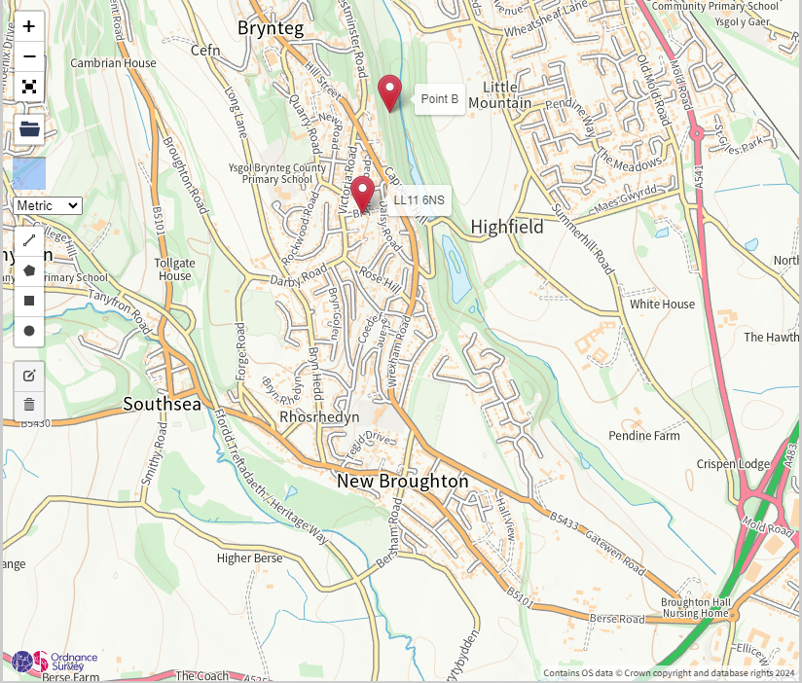

Figure 3.2 Aerial view of the site (outlined) and near surrounds, reproduced using freely-available online mapping resources (2024)
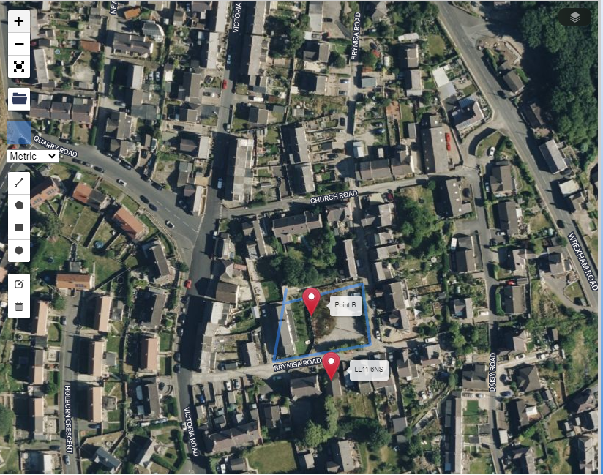

3.2 BROAD HABITATS

Built Structures

- The site consists of one (1) built structure, summarised below (Figure 3.4): The building is accessed from Brynisa road, an unadopted, unmade road.

Hardstanding/ Disturbed Ground

- The site has an established garden with manmade pond – please see figure 3.5.
- To the Southeast of the main structure is an area (point B -figure 3.2) consisting of hard standing and uncultivated area with a hedge of mixed native species. This area is currently being utilised for car parking – please see figure 3.3.
- Ty Gaffney has an established Vegetable area – please see figure 3.6

Image 3.3 South-eastern aspect

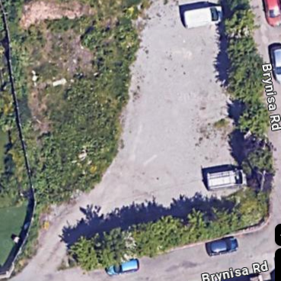

Image 3.4 Main Building – Ty Gaffney

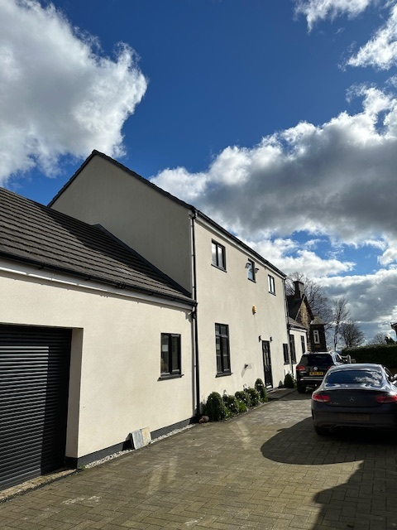

Image 3.5 Main Garden – Ty Gaffney

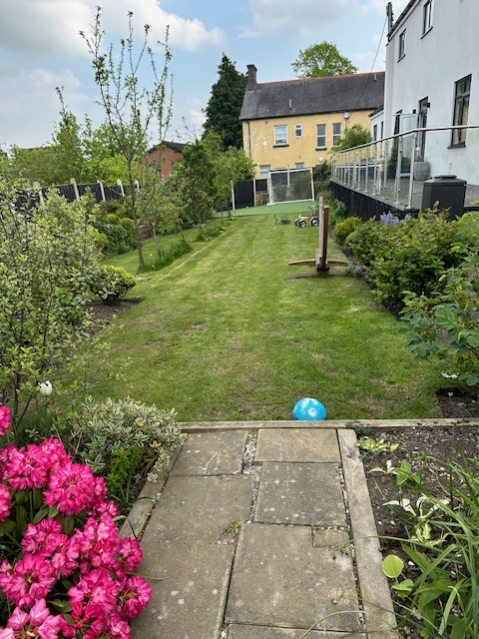

Image 3.6 Vegetable Garden – Ty Gaffney

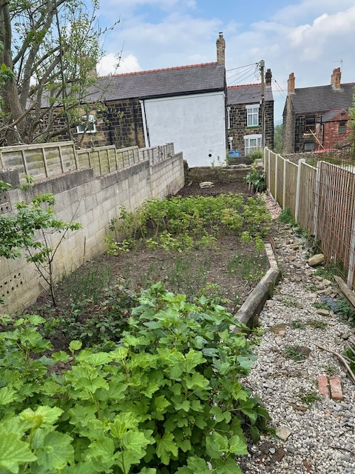

3.3 SPECIES RECORDS

- A database search of a 1km radius surrounding the site during the course of the desk study was undertaken (Appendix 2).

- Protected species of mammal include:

Common pipistrelle Pipistrellus pipistrellus
Soprano pipistrelle P. pygmaeaus
Noctule Nyctalus noctula
Badger Meles meles

- A moderate array of birds has been recorded in the wider area. Bird species recorded and listed under Schedule 1 and Schedule 2 of the Wildlife and Countryside Act 1981, include:

Kingfisher Alcedo atthis
Barn owl Tyto alba
Red Kite Milvus milvus
Canada goose Branta canadensis
Mallard Anas platyrhynchos

3.4 PRELIMINARY ROOST ASSESSMENT (PRA)

• A daytime inspection was undertaken on the 17th May 2024 to assess the potential of built structure(s) on the site to support roosting bats. A full description of those features considered suitable for roosting bats are described and illustrated using site photographs provided below.

B1 (L-shaped barn and stables)

- Ty Gaffney (SJ 30855 52414; Image 3.4) is a mix of single and two-storey constructed in a mix of brick and sandstone but now K-rendered.

- Externally and internally, Ty Gaffney is in good condition. There is no potential bat ingress/ egress opportunity at present around the entirety of the building as all access areas have been sealed with modern plastic eave covers.

- Owing to the absence of evidence indicative of the use of Ty Gaffney by bats, and given the absence of several potential roosting features, this building is considered to offer
‘negligible’ bat roosting potential.

Bat Foraging/ Commuting Habitat

• The near surrounds constitute good foraging and commuting habitat for bats with mature hedgerows, water bodies and scattered tree growth.

Nesting Birds (B1)

- No bird nests or signs of previous nesting were observed during the survey.

- Ty Gaffney is considered to offer ‘negligible’ bird nesting potential.

CONCLUSIONS

4.1 STATUS OF BATS ON THE SITE

- Ty Gaffney is deemed to offer ‘negligible’ bat roosting potential given the lack of evidence or features to suggest use of this building by bats.

- The near surrounds to the site offer good foraging and commuting habitat for bats.

- Common pipistrelle, soprano pipistrelle and noctule have been recorded within 1km of the site.

4.2 SIGNIFICANCE TO DEVELOPMENT

- The proposals involve alterations to Ty Gaffney.

- Works to Ty Gaffney are not anticipated to negatively impact upon bats, given the likely absence of bats roosting within this building, based on the results of the PRA.

4.3 RECOMMENDATIONS

- No further survey with regards to Ty Gaffney is considered necessary.

- To enhance the ecological value of the site it is recommended that a minimum of one
(1) Schwegler 2F bat box (Image 3.10) is incorporated on site.

- Bat boxes should be installed onto an existing building or mature tree at a height no less that 4m and preferably orientated in a south or southwestern aspect.

Image 3.10 Example of Schwegler 2F bat box
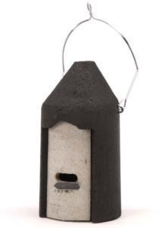

4.4 STATUS OF NESTING BIRDS ON THE SITE

- Ty Gaffney is deemed to offer ‘negligible’ bird nesting potential.

- A moderate array of bird species has been recorded within the local area primarily within the Moss valley area.

4.5 SIGNIFICANCE TO DEVELOPMENT

- Works to Ty Gaffney are not anticipated to negatively impact upon nesting birds.

4.6 RECOMMENDATIONS

• A minimum of one (1) Schwegler Woodcrete (1B) box, or equivalent, is recommended as an enhancement for common passerine bird species on the site (Image 3.11). This is to be installed onto any suitably mature tree or fencing on or near to the application site, at a height of no less than 2m and orientated in a southerly or westerly direction. Nest boxes are to be maintained for the lifetime of the development.

Image 3.11 An example of Schwegler 1B Woodcrete boxes
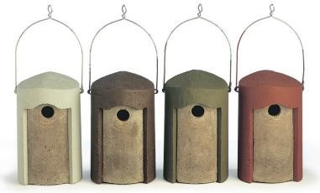

4. BIBLIOGRAPHY

Cofnod – North Wales Environmental Information Service website (www.cofnod.org.uk)

Collins J. (Ed.) (2016) Bat Surveys for Professional Ecologist: Good Practice Guidelines (3rd Ed.) The Bat Conservation Trust, London

Ty Gaffney, Brynteg, Wrexham Preliminary Bat Roost Assessment (PRA) Report
170524MM May 2024

Appendix 1 Tables 4.1 and 7.3 from Bat Surveys for Professional Ecologist: Good Practice Guidelines

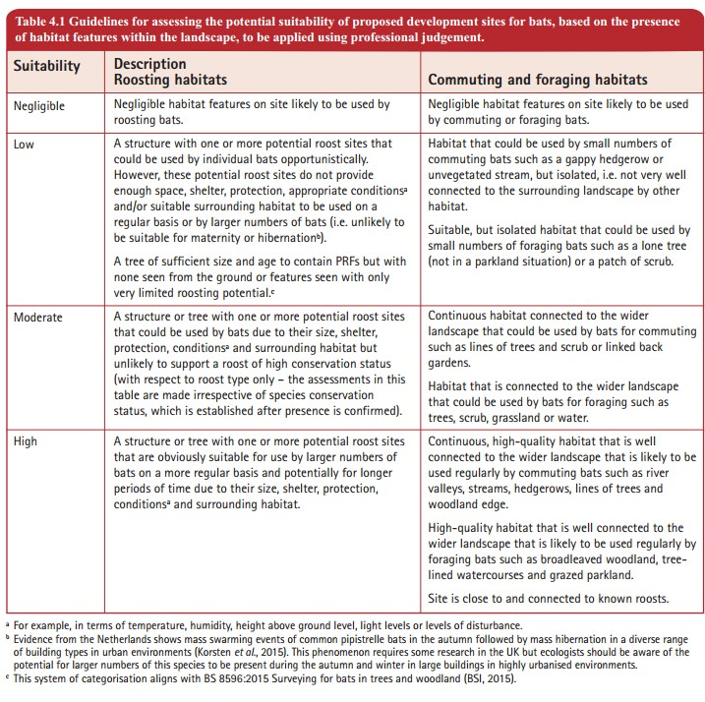

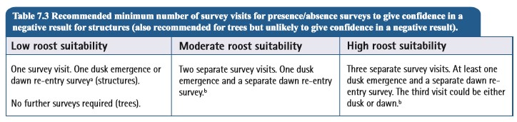

Cofnod – Local Environmental Records Centre for North Wales website (www.cofnod.ord.uk)
Collins J. (Ed.) (2016) Bat Surveys for Professional Ecologist: Good Practice Guidelines (3rd Ed.) The Bat Conservation Trust, London.
Collins J. (Ed.) (2016) Bat Surveys for Professional Ecologist: Good Practice Guidelines (3rd Ed.) The Bat Conservation Trust, London.

