SUPPORTING, DESIGN AND ACCESS STATEMENT

AGRICULTURAL GENERAL PURPOSE STORAGE BUILDING
(MACHINERY AND PRODUCE)

AT

Hugmore House
Hugmore Lane
Wrexham
LL13 9YE

AUGUST 2024

- INTRODUCTION TO THE PROPOSAL
OS Planning Ltd have been instructed by Mr and Mrs Piggott of Hugmore House to submit the subject application for a modern agricultural portal framed building for the essential and functional need of agriculture.
The building proposed is to be constructed to support the existing agricultural activities of the applicant and is justified in terms of site, size and design against the scale and nature of the agricultural operations undertaken.
The proposal projects the criteria of agricultural permitted development under Schedule 2, Part 6, Class A of the Town and Country Planning (General Permitted Development) Order 2015 (as amended).
We confirm that the applicant is solely engaged in running the agricultural operations from the site therefore is (as defined) an agricultural holding under Schedule 2, Part 6, Class A of the Town and Country Planning (General Permitted Development) (England) Order 2015 (as amended), therefore the proposal agricultural building is reasonably necessary and essential for the applicant to provide critical covered, secure, and dry storage facilities.
Agricultural building means a building or structure used to shelter farming implements, hay, grain, poultry, livestock, or other farm goods, which is not lived in nor used by the public.
The subject application is for a new purpose-built general agricultural storage building for the storage of machinery and produce, full details are contained later within this supporting statement. The building will be of a standard agricultural construction, Steel portal framed.
The National Planning Policy Framework supports sustainable economic development and a prosperous rural economy including the development of agricultural and other land-based rural businesses. It is generally acknowledged that the role of agriculture is recognised as being important to continuing maintenance and management of the open countryside and the viability of rural economies.
The agricultural unit extends to over 5 hectares of land and the building proposed extends to 465 sqm, none-livestock. This means that the subject application qualifies with the principle of development deemed acceptable under The General Permitted Development Order 2015 Schedule 2 Part 6 Class A. As defined, the statutory definition is contained in Town and Country Planning Act 1990 states:
‘Agriculture includes horticulture, fruit growing, seed growing, dairy farming, the breeding and keeping of livestock (including any creature kept for the production of food, wool, skins or fur, or for the purpose of its use in the farming of land), the use of land as grazing land, meadow land, osier land, market gardens and nursery grounds, and the use of land for woodlands where that use is ancillary to the farming of land for other agricultural purposes, and ‘agricultural’ shall be construed accordingly.
Judicial precedent in respect of the proposed application process was highlighted, in the judgement of the appeal of Murral v Secretary of State (2010) EQCA 1367 Lord Justice Richards emphasized that where land meets the criteria of the GPDO the principle of the development could not be contested.
Lord Justice Richards stated that the prior approval process should be “simple to operate and does not need to be accompanied by anything more than a written description of the proposed development and the materials to be used and a plan indicating the site, together with the required fee”. Where the area requirements of the GPDO are satisfied qualification of building size and reasonable necessity can be considered.
In reference to reasonable necessity, it was confirmed in Clarke v Secretary of State for Enforcement (1992) EWCA that's a building does not have to be reasonably necessary for the agricultural activity/ enterprise being undertaken on the unit at that time. They simply must be reasonably necessary for and design for the purpose of any agricultural use within that unit. The conclusion of this case confirmed that's the distinction of the test” not are the buildings absolutely necessary but are they reasonably necessary
The National Planning Policy Framework supports sustainable economic development and a prosperous rural economy including the development of agricultural and other land-based rural businesses. It is generally acknowledged that the role of agriculture is recognised as being important to continuing maintenance and management of the open countryside and the viability of rural economies
The land is being used for agriculture for the purposes of trade or profit and is considered to benefit from agricultural permitted development rights. The building is designed for the purpose of agriculture and provides the necessary accommodation for the agricultural needs of the unit to be conducted.
- ESSENTIAL AND FUNCTIONAL NEED (AGRICULTURAL BACKGROUND)
Hugmore House is set in 50 acres of grassland. The land is grazed with Livestock and used for production of Haylage bales (wrapped silage) that is used to feed the livestock over winter. In terms of livestock the applicant owns a flock of 150 ewes, lambing January with followers sold as store lambs later in the season. A registered agricultural unit with a county parish holding number.
The land is used to graze the applicant’s livestock and over winter sheep grazing (November to February), whilst between spring to late summer the land is used on rotation for the production or hay and haylage which is feed to the livestock.

Rotational grazing is when you:

- Fields are divided in to small paddock enclosures
- When fields are frequently rotated with livestock.
- When grassland is allowed to rest and recover.

Rotational grazing:

- increases the quantity of forage, as plants grow more quickly when they’re rested after grazing.
- improves soil health, as plant roots grow bigger and increase soil organic matter.
- improves soil fertility, as livestock spread manure across the whole field as they move between paddocks.
- reduces the need for artificial fertiliser.
- reduces the risk of fertiliser runoff into water bodies, which damages habitats and water quality
- reduces feed costs, as you can graze livestock outdoors for longer.

Well-managed rotational grazing means that you can evaluate the nutritional and forage needs of your animals, assess forage quality and quantity, regulate the acreage and control which parts of the pasture/range that the animals have access to.

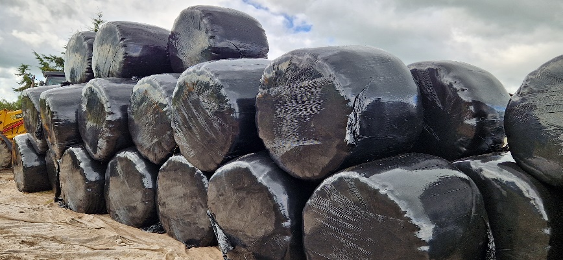
The applicant produces round bales, 5 ft diameter (equating to average of circa 3 to 6 bales per acre. This season has produced on average 2 tonnes to the acre of hay tonne of circa 180 round bales produced, as shown.
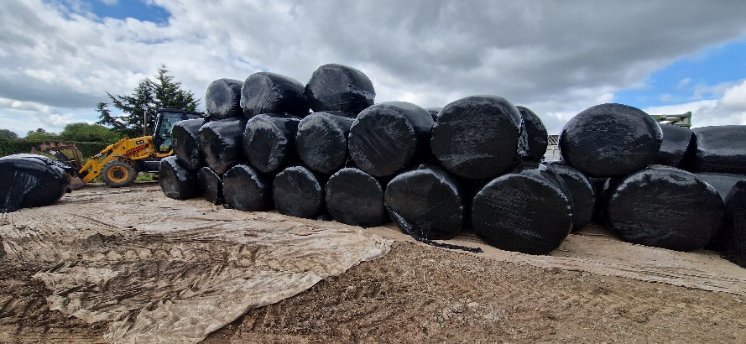
The building proposed needs to accommodate the produce to reduce the reliance on black plastic wrap and in turn reduce the farms waste and carbon footprint therefore, as such the following storage area is required:
- Stacked 3 high
(150cm each, displayed above) = 4.5m
- Stacked 10 deep
(150cm each displayed above) = 10.5m
- Stacked in a pyramid
(also displayed above) = 15 m
The total area needed for the storage of the Hay has been calculated at 157.5m
Storing the bales outdoors, it can severely reduce the quality of the bales through becoming damp and heating due to sunlight and weather conditions. Once the bales become damp, they are inappropriate for bedding. Therefore, it is essential to store the bales indoor (where possible), to reduce waste and should the produce deteriorate then it will be unsuitable for consumption.
The proposed building will also be used for the storage of agricultural machinery and implements which are used by the business for the establishment, maintenance and harvesting of the land

Not all of the agricultural machinery and equipment items, owned by the business, have access to sufficient roof cover and are having to be stored outdoors, without protection from weather elements, resulting in reduced machinery longevity and higher rates of deterioration due to exposure. Without sufficient storage cover, there is a great risk to the business that the items may be subject to theft or vandalism.

The building has also been designed to allow for all machinery, equipment, fertiliser and produce to be handled and manoeuvred efficiently within the building without moving everything in and out, pass and repass with ease.
Total storage extends to 106 sq m although an additional 50% allowance must also be included within the storage calculation to allow for manoeuvrability and access of machinery and equipment.

Therefore, the total surface area requirement of the machinery and equipment is 159 m2. This is expanded in the following table

Machinery/Equipment | Storage Area required
Tractor | 16m²
JCB | 14m²
3 x Telehandler Attachments | 14m²
Bale Trailer (flat bed) | 14m²
Grass Mowers | 8m²
Grass Sward Lifter | 8m²
Plough | 8m²
Hedge Cutter | 8m²
Power Harrow | 8m²
Fertiliser Spinner | 8m²
Furthermore, the subject building requires an area for miscellaneous items, maintenance and repair therefore the applicant also requires a “tool – workshop and store” small items (fencing and general agricultural items) workshop items and tools. This will include tractor diesel and oil.

This would equate to additional 20 sq m of storage

The isolated nature of the site means that the applicant wishes to have secure facilities to prevent theft.

.

- PLANNING POLICY
This application relates to a determination under Schedule 2, Part 6, Class A of the Town and Country Planning (General Permitted Development) (England and wales) Order 2015 (as amended).
The application seeks confirmation that the proposed building is permitted development or whether prior approval is required for the siting, design, and external appearance of the steel portal frame building.
In summary the proposed scheme is applicable as follows:
- The building is Not for Livestock.
- The use of the land is agricultural.
- The proposed building extends to 125 sq m.
- The unit is over 15 acres of agricultural land. Subject site is over 50 acre.
- The building is for machinery and produce storage. Seed and fertilser. Small workshop items.
The need to provide the proposed agricultural building has been examined within the context of national and local planning policy guidance on the sustainability of agriculture and the rural economy. National policy guidance clearly identifies how the agricultural industry is undergoing considerable change.
These changes include the integration of environmental objectives into the agricultural policies, the need for farmers to diversify into other activities to supplement their incomes and the need for landowners to have flexibility to consider a range of options for the economic use of their land and for the future.
Local planning authorities are urged to consider the need for farm businesses to adapt to the change in market conditions, and the need to maintain an efficient flexible agricultural industry to support future generations

- DESIGN

  - USE

A general storage, agricultural produce and machinery storage building

  - AMOUNT

The proposed area of the new build would 125 sq m.

Full details can be seen on the enclosed scale plan, however in summary:

Length: 13.71m
Width: 9.144m
Eaves Height: 4.2 m
Roof Pitch: 15 degrees
Ridge Height: 5.7m

  - SCALE

The building has been designed to provide purpose built covered storage essential to the operations of the unit.

The building has been located adjacent to the existing agricultural building on site, thus developing a cluster of buildings when viewed from vantage points, as opposed to a new, separate, development. Existing hedgerow and vegetation cover to the surrounding boundaries will provide sufficient natural screening to minimise the visual impact of the development.

  - APPEARANCE

The building is as shown on the enclosed elevation drawings. It is not considered that the development would have any direct detrimental impact upon neighbouring residential amenity.

The building is enclosed to three elevations with Yorkshire boarding whilst the roof to be constructed of profile 6 reinforced fibre cement roof sheets (natural grey) and roof lights (3/6). Open access to yard for ease of access and manoeuvrability of produce and machinery.

This building will incorporate sustainably sourced materials that are compliant with CE Standards set out by Government. A soakaway around or underneath the building will be used to make a low environmental-impact way of dealing with surface water and rainwater unless otherwise specified. Should lighting be required within the building it will be of low wattage LED’s.

  - ACCESS

There will be no changes to the existing access arrangements.

- CONCLUSION

In conclusion, the proposed new agricultural storage building will provide suitable facilities for the storage of produce produced by the business as well as providing covered, secure and cost-efficient storage for produce, machinery and equipment owned by the business.

The materials which have been strategically selected for the budling’s design are in keeping with other building of similar use in the surrounding areas. The materials, location and screening measures are sympathetic to the surrounding countryside and have been selected to reduce the impact of the proposed development.

