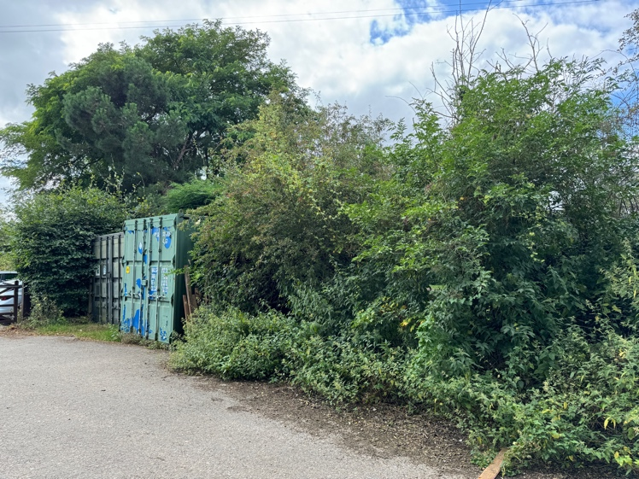

The site now

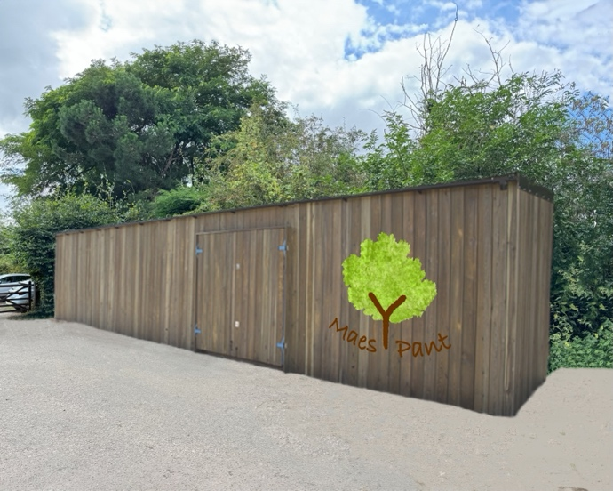

Impression of the proposed new container



Proposal for a new container

Dear neighbour,
This is just to let you know that we’ve submitted a planning application to Wrexham Council for a new storage container.
There will be no change of use, the container will be for storage of tools and equipment only.

Our reasons include:

- We’ve run out of room in the current containers.
- They are looking shabby.
- There are problems with condensation in the winter.
- They have suffered from subsidence.
- They are difficult to open.

Our proposal is to replace the 2 existing containers with one larger container.

The existing containers are both 8 feet wide and 10 feet long. One is 8 feet 6 inches tall; one is 9 feet 6 inches tall. Both are placed with the long side against the fence with the gates.

The proposed new container would be 8 feet wide, 40 feet long and 9 feet 6 inches tall. It would be placed with the long side to the tarmac roadway leading into the site.

To improve the appearance of the container, we propose to get one which has been timber clad, as shown in the illustration overleaf.

We have applied to have solar panels on the roof of the new container, so that we can move to battery powered tools in future. We would charge them from our solar generation. This would reduce our carbon footprint and would also make our operations safer and quieter for our volunteers, our visitors and our neighbours.

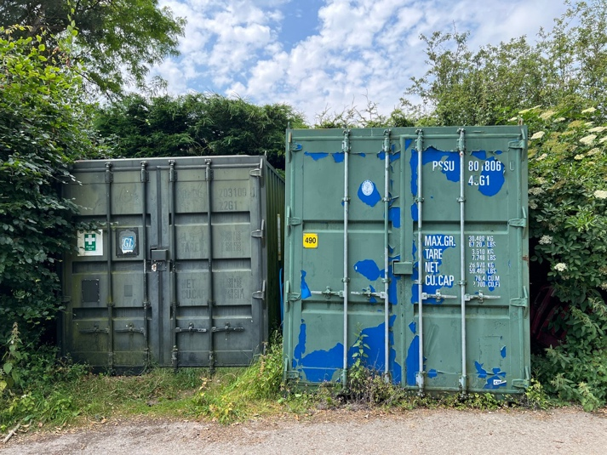

The existing storage containers.

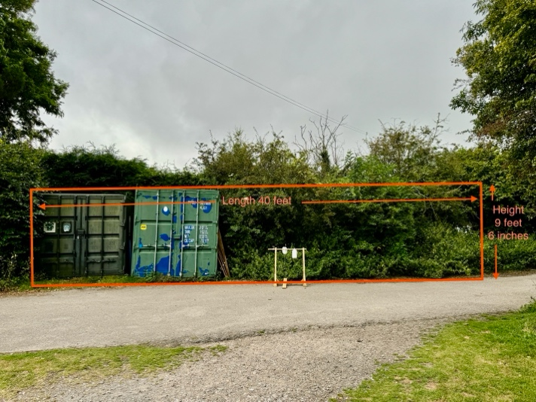
Size of new container shown against the current containers.



www.maes-y-pant.com

email mypag.gresford@icloud.com

