
METHOD STATEMENT

WORK ACTIVITY: | Soft Strip Bridgeway central, Wrexham Phase 2
METHOD STATEMENT NO: | DB0022023
PROJECT: | Bridgeway Phase 2
SITE ADDRESS: | Bridgeway Central, Bridge Road, Wrexham, LL13 9QS
CLIENT: | FI Real estate Management Ltd
CLIENT REPRESENTATIVE: | Boris Byrne FIREM
RAMS REQUESTED BY: | Boris Byrne
RAMS PRODUCED BY: | Daniel Burrows Projects Manager FI Construction
RAMS IN ACORDANCE WITH: | BS6187:2011 Code of practice for full and partial demolition.
HEALTH & SAFETY MANAGER: | Project 4 safety consultants
PROJECTS MANAGER: | Daniel Burrows dburrows@fi-construction.com

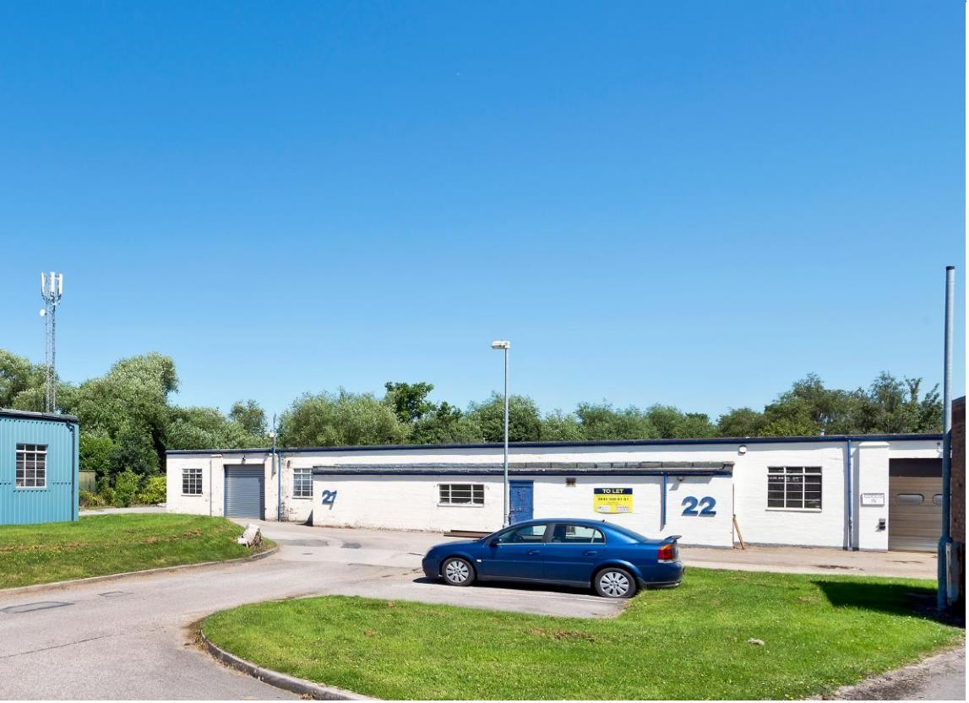

INTRODUCTION:
The purpose of the demolition method statement is to outline our approach to managing the strip out works for the multiple buildings at Bridgeway Wrexham. This document Includes specific comments on the site establishment, logistics, and the process of managing the overall environment surrounding the property. It will also ensure that the breakouts and associated works cause the minimum disruption to the adjacent residents with a safe working and living environment maintained. The agreed contents of this method statement will form part of the development plan and will be agreed with the FI
Construction & demolition teams. The plan will be constantly reviewed, and any changes or improvements will be added and agreed, the plan will then be revised and re- issued.

TRAINING FOR OPERATIVES ON SITE
INDUCTION TRAINING
FI site operatives will receive health and safety site specific induction training by the FI Construction & demolition site management team.
RISK MANAGEMENT, DABS, DAILY ACTION BRIEFING
All operatives associated with site activities which create significant risk of injury will be specifically briefed in the hazards and control measures applicable to the safe system of works. All operatives receiving daily briefings will sign documentation to say they fully understand the risks and control measures implemented to ensure the safety and wellbeing of themselves and others.
Specific Tool box talks will include
SPECIFIC TRAINING
All operatives / operators / managers / or supervisors must hold the appropriate training cards or certificate of training achievement relevant to their positions on site.
TOOL BOX TALK TRAINING
Toolbox talk training will be used to instruct and train employees on specific site tasks, as and when necessary. The manager, supervisor or designated operative presenting the toolbox talk must try to promote an open discussion with all the site team. The presenter must discuss the risk elements of the tasks being discussed and try to get feedback from the site team on the best way of controlling the risks. Feedback from the workforce and actions implemented via the toolbox talks will ensure that everyone feels included and that their participation is meaningful. All toolbox talks and actions because of the toolbox talk must be recorded and signed by all attendees; the record must then be entered into the site file.

Specific Toolbox talks will include
- Interface with other contractors.

TRAINING & PERSONNEL
PROJECTS MANAGER | Daniel Burrows | CCDO GOLD CARD DEMOLITION SUPERVISOR FIRST AID AT WORK  TEMP WORKS CO-ORDINATOR CPCS EXCAVATOR OPERATOR MEWP OPERATOR  NNLW ASBESTOS REMOVAL COURSE

SITE MANAGER | Martin Shone | CCDO GOLD CARD DEMOLITION SUPERVISOR CPCS EXCAVATOR OPERATOR  SLINGER SIGNALLER FIRST AID AT WORK MEWP  BOBCAT SKID LOADER  NNLW ASBESTOS REMOVAL COURSE

SITE SUPERVISOR | TBA | TOP MAN CCDO SLINGER SIGNALLER FIRST AID AT WORK BOBCAT SKID LOADER  NNLW ASBESTOS REMOVAL COURSE

SITE OPERATIVE | TBA | TOP MAN CCDO SLINGER SIGNALLER  NNLW ASBESTOS REMOVAL COURSE

TOOLS & EQUIPMENT
Tools: | Mattocks Sledgehammers Crow bars  Cut off saws  Reciprocating saw
Equipment: | Podium steps Trolleys  Tower Scaffold

PPE
Mandatory PPE: | Hard hat (BSEN397)  Safety boots (BSEN345 steel toe cap & steel midsole)  Hi visibility vest or jacket (class 2) Gloves  Safety Spectacles (1F) or task specific
Task Specific PPE: | Respiratory Protective Equipment with P3 filter (operatives are face fitted) Hearing protection (during use of cut off saws & breakers)

PUBLIC INTERFACE ARRANGEMENTS
Segregation: | All works will be undertaken inside the building and materials will be removed into  waiting skips via the drop zone as mentioned in activity 3

DRAWINGS / SURVEYS
Surveys: | Asbestos survey in site file
Drawings:

PRE-COMMENCEMENT WORKS
Utility Disconnections: | All utility services will be isolated or disconnected prior to commencing works, see activity 1& 2

SEQUENCE OF TASKS

The Site Supervisor/Manager will ensure this method statement and risk assessment is explained to all operatives involved in the task. All operatives will sign to confirm they have understood this method, the risks involved, and the control measures put in place.

Daily task briefings will be carried out and operatives given the opportunity to give feedback on tasks/method statements, where required changes will be made by the FI Construction site team.

Activity 1 : Ensure utility isolations/disconnections have been carried out

HOLD POINT

A1.1 FI Construction & demolition Site Management team will check that written confirmation has been obtained to ensure all utility services have been isolated or disconnected.

A1.2 Upon review of the disconnection certificates a member of FI Management team will sign below and move onto Activity 2.
Please not there are residual live cables within the work areas, the live cables will be highlighted by the site management team and left in place during the soft strip phase.

NAME:…………………………………………… SIG:……………………………… DATE:……………………

ASBESTOS

HOLD POINT

A2.1 The site Management team will check that written confirmation has been obtained to ensure all known asbestos containing materials ACMs have been removed as highlighted in the D&R survey. The site management team will sign below to say all known ACMs have been removed.

NAME:…………………………………………… SIG:……………………………… DATE:……………………

Activity 3 : Establish loading area

A3.1 The site team will establish a loading away area,
A3.2 An exclusion zone consisting of Heras fencing (double clipped) will be established in this area. A4.4 The site team will place 45- yard bins outside the building once the site boundary is established.
A4.5 The soft strip team will segregate all materials into piles ready for placing into the loading away area.

Activity 4 : Commence soft strip

A4.1 The site team will commence the soft strip. Operatives using crow bars, mattocks and sledgehammers will remove the doors, door casings, ceiling tiles and skirting boards as highlighted by the site manager.
A4.2 Operatives working from mobile towers and or hop ups using mattocks and bar will remove the high- level soft strip including ceiling tiles and associated trimming.

Recycling & Separation of Materials

- Operatives will separate all materials and place into separate piles for recycling or for disposal at a licensed recycling facility.

▫ Clean timber
▫ Metals
▫ Mixed waste (taken to a licensed facility for further separation into waste streams)
▫ Hazardous

Manual Handling

- Individual operatives will undertake a manual handling assessment on all materials that they are moving. It is not envisaged any weights will be stamped on the materials to be removed therefore all operatives are trained in manual handling operations and will carry out a ‘mental’ manual handling assessment prior to moving any loads.

- Any items that are too heavy or bulky to lift will be broken down in size and weight using hand tools such as mattocks, sledgehammers and jemmy bars. Mechanical aids such as excavator with grabs, trolleys and sack trucks will be utilised to move materials and team lifting techniques will be utilised.

- AFTER YOUR INDIVIDUAL ‘MENTAL’ MANUAL HANDLING ASSESSMENT IF YOU FEEL YOU CANNOT LIFT OR MOVE A LOAD DO NOT ATTEMPT TO LIFT OR MOVE IT! LEAVE THE LOAD IN SITU AND THE LOAD WILL BE MOVED USING A MECHANICAL EXCAVATOR FITTED WITH GRAB DURING THE MECHANICAL DEMOLITION PROCESS.

- When lifting always use the correct kinetic method of lifting as shown in figure 1;

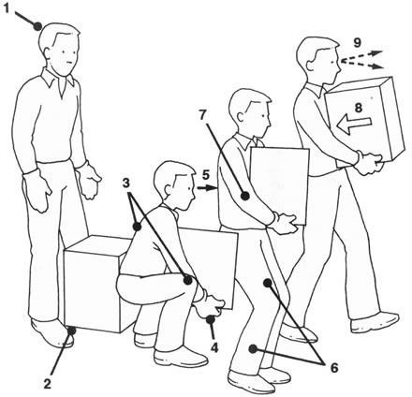
Figure 1

Kinetic lifting technique.

  - Keep head straight
  - Access the load
  - Keep back straight & bend knees
  - Take a good grip of the load
  - Keep head straight & look forward
  - Lift the load using the power in your thighs
  - Keep elbows in close to your body
  - Keep load close to the
  - Look straight ahead in the direction of travel

- The materials will be taken to a designated skip or stockpile in readiness for loading into a skip. The stockpiles will consist of each separate material waste stream.

Access Routes & lighting

- All existing access routes leading into and through the buildings (corridors and stairs) will be used as access to the place of works and will remain clear of all obstructions to ensure a safe trip free access route for all personnel accessing their place of works.

- FI Construction & demolition Site Management team will monitor the lighting within the building and units, where necessary task lighting will be established.

Work at Height

- Work at height to undertake the soft strip will be carried out using one of the following methods.

▫ Mobile towers/podium steps

Mobile Tower / Podium steps

- All mobile towers and podium steps will be erected as per the manufacturer’s instructions ensuring that double handrails and toe boards are always in place.

- Mobile towers are to be erected, altered, and dismantled by PASMA trained operatives only. Operatives are NOT to be on the tower/podium steps when the steps are being moved.

- Scaff tags will be established on all towers. Where a tower is erected for more than 7 days it will be subject to a 7-day recorded inspection.

- All operatives have been issued with respiratory protective equipment fitted with a p3 filter and will have a face fit certificate for the make and model and size of RPE being used, these will be worn for

activities that create dust as determined by relevant risk assessment; daily task briefings will also determine the need for RPE. RPE will be worn when carrying out the following activities.

▫ Sweeping concrete
▫ Breaking out concrete
▫ Shovelling concrete
▫ Removing/breaking out plasterboard

Loose Insulation:

- Fibrous insulation will be removed by hand and placed into bags to prevent cross contamination around the site.

- Task specific disposable overalls and RPE with P3 filters will be worn when removing and handling fibrous insulation. All operatives will have a face fit certificate for the make and model and size of RPE being used.

Doors/Door Cases/Skirting Boards/kitchen units/furniture/wall joists:

- All doors, associated woodwork and furniture will be removed by hand using jemmy bars, crow bars and mattocks.

- The materials will be broken down into manageable weights and sizes.

Non-Load Bearing Walls (stud partitions);

- Internal non-load bearing walls will be removed by operatives using the following method.

Operatives using non vibratory hand tools (plasterboard walls)

- Operatives will break through the plasterboard using mattocks and sledgehammers to reveal the wooden stud work. The stud work will be prised away from its fixings using mattocks, sledgehammers and or crow bars. Operatives will wear RPE when carrying gout this task.

- Any nails left sticking out of stud work timber are to be bent over or removed so no sharp edges are left.

cut off Saw:

- Operatives using a cut off saw will wear task specific PPE consisting of eye protection, hearing protection and RPE consisting of P3 filters. An operative with abrasive wheels training will change the wheel when needed.

- A direct water feed from the cut off saw will be used to suppress and dusts when cutting concrete/brick etc.

- Operatives using a cut off saw will wear task specific PPE consisting of eye protection, hearing protection and RPE consisting of P3 filters. An operative with abrasive wheels training will change the wheel when needed.

Suspect Materials/Asbestos (if found)
If operatives suspect that they have found ACMs works must stop and other operatives stopped from working in the same area.

The area must be sealed off and the site manager informed.

Works must not re-commence until the site manager is confident that the material is not asbestos. If the site manager is not sure the material must be sent for analysis. Only when the analyst has confirmed that the material test negative for asbestos can works continue.

Section 2 SOFT STRIP RISK ASSESSMENTS

What are the hazards | Who might be harmed and how | Risk rating before control measures have been  implemented | What control measures are in place | Risk rating after control measures have been  implemented
Manual Handling | Operatives may suffer broken bones, cuts or lacerations from handling materials | Medium | - Operatives to wear gloves, hard hats, safety spectacles and steel toe capped boots with steel midsoles | Low
Manual Handling | Operatives may suffer back pain when manually handling materials | High | - Trolleys and wheelbarrows to be used to move loads  - If manual handling must be carried out assess the loads before lifting, if required break down the load into manageable weights & sizes using handheld tools  - Kinetic lifting techniques to be used to lift all loads  - Do not move any load if you, as an individual, feel the load is too heavy to move | Low
Slips & trips | Operatives may suffer broken bones, sprains or cuts due to tripping over materials | Medium | - Pedestrian access routes to be kept clear of all materials  - Pedestrian routes to be clearly lit | Low
Falls from height | Operatives may suffer fatal or serious injury when working at height carrying out soft strip activities | High | - No ladders to be used on site to carry out soft strip activities  - The following equipment will be used to provide a safe working platform when working at height.  - Podium steps / mobile towers | Low
Falls from height | Operatives may suffer fatal or serious injury if fall occurs when working from mobile towers or podium steps | High | - Mobile towers and podium steps to be erected as per manufactures instructions ensuring that double edge protection is always in place.  - All mobile towers to be erected, altered, and dismantled by a PASMA trained operative.  - Scaff tags to be used on all towers.  - Recorded inspections to be undertaken if towers are erected for more than 7 days.  - Operatives are not to be on the towers or podium steps whist it is being moved. | Low
Falling materials | Operatives may suffer fatal or serious injury if struck by falling materials | High | - Safety helmets to be always worn  - Exclusion zones to be erected  - Do not access any unsafe structures  - Controlled drop zone must be adhered to. | Low

Contact/strikes of live utility services | Operatives may suffer fatal or serious injury if electric cables or gas pipes are struck | High | - All utility services to be isolated/disconnected prior to commencing soft strip  - Utility disconnection paperwork to be located within the CPHSP  - All live utility services to be identified and marked live  • | Low
Handling sharps | Operatives may suffer disease if pierced by a sharp | High | - Visual inspection of the works area to be carried out prior to commencing soft stripping  - Anti piercing gloves to be used when carrying out sharp’s removal  - Third hand to be used to pick up sharps, never pick up sharps by hand  - Sharps to be placed directly into sharps box | Low
Exposure to asbestos | N/A
Dust from disturbing soft strip materials, | Operatives may suffer respiratory problems due to inhalation of dusts | High | - RPE to be worn when removing fibrous insulation  - RPE to be worn when the environment has become contaminated with dust | Low

Section 3

I confirm I have read and understood the method statement and risks involved and will work in accordance with the method statement as described

OPERATIVE SIGNATURES
Name | Signature | Date | Revision No.

AMENDMENTS
Time/Date | Description of amendment | Signature of  Manager/Supervisor

M/S PREPARED BY: Daniel Burrows | DATE: 06- September 2024

