
METHOD STATEMENT

WORK ACTIVITY: | Mechanical demolition multiple buildings Wrexham
METHOD STATEMENT NO: | FI0012021
PROJECT: | Bridgeway Phase 2
SITE ADDRESS: | Bridgeway Central, Bridge Road, Wrexham, LL13 9QS
CLIENT: | FI Real estate Management Ltd
CLIENT REPRESENTATIVE: | Boris Byrne
RAMS REQUESTED BY: | Boris Byrne
RAMS PRODUCED BY: | Daniel Burrows
RAMS IN ACORDANCE WITH: | BS6187:2011 Code of practice for full and partial demolition.
HEALTH & SAFETY MANAGER: | Project four Safety consultancy
PROJECTS MANAGER: | Daniel Burrows FI Construction Ltd

INTRODUCTION:
The purpose of the demolition method statement is to outline our approach to managing the demolition works for the mechanical demolition at Bridgeway Central. This document Includes specific comments on the site establishment, logistics, and the process of managing the overall environment and surrounding property. It will also ensure that the demolition and associated works cause the minimum disruption to the adjacent businesses with a safe working and living environment maintained. The agreed contents of the demolition method statement will form part of the development plan and will be agreed with FI Construction Ltd site team. The plan will be constantly reviewed, and any changes or improvements will be
added and agreed, the plan will then be revised and re- issued.

BRIEF DESCRIPTION OF WORKS TO BE UNDERTAKEN
DESCRIPTION OF WORKS: | To mechanically demolish multiple units using a series of demolition excavators fitted with rotating pulverisers and demolition sorting grabs.

TRAINING FOR OPERATIVES ON SITE
INDUCTION TRAINING
Prior to any operatives commencing works on site they will receive health and safety induction training by the demolition site manager or supervisor FI Construction Ltd
RISK MANAGEMENT, DABS, DAILY ACTION BRIEFING
All operatives associated with site activities which create significant risk of injury will be specifically briefed in the hazards and control measures applicable to the safe system of works. All operatives receiving daily briefings will sign documentation to say they fully understand the risks and control measures implemented to
ensure the safety and wellbeing of themselves and others.
SPECIFIC TRAINING
All operatives / operators / managers / or supervisors must hold the appropriate training cards or certificate of training achievement relevant to their positions on site.
TOOL BOX TALK TRAINING
Toolbox talk training will be used to instruct and train employees on specific site tasks, as and when necessary. The manager, supervisor or designated operative presenting the toolbox talk must try to promote an open discussion with all the site team. The presenter must discuss the risk elements of the tasks being discussed and try to get feedback from the site team on the best way of controlling the risks. Feedback from the workforce and actions implemented via the toolbox talks will ensure that everyone feels included and that their participation is meaningful. All toolbox talks and actions because of the toolbox talk must be
recorded and signed by all attendees; the record must then be entered into the site file.

TRAINING & PERSONNEL
PROJECTS MANAGER | Daniel Burrows | CCDO GOLD CARD DEMOLITION SUPERVISOR CPCS EXCAVATOR OPERATOR  FIRST AID AT WORK  CPCS EXCAVATOR OPERATOR MEWP OPERATOR  NNLW ASBESTOS REMOVAL COURSE

SITE MANAGER | Martin Shone | CCDO GOLD CARD DEMOLITION SUPERVISOR CPCS EXCAVATOR OPERATOR  SLINGER SIGNALLER FIRST AID AT WORK BOBCAT SKID LOADER  NNLW ASBESTOS REMOVAL COURSE

SITE SUPERVISOR | TBA | CCDO DEMOLITION OPERATIVE CPCS EXCAVATOR

SITE OPERATIVE | TBA | CCDO DEMOLITION OPERATIVE NNLW ASBESTOS REMOVAL COURSE CPCS EXCAVATOR

PLANT & EQUIPMENT
PLANT: | Multipul Demolition specification 360’ excavators
ATTACHMENTS: | 360- degree rotating combination shear (capable of cutting steel and concrete)  360- degree rotating demolition grab  Test certificates for the equipment as required under PUWER will be supplied upon delivery to site and prior to any works commencing.  NOTE – the excavators are demolition plant and are not classed as lifting devices when carrying demolition attachments and do not come under  LOLER when operating as demolition excavators.
WORK EQUIPMENT: | Hose pipe for dust suppression  Heras’s fencing panels

PPE
MANDATORY PPE: | Hard hat (BSEN397)  Safety boots (BSEN345 steel toe cap & steel midsole)  Hi visibility vest or jacket (class 2) Safety Spectacles (1F)  Gloves (KV2101)
TASK SPECIFIC: | RPE with P3 filters (all operatives face fitted, cleanly shaven every day)

PUBLIC INTERFACE ARRANGEMENTS
SEGREGATION: PROTECTION: | Temporary exclusion zones will be erected during specific stages of the demolition. The details of the exclusion zones are attached.  The pavements will be cleared at the end of each working day along care will be taken to ensure that emergency vehicle access is not impeded.

DRAWINGS / SURVEYS
SURVEYS: | A photographic dilapidation survey of the pavement and road will be undertaken prior to commencing demolition activities and forwarded to  head office for information. N/A
DRAWINGS:
PERMITS: | Permit to excavate to be issued prior to any excavations

ENVIRONMENTAL / MONITORING
DUST: | A water suppression unit will be located on site to spray a fine mist of water over the structure during the mechanical demolition process.
NOISE & VIBRATION: | N/A

SERVICE DISCONECTIONS / ISOLATIONS
Electricity | - Isolated  - Disconnected
Sign off……………………Comments ……………………….………………………………………

SERVICE DISCONECTIONS / ISOLATIONS
Gas | - Isolated…………………………….  - Disconnected……………………………………
Sign off……………………Comments ……………………….………………………………………

SERVICE DISCONECTIONS / ISOLATIONS
Water | - Isolated
Sign off……………………Comments ……………………….………………………………………

ASBESTOS SURVEY / REMOVAL
Asbestos

Sign off……………………Comments ……………………….………………………………………

ENVIRONMENTAL SURVEY
See site file

ECOLOGY
See site file

TREE PROTECTION
Tree constraints plan attached

Please note Prior to any mechanical demolition the site team must install robust protection to all trees as shown on the report. The protection will be made up of Heras fence panels and signage. The site management teams will present regular toolbox talks to remind the site teams of the importance of protecting the trees.
Protective Fencing This fencing must be
maintained in accordance with he approved plans and drawings for this development.

SEQUENCE OF TASKS

The Site Supervisor/Manager will ensure this method statement and risk assessment is explained and briefed to all operatives involved in the task. All operatives will sign to confirm they have understood this method, the risks involved and the control measures put in place.

Activity 1 – Erect exclusion zone
A1.1 An exclusion zone will be erected as shown picture below. This area will be controlled by FI Construction Ltd banksman during the demolition operations. The banksman will be in contact with the excavator operator and the FI Construction and Demolition Ltd site manager.

A1.2 The exclusion zone will be controlled by a minimum of two operatives always acting as banksman. The banksman will be always in visual contact with the excavator operator and Site Manager. The banksman will have full authority to stop works at any time during the demolition operations. If at any time access is required by emergency vehicles or delivery driver’s demolition works will cease and the exclusion zone gates will be opened to allow controlled access past the demolition works.
A1.3 The demolition works will be carried out within the exclusion zone. Banksman will control vehicle in and out of site. No reversing outside site without a banksman.

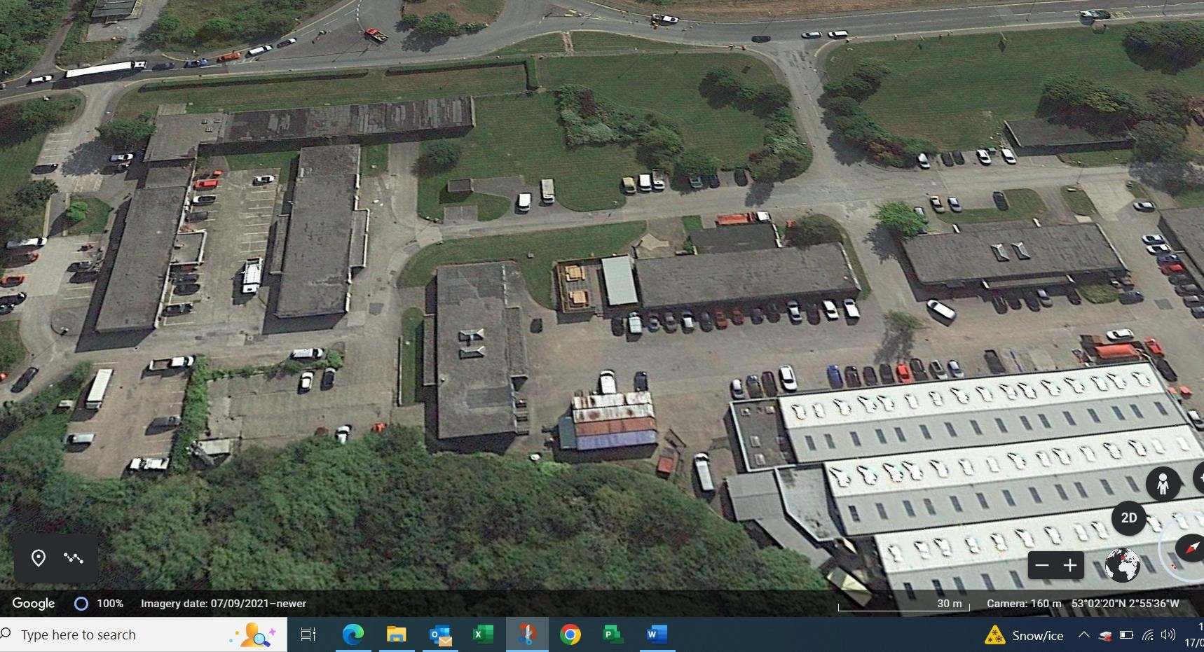

Activity 2 - Set up dust suppression
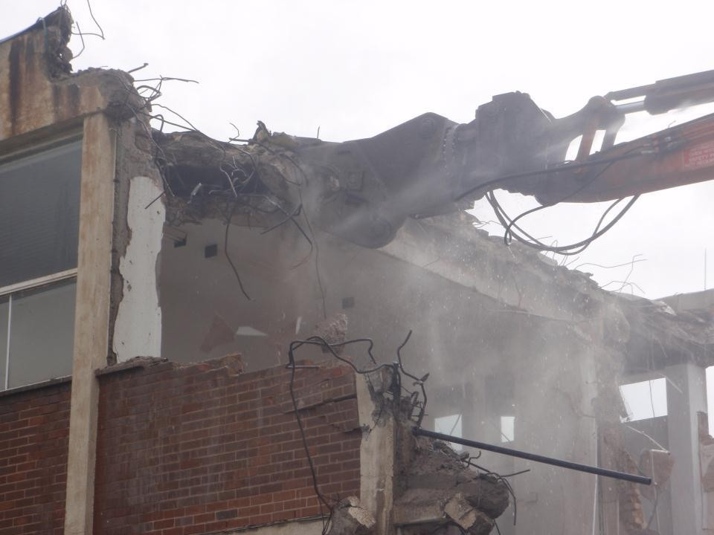
A2.1 Water suppression will be set up to enable a constant spray of water to be directed onto the structure during mechanical demolition. The water suppression is a direct feed water system that enables a fine mist to be sprayed close to the end of the pulveriser that is fitted to the excavator.

Dust suppression at source

Activity 3 - Commence mechanical demolition

A3.1 A 360 Excavator fitted with a rotating demolition sorting grab will commence to demolish the first section of the single storey building. The operator will strip off the roof section and will place any bitumen covering directly into a 45 yard bin
A3.2 The operator using the 360 excavator fitted with the sorting grab will then reduce the walls down to slab level. The demolition arisings will be separated for recycling as described in activity 4.

A3.3 Once the walls are down and removed the excavator operator using the 360 excavator fitted with a bucket will commence lifting the slabs and foundations. The slabs will be lifted and processed using a concrete pulveriser. The demolition arisings will be separated and stockpiled for crushing.

Activity 4 – Segregation and recycling

A4.1 The site team using multiple excavators fitted with sorting grabs, demolition shears and pulverisers will commence sorting through the demolition arisings.

A4.2 The excavator operators will sort through the demolition arisings and place the separated products into pile for recycling. The teams will have skips and bulker trailers at hand to load away all recyclable materials.

A4.3 The excavator operators will spread demolition arisings into a safe area where operatives can sort through without risk of being struck by excavators or moving vehicles. Operatives working in the safe area will sort through the debris pulling out any cable or non- ferrous metals for recycling. The recycling materials will be placed into 10- yard bins to be sent to the recycling facility.

Section 2
MECHANICAL DEMOLITION RISK ASSESSMENTS

What are the hazards | Who might be harmed and how | Risk rating before control  measures have been implemented | What control measures are in place | Risk rating after control  measures have been implemented
Manual Handling | Operatives may suffer broken bones, cuts or lacerations from handling materials. | Medium | - Operatives to wear gloves, hard hats, safety spectacles and steel toe capped boots with steel midsoles | Low
Manual Handling | Operatives may suffer muscular skeletal injuries when manually handling materials. | High | - 360 excavators to be utilised to demolish the building and move loads where possible.  - If manual handling has to be carried out assess the loads before lifting, if required break down the load into manageable weights & sizes using handheld tools  - Kinetic lifting techniques to be used to lift all loads.  - All operatives to have undergone manual handling training. | Low
Slips & trips | Operatives & members of the public may suffer broken bones, sprains or cuts due to tripping over materials | Medium | - Pedestrian access routes to be kept clear of all materials.  - Pedestrian routes to be clearly lit.  - Exclusion zones to be banked and manned.  - Exclusion zones to be removed at the end of each working day. | Low
Falling objects | Operatives on site and members of the public may suffer serious or minor injury due to falling materials | High | - Site to be enclosed with fencing prior to commencing demolition.  - No operatives are to be inside the building during mechanical demolition.  - Operatives to wear hard hats and steel toe capped & steel mid sole safety boots.  - No loads to pass over the top of any operatives.  - Banksman to be used on site to ensure no personnel encroach into the demolition area.  - Excavator operator to be experienced in demolition works.  - Building to be demolished in bays ensuring the building is never undermined.  - Building to be left in a safe state at the end of each shift. | Low

- Sequence and methodology to be approved by a structural engineer.
- Arisings to be scrapped off the floors to prevent overloading.
- Road narrows and road closures to be implemented during certain phases of the demolition process.
- ​
Excavator operations | Operatives on site & public may suffer fatal or serious injury if struck by an excavator | High | - Plant operators to be trained and competent.  - Always approach excavator from the front & ensure operator has contacted you prior to walking into the arc of the excavator.  - Never walk into the arc of the excavator  - Ensure site traffic management plan is followed on site.  - Exclusion zones to be erected around the site. | Low
Excavator operations | Excavator operator may suffer fatal or serious injury due to excavator overturning | High | - Excavator operator to wear seat belts at all times.  - Excavator to be operated on firm level ground. | Low
Excavator operations | Site operatives may suffer fatal or serious injury due to incorrect use of quick hitch, working under attachments or if the attachment becomes detached from excavator  Excavator operators may suffer serous injury when re- fuelling excavators. | High | - All plant operators to have undergone quick hitch training.  - All plant operators to use quick hitch as per manufactures instructions.  - Attachments or loads must not be manoeuvred over the top of any personnel and must not be slewed over any of the site boundary  - Excavator operators must be extremely careful when re- fuelling excavators.  - Operators must use safe platform when re-fuelling.  - Operators must be careful not to spill fuel when filling up.  - Mobile towers may have to be introduced when filling up if excavators are not fitted with a boxing ring.  - Operatives must carry out a risk assessment prior to filling up excavators. | Low
Contact/strikes of live utility services | Plant operator operatives may suffer fatal or serious injury if electric cables or gas pipes are struck | High | - All utility services to be disconnected prior to commencing mechanical demolition.  - Utility disconnection paperwork to be located within the CPHSP | Low
Contact / being  struck by HGV’s | Operatives on site may suffer fatal or serious injury if struck by an HGV | High | - Ensure site traffic management plan is followed on site.  - Any reversing into site must directed with the aid of a banksman. | Low
Dust during demolition activities | Operatives and members of the public may suffer minor respiratory problems due to dust being created from | High | - Water will be directed onto the building to suppress any dust that may occur from demolition activities | Low

 | mechanical demolition activities
Noise during demolition activities | Members of the public and may suffer nuisance noise during mechanical demolition | High | - Structure to be demolished using a pulveriser to reduce the noise | Low
Collapse of building | Members of the public and may suffer fatal injuries if building collapses during mechanical demolition. | High | - Structure to be demolished working in bays ensuring that the building is stepped, and the floors are cleared of demolition arisings as the demolition progresses through the structure.  - Exclusion zones to be implemented around the structure.  - Road narrows and road closures to be implemented during certain phases of the demolition process.  - ​ | Low

Section 3

I confirm I have read and understood the method statement and risks involved and will work in accordance with the method statement as described

OPERATIVE SIGNATURES
Name | Signature | Date | Revision No.

AMENDMENTS
Time/Date | Description of amendment | Signature of Manager/Supervisor

Method Statement Produced By: Daniel Burrows Projects Manager | 04-09-2024

