FI Construction Ltd
Canal Mill, Botany Brow, Chorley, Lancashire, PR6 9AF
FI Construction Ltd Company Reg No. 11521242
FI Construction is part of the FI wider group which includes FI Real Estate Management and FI Facilities Management.
Revision: 02
Copy No 1 Demolition of redundant buildings Wrexham Bridgeway
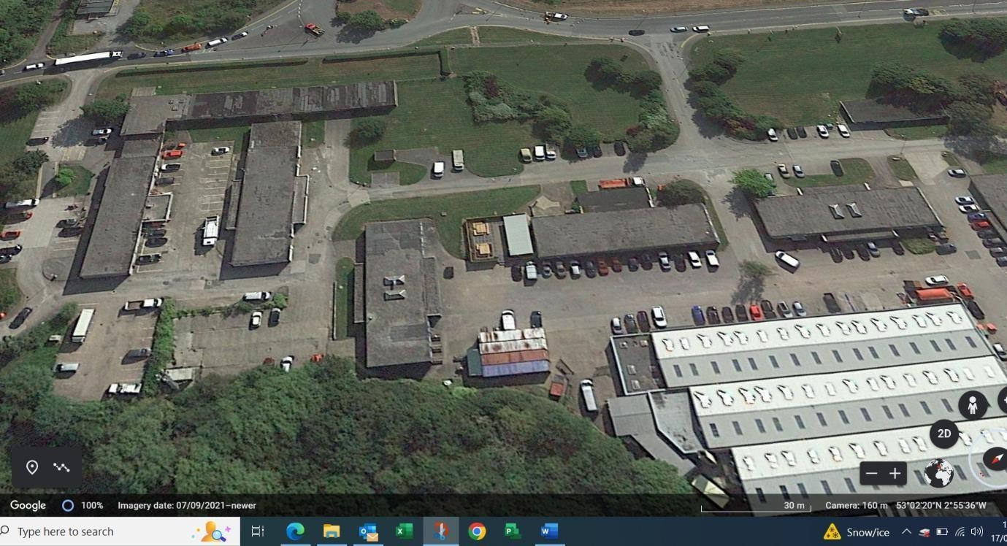

 | Name | Signature | Job Title | Date
Prepared by | D Burrows |  | Projects Manager | August 2024
Reviewed by | B Byrne |  | Client: FI REM | August 24
Approved by | J Lohan |  | Construction Director FI Construction | September 24

Section | Title | Page
1.0 | Introductory statement
2.0 | Key project information
2.1 | Client
2.2 | Principal designer
2.3 | Principal contractor
2.4 | Site location
2.5 | Scope of works
2.6 | Program
Section | Title | Page
3.0 | Health &safety information
3.1 | Company health &safety policy
3.2 | Company health and safety management structure
3.3 | Procedures for communicating health & safety information on site
3.4 | Emergency procedures
3.5 | Notification to HSE
3.6 | Monitoring health & safety standards
3.7 | Unplanned events
3.8 | Health & safety file
Section | Title | Page
4.0 | Existing Site information
4.1 | The surrounding environment
4.2 | Services
4.3 | Site conditions
4.4 | Access to site
4.5 | Drawings
4.6 | Other information
Section | Title | Page
5.0 | Design
5.1 | Anticipated hazards

5.2 | Method statements
5.3 | Risk assessments
Section | Title | Page
6.0 | Construction materials
6.1 | Materials
6.2 | COSHH
6.3 | Lifting/ manual handling
6.4 | Storage of materials
Section | Title | Page
7.0 | Site wide elements
7.1 | Traffic systems and restrictions
7.2 | Welfare facilities
7.3 | Fire and explosion
7.4 | Waste control
7.5 | Control of noise and vibration
7.6 | Control of dust
7.7 | Children
7.8 | PPE
7.9 | Asbestos
7.10 | Security
7.11 | Electricity
Section | Title | page
8.0 | Site procedures
8.1 | Site rules
8.2 | Training and information
8.3 | Site liaison
8.4 | Continuing liaison

Section | Title | page
Appendix 1 | Hazard identification
Appendix 1 | Risk Assessments
Appendix 1 | COSHH assessment
Appendix 1 | Fire prevention

Section | Title | page
Appendix 2 | Method Statements
Appendix 2 | Specification / schedule of works
Appendix 2 | Permits to work
Appendix 2 | Accident and emergency procedures
Appendix 2 | Route and directions to hospital

Section | Title | page
Appendix 3 | Record of site briefing
Appendix 3 | Record of site audits
Appendix 3 | Waste transfer licence
Appendix 3 | Insurance documents

Section | Title | page
Appendix 4 | Scaffold register
Appendix 4 | Plant operators register
Appendix 4 | Plant register
Appendix 4 | Lifting gear register

Section | Title | page
Appendix 5 | Program of works
Appendix 5 | Register of drawings
Appendix 5 | Record of sketches

Section | Title | page
Appendix 6 | Site induction file | Page 1
Appendix 6 | Method statements | Page 2
Appendix 6 | Toolbox talk register | Page 3
Appendix 6 | Work equipment inspection forms | Page 4
Appendix 6 | Scaffold inspection forms | Page 5
Appendix 6 | Lifting equipment forms | Page 6
Appendix 6 | Site safety inspection forms | Page 7
Appendix 6 | Complaint’s log | Page 8
Appendix 6 | Hot works permits | Page 9
Appendix 6 | Permit to excavate | Page 10
Appendix 6 | Incident/ near miss forms | Page 11
Appendix 6 | Service disconnection / isolation forms | Page 12

1.0 Introductory Statement
This construction phase health & safety plan has been prepared from all available and relevant information relating to the project. It sets out the general framework for the management of health and safety during the duration of the Bridgeway project.
The work will be carried out under the [CONSTRUCTION DESIGN AND MANAGEMENT REGULATIONS 2015] and MANAGEMENT OF HEALTH AND SAFETY AT WORK REGULATIONS 1999.

This document will have to be developed, reviewed, and updated as the project progresses, further design work is completed, information from sub- contractors becomes available and unforeseen circumstances or variations arise.

In order to maintain high standards of health and safety all demolition work will be monitored and controlled throughout the duration of the project.
The main objectives of this health and safety plan are to achieve a safe working environment for all persons who may be affected by the work operations. Such objectives include inter alia:

- The elimination of all reportable accidents [under the provisions of the reporting of injuries, Dangerous Occurrences Regulations 2013]

- To actively manage safety and in doing so improve the safety awareness of all personnel involved with the site and to ensure safe working practices for all employees are established and adhered to.

- To encourage all employees to play an active part in improving the health and safety standards as detailed in this health and safety plan.

This document details the various health and safety arrangements, which will be during the progress of all demolition work on the client’s property.
This document will be completed in full, where relevant to this project and developed as the project progresses and will provide the basis for the health and safety file.

2.0 Key project information

2.1 The client for the project is:
FI-Real Estate Management
Canal Mill, Botany Bay, Chorley, Lancashire, England, PR6 9AF

Client representative:
Boris Burn: FI Real Estate Management

Architect:
T.B.A

Mechanical and electrical engineer:
T.B.A.

Structural Engineer
T.B.A.

2.2 The principal designer for the project
George Steele

2.3 The principal contractor for the project
2.3 The principal contractor for the project is:
FI Construction Ltd Canal Mill
Botany Bay Chorley Lancashire England PR6 9AF
Contact: Daniel Burrows dburrows@fi-construction.com

.4 Site location
The Bridgeway Centre, Wrexham industrial Estate, Wrexham, Wales
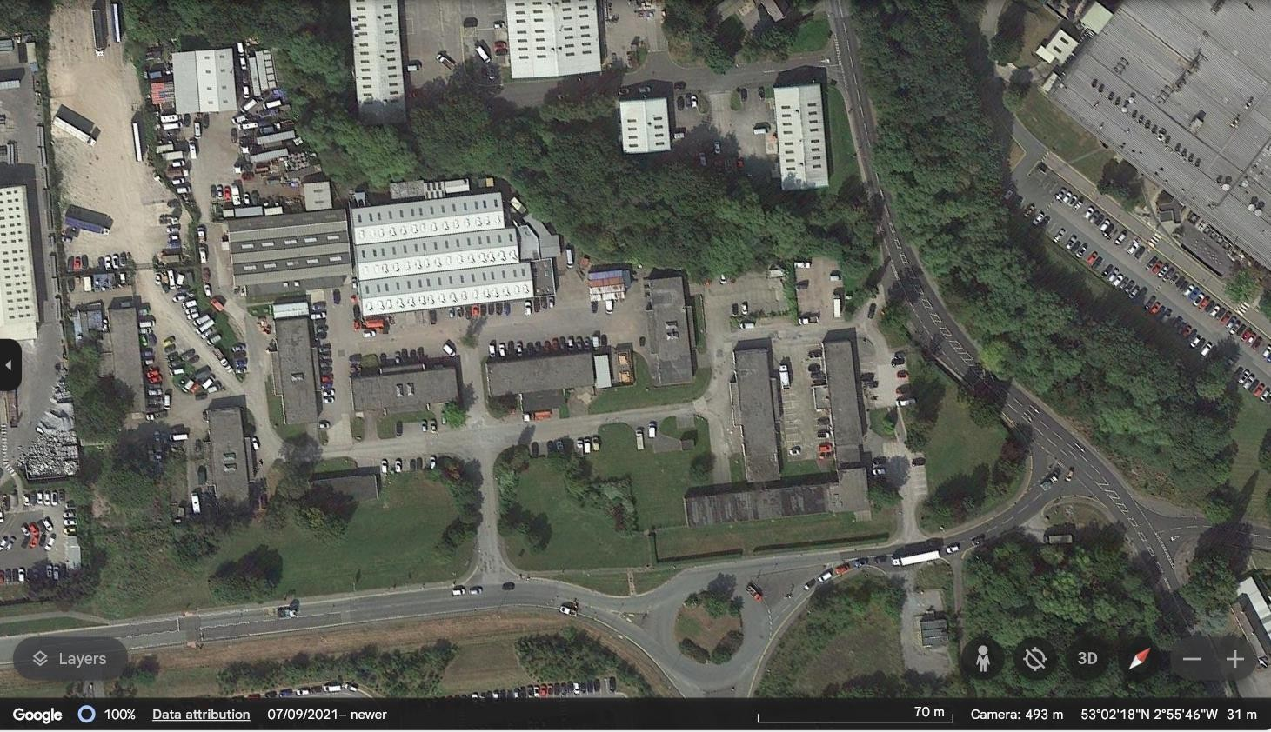
Phase 2 demo
Phase 1 demo

2.5 scope of works

Scope of works Bridgeway Wrexham Demolition Phase
Prior to the soft strip phase an asbestos demolition survey was commissioned by FI Real estate Management. [Home counties asbestos] carried out site investigations and produced surveys HCA02990- HCA991-HCA992 all surveys in the site file. Please note the surveys found low risk, non- notifiable asbestos cement materials [ACMs]
The strip out works shall include the removal of all equipment including loose furnishings, floor coverings, doors, door casings, ceilings, including mechanical and electrical equipment. The items included in this document generally describe the works, but do not attempt to give a detailed description of the work moreover do not absolve the contractor from his responsibility to visit the site and make himself aware of all governing factors which may affect the content, program, and method of stripping out.
Fi Construction will continue to liaise and co-ordinate with the site management teams prior to any strip out works commencing. Such liaison will minimise disruption to the operation of other contractors and tenants. Disruption to the operation of tenants is not acceptable and evidence of pre- planning all isolations is required before undertaking.
FI Construction will comply with fully with all COSHH regulations in respect of hazardous substances, the control of pollution act 1974 and environmental Protection Act 1990, All Refrigerant gases should be safely captured in line with current guidelines. Under no circumstances are any F gases to be released into the atmosphere.
FI Construction will comply fully with the control of asbestos regulations [CAR 2012]
FI construction will solely utilise registered disposal sites for the disposal of non- recyclable waste materials. FI will produce waste consignment notes for all materials leaving site.
FI Construction and the Brunel management team will continually liaise with the M&E team when isolating or disconnecting mechanical and electrical items passing through tenanted businesses. FI Construction will take every precaution to prevent isolating or disconnecting live services feeding tenanted units by employing competent persons and implementing a safe system of works. The Brunel management team will liaise with tenants and provide emergency contact details in the event of an incident involving an incorrect M&E isolations / disconnection. All redundant items of plant and equipment must be offered to the Landlord prior to being removed from site. The Contractor shall ensure that adequate protection is provided to any services to be retained and shall be responsible for repair and/or remedial works to retained services required due to site damage or failure to provide adequate protection.

Electrical incoming mains
The electrical incoming mains will be disconnected prior to works commencing. FI Constructions in house electrical engineers will carry out the disconnections and provide written disconnection or isolation certificates.

Gas
- Isolate incoming gas supply at the meter and safely and thoroughly vent/purge the remaining gas in accordance with Good Practice, Institute of Gas Engineers Regulations and gas safe recommendations prior to removal of gas distribution
pipework within the Arcade units back to the meter position.
•
Decommission, isolate, drain down and safely remove all gas operated
appliances to include, but not limited to, boilers, water heaters and catering
equipment and all associated accessories.
WATER

The existing water supply is derived from the mains.
The meter is located within the landlord corridor just before the entry point into each unit. FI Construction will utilise the incoming water for dust suppression.

2.6 Programme timings
Start date: Estimated April 2024 subject to bat licence approval Duration: weeks 14 Weeks
Completion date:
Monday to Friday 7am – 6pm
Saturday: to be agreed with local authority. Sunday: no works
Bank holidays: no works

3.0 Health & Safety information

3.1 Company health & safety policy Statement
My commitment and that of the Board members to the health and safety is absolute and in reflecting this commitment the following objectives shall be implemented within the company:
To ensure a safe and healthy working environment for all employees, sub- contractors and those others affected by the companies’ activities by prioritisation of funding and resources for safe working systems.
Specific responsibilities are allotted to the Directors and Managers these are detailed within the job descriptions and safety responsibility statements. The responsibilities are designed to enable those individuals to develop suitable standards and procedures by which to meet the safety management system.
Ensuring company goals of client satisfaction, ongoing business development and profit are not in conflict with good safety and industry best practise. A good safety record is of benefit to business, while a safe healthy environment protects and encourages our staff, our most important asset.
I also believe that concern for the environment is an essential element of safety management, and I shall set positive environmental policies supported by environmental procedures.
Specifically, I will ensure that:
- The health & Safety at work act 1974 and all relevant legislation is seen as the minimum requirement.
- A competent person is appointed to ensure all compliance with legislation providing professional safety, environmental, Training, Safety advise and strategy to the board in all related matters affecting the company.
- A safety committee meeting structure is established, aimed at including all employees and safety representatives.
- There is support for staff who abort work on grounds of safety and/or health.
- Fire and security arrangements exist and are maintained to meet the legal requirements, industry standards and to exercise loss control.
- Arrangements exist and are applied to the identification of hazards, the assessment of risk associated with such hazards and the implementation of suitable control measures.
- That first aid facilities are provided and maintained.
- Safety information, data and trends are reviewed and used for accident prevention and continuing improvement of the safety management system.
- All employees, including visitors and subcontractors are given sufficient information to carry out their duties with the minimum of risk.
- Training needs to be identified and met.
- Managers demonstrate our care for them, there safety, health, and welfare.
- Plant and equipment owned or hired is of safe design and properly maintained.
- Suitable welfare facilities are provided for all staff at or near work sites, providing shelter and messing facilities.
- Suitable personnel protective equipment is provided with training for all employees exposed to risk to their health and safety whilst at work.
- A robust system of self-audit shall be instigated. This will involve inspections, safety tours and continuous monitoring in line with the HSE guidance document[G]65, safety objectives will be set annually by myself for my management team.
- A procurement policy to ensure compliance with the relevant statuary requirements, clients standards and industry best practise.
- There is the provision of adequate resources to meet these commitments. Name of responsible person John Lohan Construction Director
Name………………………………………………. Sign……………………………………………….. Date………………………..

3.2 Companies health & safety management structure
- Daniel Burrows has overall responsibility for the demolition sector health and safety performance.
- Project 4 health & Safety consultants are employed to carry out regular site safety inspections.
The site manager has the day-to-day responsibility for the management of health and safety on site.
Health & safety management structure

Client: FI Real Estate | Client representative: Boris Burn

Construction Director John Lohan

Health & Safety Consultants: Project four

Projects Manager Daniel Burrows

Site Manager Martin Shone
Site supervisor TBA

Operatives | Sub- contractor operatives

3.3 Procedures for communicating health and safety information on site
This health and safety plan will be issued to the site manager prior to commencement of works.
All personnel entering site will be checked, recorded, and inducted. There is likely to be interface with retail staff working near the strip out works. Liaison with safety representatives from the adjacent businesses and accommodation will be deemed necessary. This will further be augmented by ongoing inductions of all new operatives prior to commencement of works on site. The site management teams will raise toolbox talks, at least one per week relevant to the tasks being carried out.
Daily action briefing DABs is mandatory on all FI sites and will be carried out every
morning before shifts commence. No Dabs! No Works!

3.4 Emergency procedures
The emergency plan will be developed by the site manager on commencement and displayed in the site office.
The nearest hospital is

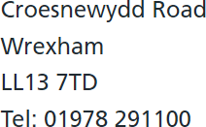

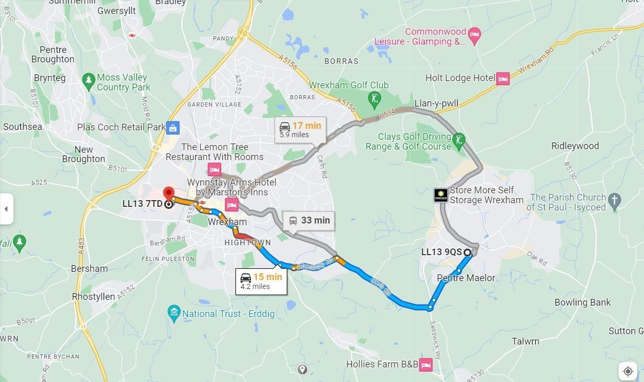

3.5 Notification to the HSE
The principal designer has completed a copy of the initial notification form F10 on behalf of the client and returned it to the HSE. A copy will be displayed in the site office for the duration of the works.
The controlling Health & Safety Executive is: Regent House
Regent Street Wrexham LL11 1PR

3.6 Monitoring health & safety standards
Regular visits will be made by Project four health & Safety consultants services who will carry out site inspections’ and prepare reports, drawing any non- compliance to the site managers immediate attention. Any serious situations or continuing non- compliance will be reported to the principal designer and the client.
Weekly inspections to be carried out by the contracts manager, results of the inspection must be entered into the site file for reference.
Unannounced inspections will be carried out by a company director.

3.7 Unplanned events
The site manager shall inform John Lohan, Construction director, by telephone immediately and subsequently confirm in writing, any of the following to the client, principal designer, and the safety consultant.
- Any incident/ accident required under UK legislation to be reported to the HSE under R.I.D.D.O.R 2013 Regulations.
- Any major change of the design and / or to the resources required to complete the work, which may involve amendment to the Construction Phase Health & Safety Plan.
- 5 Health & Safety file building manual
All relevant documentation will be handed over to the principal designer at the end of the project for incorporation into the project health & Safety file.
Any additional information requested by the principal designer for the project Health & Safety file will be provided.
All alterations to the original design proposals will be recorded by the contractor sub – contractor concerned and incorporated withing the health & Safety plan in order that they can be included within the health & Safety file.

3.8 Health & Safety file
Health & Safety file building manual
All relevant documentation will be handed over to the principal designer at the end of the project for incorporation into the project health & Safety file.
Any additional information requested by the principal designer for the project Health & Safety file will be provided.
All alterations to the original design proposals will be recorded by the contractor sub – contractor concerned and incorporated withing the health & Safety plan in
order that they can be included within the health & Safety file.

4.0 Existing Site information
See site file

4.1 The surrounding environment
LOCATION
Wrexham industrial estate is well connected with the A483, A534 and A55 all located within proximity. The A55 links with the M53 and M56 motorways to the North and these provide onward access to the national motorway network.
Wrexham railway station sits to the west of the town centre, providing services to Chester in around 15 minutes. Meanwhile, Liverpool john Lennon airport and Manchester international Airport are only 38 and 48 miles away respectively.

4.2 Services
- All services will be identified by FI Construction mechanical & electrical teams.
- Where possible services will be disconnected or isolated.
- Some service may be diverted but will remain live, these services must be clearly marked and protected.
- Services that are to remain live will be entered into the site daily action briefing document and highlighted at every briefing.
- Disconnection and isolation certification to be provided by the centre management in house mechanical and electrical team.
The site will remain under the control of FI construction until the work has been completed and the necessary handover meetings have concluded to the satisfaction of all involved. The site manager will ensure that the client and their representatives receive regular briefings on site conditions and programme.
4.3 Site conditions

4.4 Access to site
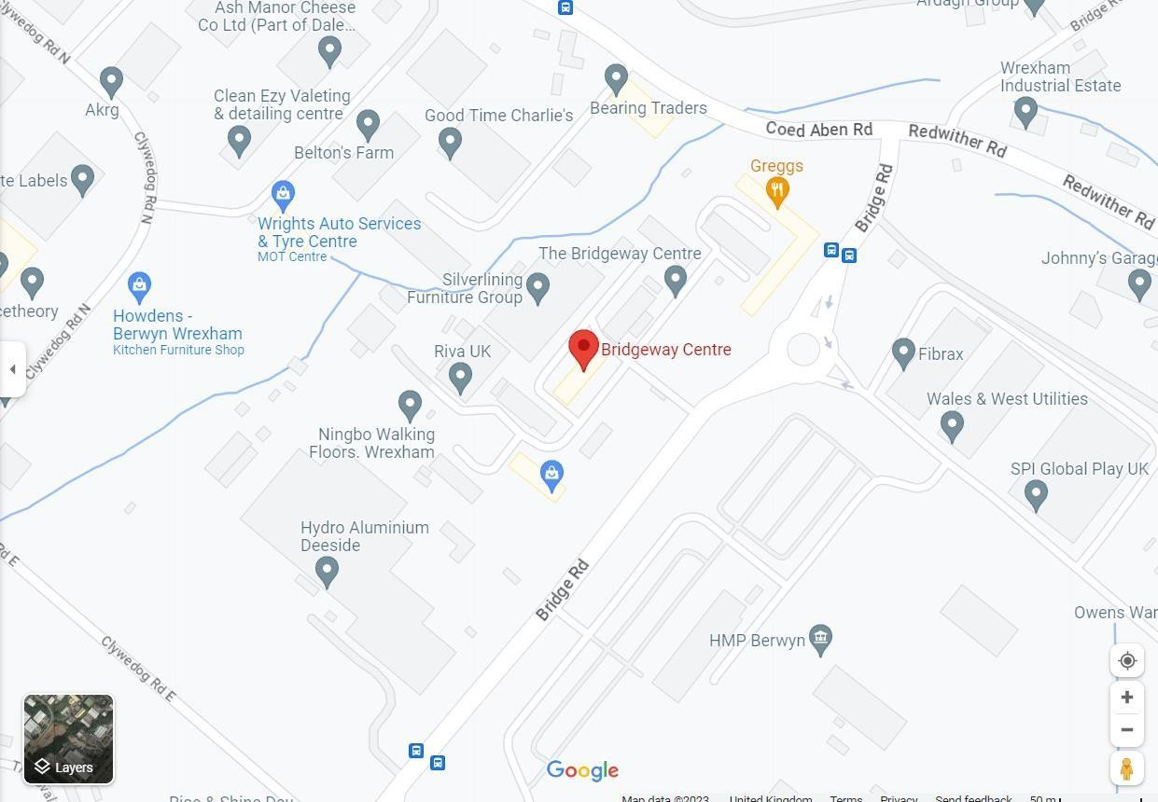

Deliveries to be made to the existing loading area located by the site entrance off Bridge Rd. All visitors and personnel will report to the site office and receive inductions or DABs briefing before commencing any works. Access will be defined on the agreed traffic management drawings.

4.5 Existing drawings
Available in site file
4.6 Other information

5.0 Design
Schedule of strip out to be obtained Scope of works included

5.1 Anticipated Hazards
The following anticipated hazards or works sequences, which cannot be avoided or designed out, have been identified:
- Work at height requires careful planning. Site inductions, toolbox talks and daily action briefing to implemented to show good communication between management and site operatives. Only trained personnel to operated plant on site.
- Operatives may use mobile towers to access height, only trained personnel to erect mobile towers. Operatives must never push towers when other operatives are on the working platform.
- Strip out works are near some live services, operatives must liaise with the site management team to ensure they are working safely, all live service will be marked as live, inductions, toolbox talks, and daily action briefings will remind all operatives on site of any live services on site.

5.2 Method
Method statements and risk assessments addressing the forementioned hazards have been produced and will be briefed to all operatives working on the project. Operatives
will sign the method statement to say they fully understand the document and are happy that the risks and control measures have been addressed.

5.3 Risk assessments
When preparing the method statement the above-mentioned hazards have been addressed within the risks and control measures. However, it is likely that there will be additional hazards to address throughout the project that must be dealt with as soon as they are highlighted. Method statements and Risk assessments [RAMs] are deemed as a working document and can be changed as often as needed providing all operatives involved with, the tasks are re- briefed on any changes and sign to say they are happy with any changes to the method, hazards involved, and the risks and control measures put I place. Method statements including risk assessments will be
required from all sub – contractors working on the project and approved by the PC prior to any sub- contract teams arriving on site.

6.0 Construction materials

6.1 Materials
In general, the materials used on this project are commonly used in demolition and there handling and use will be strictly in accordance with the manufacturer’s
instructions, recommendations, and good practice.

6.2 COSHH
Any materials or substances, which fall under the control of substances hazardous to health regulations 2004: The manufactures health and safety data sheets will be obtained and COSHH assessments prepared before any such materials are brought to site.
This information will be made readily available on site and all operatives are instructed to refer to COSHH assessments before handling, storing, or using the materials.
All sub-contractors will be required to carry out their own COSHH assessments on any materials which they intend to use and these together with the manufacturer’s safety
data sheets will be submitted to the site manager for approval before the materials are brought to site.

6.3 Lifting / manual handling
Risk assessments in relation to handling, lifting or carrying of heavy or awkward loads will be carried out in accordance with the manual handling operations regulations 1996 and all operatives will be instructed and trained accordingly. Wherever
practicable, mechanical handling aids will be employed, or additional labour will be used to assist.

6.4 Storage of materials
All materials will be stored securely and in accordance with their COSHH assessment within the compound/ site area. When materials are moved around the site using either mechanical means or manually a banksman will be employed. Storage areas will
be signed and lockable.

7.0 Site wide elements

7.1 Traffic systems and restrictions
A traffic management plan will be drawn up and implemented by the site manager. The plan will take into consideration any interface with the public, other workers,
businesses close to the site entrance and operatives working on the project.

7.2 Welfare facilities
The site welfare will be established within building. The existing toilets are fit for
purpose and there are good washing facilities, somewhere warm to site at breaktimes and cooking facilities.

7.3 Fire and explosion
The site fire and emergency arrangements will be briefed on induction by the site manager and will be posted in the site office and the site welfare facilities.
All hot works will be carried out only when a hot works permit has been issued and briefed to the workforce. A hot work permit will be issued daily and for each separate work area in the case of multiple work areas. Suitable and sufficient fire extinguishers will be readily available in all areas where hot works are taking place.
All site accommodation will be fitted with suitable fire extinguishers and all site personnel will be made aware of the correct use in case of emergency.
All materials and substances must be stored in accordance with the manufacturer’s
instructions and the information contained in the COSHH assessments and safety data
sheets. There will be no burning of waste materials or timber on site.

7.4 Waste disposal
Rubbish, debris, redundant materials, etc will be removed regularly from the loading area using 45-yard bins. The site manager will not allow waste to accumulate.
FI will utilise a local waste management company to remove segregated recycled
materials from site. The management company will raise consignment notes for all, materials removed from site.

7.5 Control of noise and vibration
All necessary steps will be taken to reduce noise levels from plant, machinery and work activities in accordance with the noise at work regulations 2005. Where reasonably practicable, noise levels will be reduced at source to their lowest reasonable level and PPE must only be employed as the last resort.
If necessary, the site manager will carry out noise assessments with guidance from the safety consultants. Where considered necessary and appropriate measures taken to
protect site operatives, residents, and members of the public from site noise.

7.6 Control of dust
All necessary precautions will be taken to protect the building residents, members of the public and site operatives from the effects of the inhalation of respirable dust that may be caused by the works, such as damping down or mechanical dust extraction.
This applies especially, to cutting and grinding operations. All operatives will be issued with and required to wear suitable goggles and respirators providing a minimum P3
protection.

7.7 Children
There will be no children visiting the site. Therefore, all work operations will be carried out in accordance with HSE guidance note G27 Accidents to children on construction sites, and HSE publication “Protecting the public- your next move”
All sites are secured around the clock to ensure that members of the public and unauthorized persons including children cannot enter site. The site is secured and locked after the end of shift. Where necessary site security will be employed to ensure children or others cannot enter site. Warning signs will be fitted to the site boundary fencing [Demolition keep out]
Plant and machinery are very attractive to children, plant operators must follow protocol when parking up their machines. The machine must be parked with the arm on the ground. The machine must be immobilised, either electronically or manually at the cut- off switch located near the battery. Machine covers must be fitted and locked the more deterrents on the machines the less attractive they seem to children. Operatives must never leave keys hidden on the machines. Operators must never write the machine codes on windows or in the machine.

7.8 PPE
All necessary steps will be taken to ensure that suitable personal protective equipment is provided to all our employees who may be exposed to a risk to their health or safety at work except where and to the extent that such risk has been adequately controlled by other means which are equally more effective.
All necessary steps will be taken to ensure that suitable personal protective equipment is provided to all our Sub- contractors who may be exposed to a risk to their health or safety at work except where and to the extent that such risk has been adequately controlled by other means which are equally more effective.
Risk assessments and method statements will identify the need for PPE/ RPE, at design stage, for example basic PPE will get operatives onto site, example, hard hat, vis jacket boots and gloves. Certain tasks may require additional PPE or even RPE an example would be using a cut off saw, the users and maybe operatives working nearby would be expected to wear task specific PPE, RPE, eye protection ear protection and if the risk assessment deems necessary RPE, one example would be the use of a P3 Sundstrom type
respirator.

7.9 Asbestos
What is a refurbishment or demolition survey?
A refurbishment survey is used to locate and describe, as far as reasonably practicable, all ACMs in the area where the refurbishment will take place or in the whole building if demolition is planned.
It is necessary when the building or [part of it] is to be upgraded, refurbishment or demolished. It is required for all work which disturbs the fabric of the building in areas particularly where the management survey has not been intrusive.
Refurbishment and demolition surveys should only be conducted in unoccupied areas to minimise risks to the public or employees on the premises. Ideally, the building should not be in service, and furnishings removed. For minor refurbishment, this would only apply to the room involved or even part of the room where the work is small, and the room is large. In these situations, there should be effective isolation, and furnishings should be removed as far as possible or protected using sheeting.
Only when a refurbishment and demolition survey [R&D] has been carried out can an employer instruct ACMs to be removed from a building.

7.10 Security
FI Construction and Demolition are responsible for the building and will take all reasonable measures to protect the site from trespassers, vandalism, arson, and theft. The site perimeter fencing will be closed and always locked, regular checks of the fencing will be carried out and any breached dealt with immediately. The site gates and entrances will be always locked by coded lock, the code will be changed every couple of weeks to prevent
unauthorised entry.

7.11 Electricity
FI Construction and Demolition are responsible for the building and will take all reasonable measures to protect the site from trespassers, vandalism, arson, and theft. The site perimeter fencing will be closed and always locked, regular checks of the fencing will be carried out and any breached dealt with immediately. The site gates and entrances will be always locked by coded lock, the code will be changed every couple of weeks to prevent
unauthorised entry.

8.0 Site procedures

8.1 Site rules
The following site rule shall be copied and displayed in the site office and canteen in order that all operatives will have the opportunity to make themselves aware of them. All site staff, Operatives and subcontractors whilst on site will comply with the following do’s and do not’s.
Do - comply with all site instructions, method statements and risk/ COSHH assessments
Do – Wear clean reflective jacket [hi vis] hard hat, safety boots and any other equipment including task specific PPE RPE
Always do – act in a responsible manner
Do – follow safety instructions issued by supervisors or clients representative.
Do -Report any accident you have on site to the client or his representative as well as using the
company’s reporting procedures.
Do- Ensure plant equipment or materials are securely stored.
Do- Use ear defenders in areas above 80 decibels [guide if you have to shout to be heard at one meter]
Do- Keep your work area clean and free of obstructions. Do- obey site fire precautions
Do- Report anything suspicious to your site manager.
Do not- Obstruct access / exit points or emergency routes Do not- Enter any areas you have not been briefed to do so.
Do not- Operate plant and equipment if you are not trained to do so. Do not- Use mobile phones, personal headphones, iPod’s etc.
Do not- Place LPG in the back of closed vans
Do not- Pollute drains and water courses liquids or oils, or solvents. Do not- Smoke on site other than in designated areas.
Never report for work under the influence of drugs or alcohol. Consume drugs or alcohol whilst on duty. Smoke or use e cigs on site other than designated areas.
Do Leave sites clean and tidy Do sign out when leaving site

8.2 Training and Information
All personnel on site will receive an induction on arrival prior to any works commencing. Toolbox talks will be given at regular intervals relevant to works being carried out. The workforce including sub- contract teams will receive a daily action briefing [DABs] every morning prior to shifts commencing. The briefing may include risks and control measures form the previous shift highlighted by a team member. Briefings, inductions, and toolbox talks are all mandatory at FI construction and demolition ltd.
Only trained personnel to operate plant Only trained personnel to erect scaffolding
Only trained personnel to erect mobile towers
Operators of plant, machinery and portable electric equipment will be trained in accordance with relevant legislation before being authorised to use these items on site.
All personnel will on site will have already received, or will be given, suitable training to ensure their health and safety and that of other so far as reasonably practicable as required by the management of health and safety regulations 1999. Training falls into three categories:
- General trading
- Trade training
- Site specific
General training
Employees will be given information on the risks to their health and safety. Training is link to their capabilities to ensure that anyone given a specific task can carry this out in the prescribed manner.
Trade specific
Most of this training is covered by organisations such as CITB and the site manager will ensure that only properly trained persons holding a current training certificate undertake the required work during the duration of the project.
Site specific
All personnel employed on site will receive a site-specific induction before commencing work on site.
All personnel on site will receive regular toolbox talks relevant to the tasks being caried out.
Think before you act!!
If you do not know or you are not sure ask!!
Your site manager will ensure you are properly trained to carry out the tasks presented to you.

8.3 Site liaison
Regular site meetings will be held with all operatives, client representatives and safety advisors, at which the company will present the following information in relation to health and safety:
- A report on any accident along with any comments, lessons learnt and a copy of the accident report.
- Notes of any meetings between the client/ local managers/ police/emergency services.
Arrangements for co-operation and co-ordination between the onsite operatives and major suppliers will be discussed and methods agreed for ensuring that all health and safety decisions will be passed between all parties and to the site operatives.
Meetings to discuss health and safety will be held, as and when required either by the client, the principal designer or FI construction and Demolition Ltd
Any unforeseen eventualities during the execution of the works, which could have implications on health and safety, will be brought to the attention of the company’s safety & assurance consultant immediately.
Any of the following events will be reported to the client, principal designer and the site manager immediately.
  - Accident/ incident/near miss
  - Visit to site by any enforcement agency
  - Improvement or prohibition notices issued by an enforcement agency
  - Any formal warning issued to operatives
Continuing Liaison
This document will be reviewed and developed throughout the duration of any project incorporate any procedures occurring later in the program, which may not have been detailed in the issue of the health and safety plan.
The site manager will act as the point of contact for the principal designer and the client. If
this appointment changes, all parties involved will be notified.

8.4 Design changes
Where a change in design is required then FI Construction and demolition Ltd will consult with the designer to consider safety implications of possible design changes: for example:
- What new hazards arise from the design changes?
- How these hazards can be designed out or minimised and any additional safety measures that may be required.
Liaison with any sub- contractor who may be involved or possibly manufacturers/ suppliers may be necessary during consultations, but in all cases the contract administrator/ planning
supervisor will be advised on the outcome and the effect upon his health and safety plan.

8.5 Site safety file
See site safety file for Appendix one to six in site file

