Heritage Impact Statement

Sycamore House

Currently under major reconstruction and addition.

Pate Gate and Vehicular Access overview

As with the property have had little or no maintenance in the past, and current wall attached to Pate Gate leans heavily forward due to damage caused by a Holme Oak tree (This has now been removed in agreeance with Wrexham Council)

Sympathetic straightening of wall attached to Pate Gate is proposed and the creation of a splayed entranceway in keeping with the wall design to ensure no further damage can be caused and improve Safe access to and from Sycamore House. This work will come within 3m of LHS of Pate Gate. It is also proposed some Re Bedding will be required to Sandstone Copings loosened by Ivy growth on both sides of Pate Gate.
Car Port 21+m from The Pate Gate to the Eastern Boundary of Site
This will be constructed in keeping with local materials. Oak timber Framed frontage finished with a Slate Roof and Vertical Softwood Boards.

Separation Wall up to new Home Entrance on LHS of Path to create safe passage for pedestrians. This will be of 225mm construction in a Ruabon Brick with Ruabon Copings and will be approximately no higher than 1100mm from ground and below underside of Coping Height of Sandstone Wall
. No requirement will be required for wall to touch Pate Gate and a 25mm Gap can be maintained
This work is required to ensure stability and reduce the walls deterioration and will also provide safer access to and from Sycamore House.

1/ (a)Current Condition of Wall
Leaning substantially towards Roadway due to Holme \oak tree, since removed
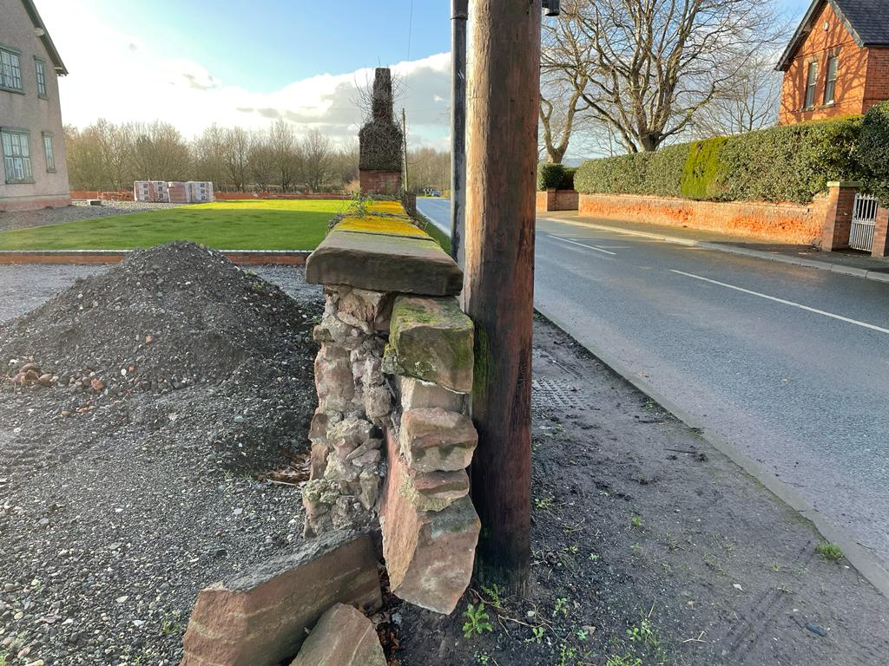

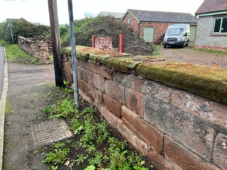

1/(b) Roadside Wall is of feature course design requiring 4m +/- to be straightened on new foundation using a Hydrated NHL 2.5-3 Lime mortar mixed with washed sand - internal wall is of random design.
Intention is to improve structural integrity without any change to walls design
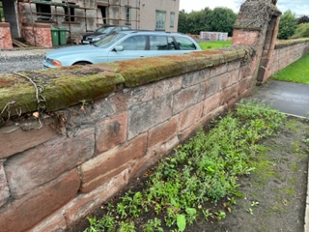
1(c)
Current non original Gate to Pate Gate. Assumption this is a addition within the last 20 years from design and construction technique
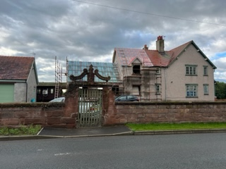
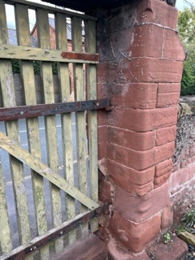
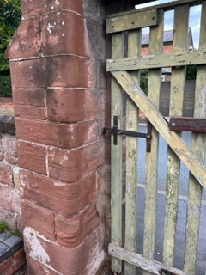

Replacement Gate to be of an Edwardian Style in Keeping with New and Old Entranceway. Wood in Construction with a Panelled Base and Slatted upper Measuring 1900mm x 1350mm.

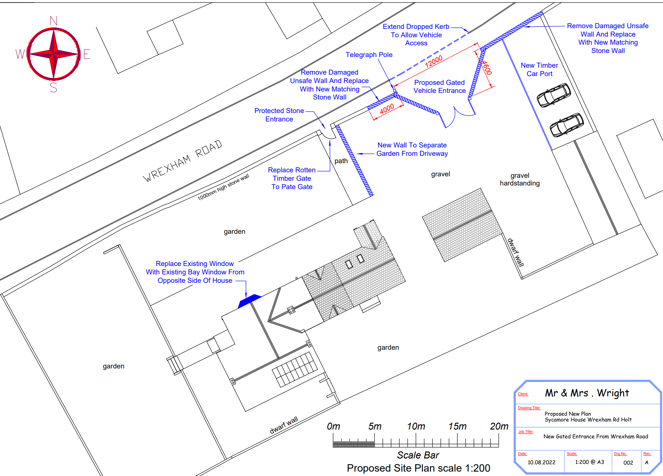
Example of Design below to be scaled up to fit entrance
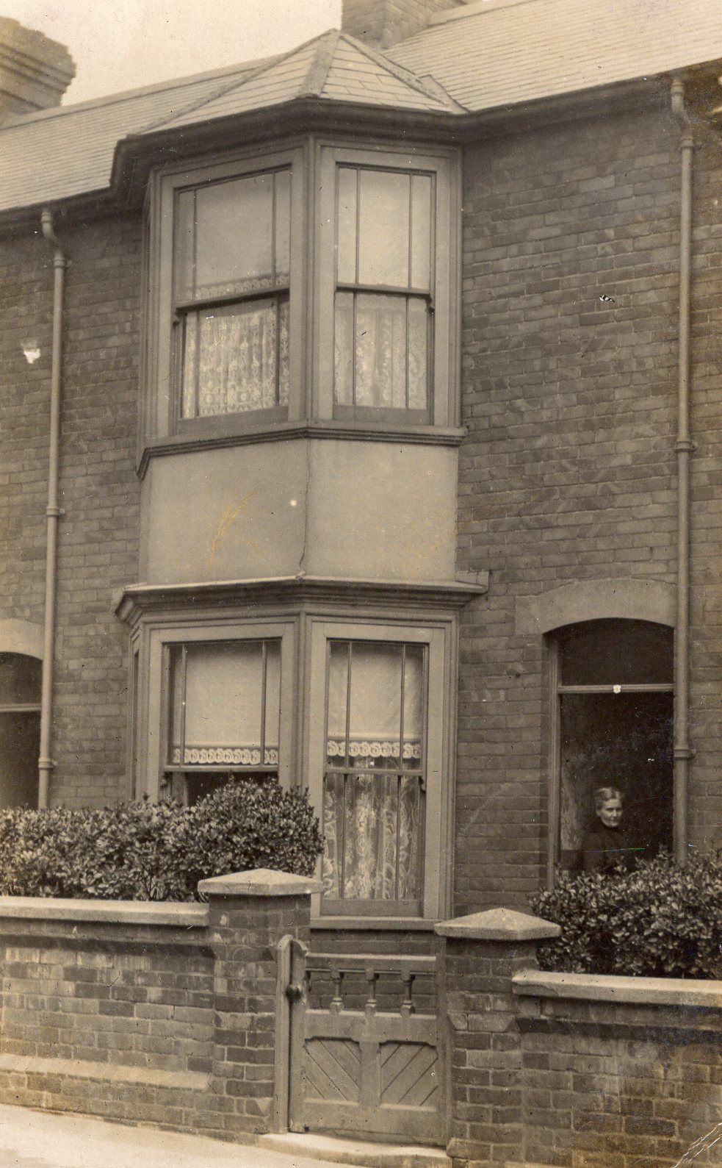

2 (a)Current Status with Tree Removed

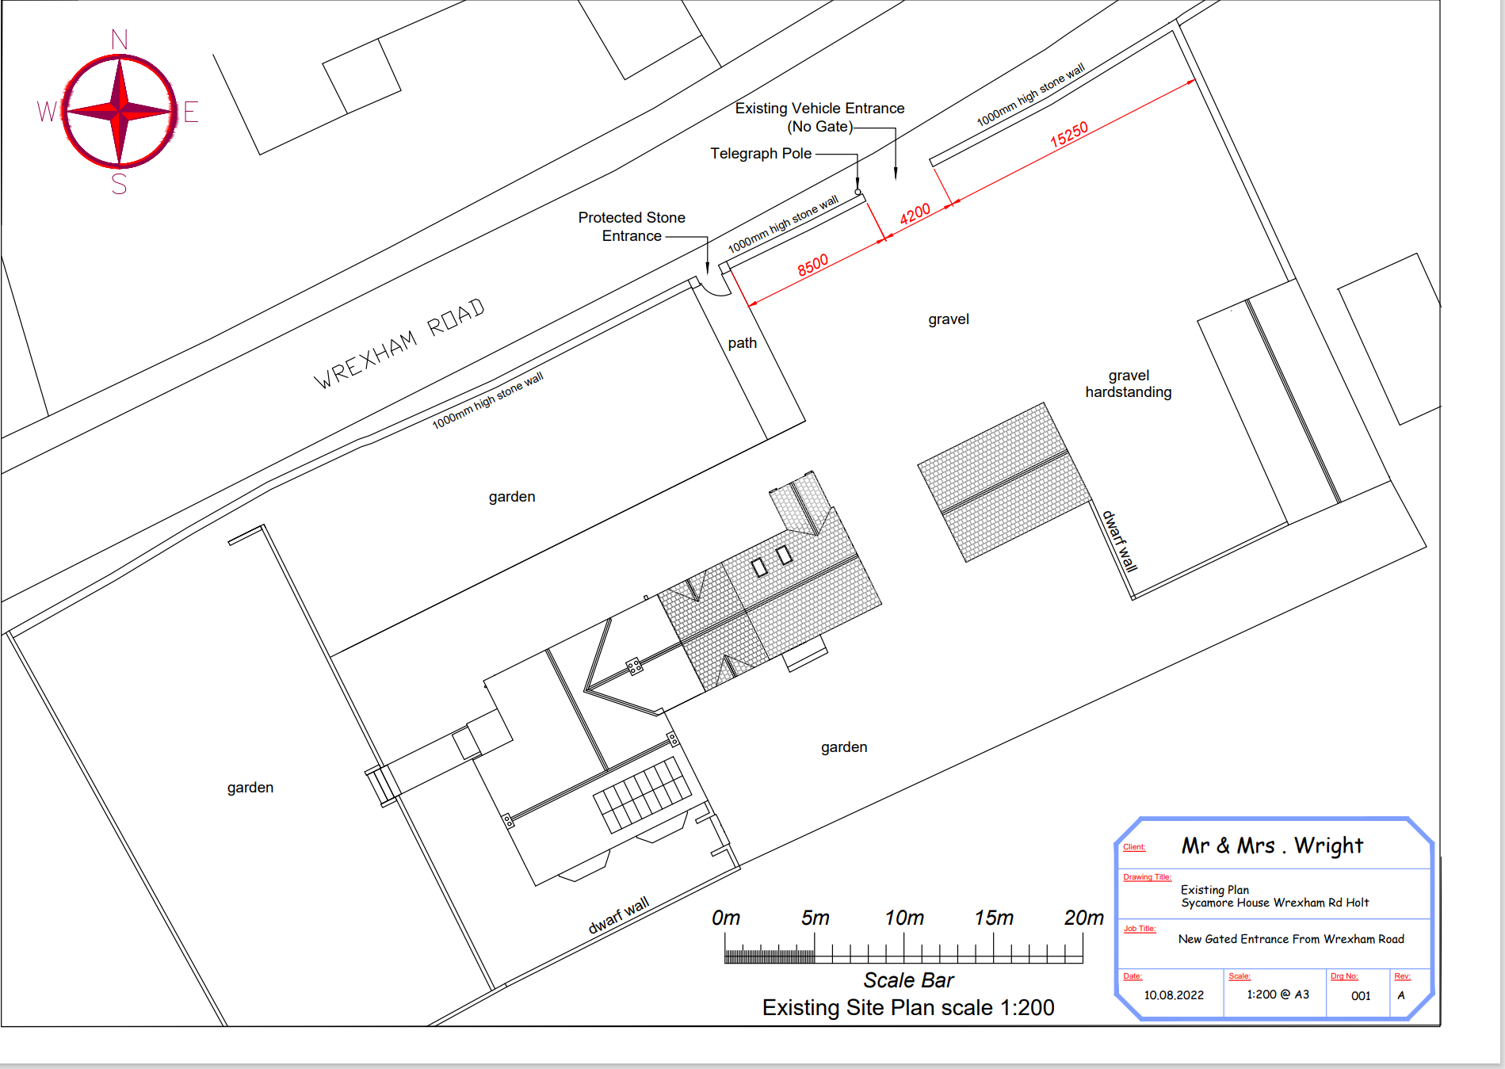

(b) Proposed Site Layout once Works completed

