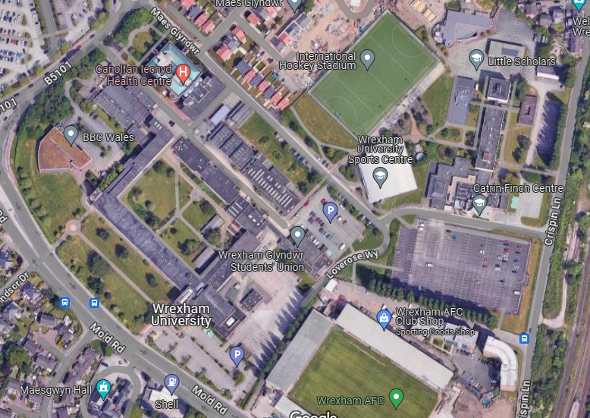
T9
G9
G8
T10
T8
T7
G4
T6
T4
T5
G5
T16
T15
T14
G3
T2
T13
G7 – This is shown as G2 on TPO order no WMBC 109
G6 – This is shown as G2 on TPO order no WMBC 109
T3 – This is shown as T5 on TPO order no WMBC 109
T12
T11
G2 – This includes T23 from TPO order no WMBC 109
G1 – This includes T21 to T27 from the TPO order no WMBC 109
T1

