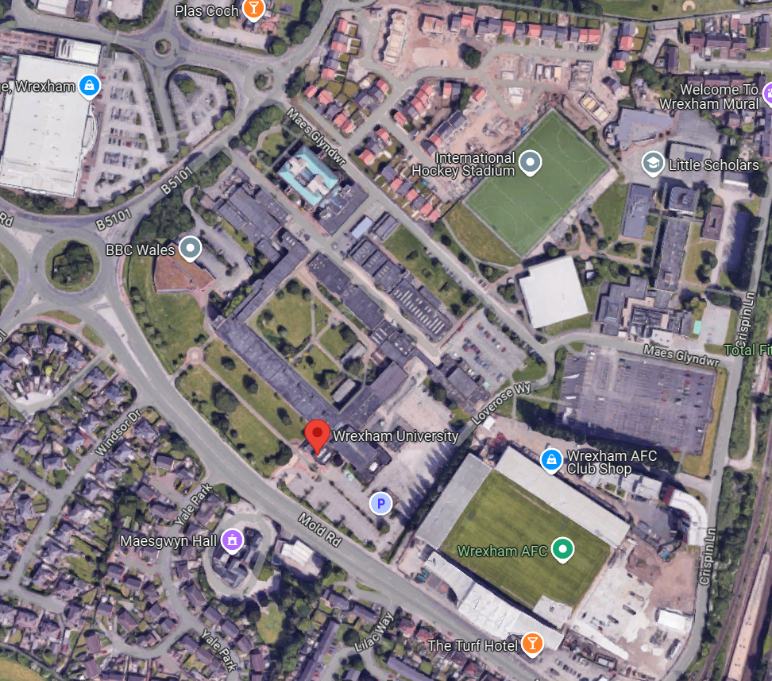
Wrexham University,
Mold Road,
Wrexham,
LL11 2AW

