Discharge of Conditions

Application: - P/2024/1087 – Erection of garage/workshop and stable at Croxton Cottage, Hanmer, Whitchurch, Wrexham, SY13 3DB.
Condition 3: - Prior to their use on the development hereby permitted, samples of the materials to be used in the construction of the external surfaces of the development shall be submitted for the written approval of the Local Planning Authority. Development shall be carried out in accordance with the details that are approved.

- External finish is to be Yorkshire Boarding and Castle Boarding.

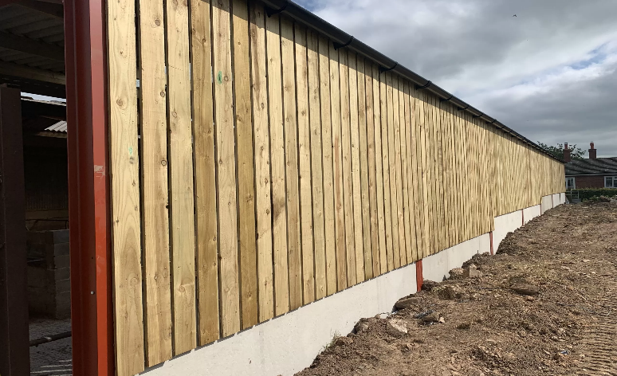  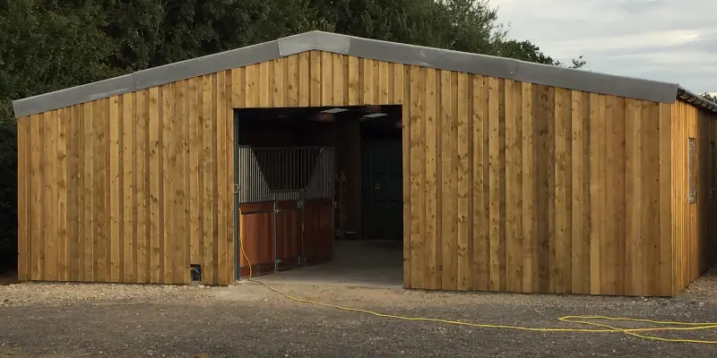 | Yorkshire Boarding  Castle Boarding

- Roof will be laid with fibre cement sheets in grey
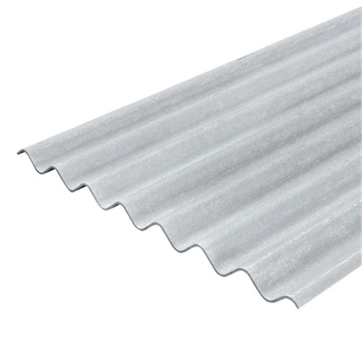 | Fibre cement sheet - grey

