SITE SPECIFIC SUPPLEMENTARY INFORMATION
- Site Details

Site Name: | Whitegate Industrial Estate 2 | Site Address: | Whitegate Industrial Estate  Whitegate Road  Wrexham  LL13 8UG
NGR: | E: 334793, N: 349662 | Site Address:
Site Ref Number: | NTQ 39746 | Site Type: Macro | NTQ Replacement

- Pre-Application Check List

Site Selection

Was an LPA mast register used to check for suitable sites by the operator or the LPA? |  | No
If no explain why:

After a phone call to the LPA, it was felt that the industry database was a more up to date source of information.

Was the industry site database checked for suitable sites by the operator: | Yes
If no explain why:

N/A

Annual roll out consultation with LPA

Date of last annual rollout information/submission: | This information can be emailed to the LPA on request
Name of Contact: | As above
Summary of outcome/Main issues raised: | As above

Pre-application consultation with LPA

Date of written offer of pre-application consultation: | 3rd October 2024
Was there pre-application contact: |  | No
Date of pre-application contact: | N/A
Name of contact: | The Director of Planning

Summary of outcome/Main issues raised:

Positive and negative comments have been received from the consultees (see below). It is imperative to consider that this was the only agreed available location given on the industrial estate. The site is in close proximity to the existing mast that will be decommissioned as part of the NTQ process.

Dear Sir/Madam

Reference: ENQ/2024/1129
Proposal :/INSTALLATION OF TELECOMMUNICATIONS APPARATUS
Location: LAND ADJACENT TO UNIT 4, WHITEGATE INDUSTRIAL ESTATE, WREXHAM, LL13 8UG

Your Ref NTQ 39746

Thank you for your consultation regarding the proposed new mast in Wrexham.

Wrexham Council is generally supportive of new telecommunication masts that will improved connectivity within the County.

The proposed site is on the edge of an Industrial Estate on an area of unused land adjacent to a car park and it is considered that the loss of this land will not have an adverse impact on any of the adjoining uses. As there are industrial buildings in the area there is no general landscape concerns for this location.

With any submitted application the Council will require the full details of the INCIRP compliance and information relating to why the existing mast cannot be utilised and a new (taller) one is required.

Additionally all applications in Wales have to demonstrate how they bring Net Biodiversity Benefits (NBB) to the area. This may include additional planting in the vicinity of the mast to replace and enhance any which is lost as a result of the proposed development.

If you require any additional information please do not hesitate to contact me.

Regards

Louise Phillips

Good afternoon Julia

I have now had better thoughts on this issue.

I have to say of all the places on the Industrial estate it could have been put I find I can’t support this application for the following reason1. To Housing both on the approach to the industrial estate and also the houses at the rear of were the tower is suggested to close on the Queensway in full view from these properties.

2.Safety it paramount and if you investigate there are some steps that say there is no danger of radiation but others say be wary of children in close proximity and with the football pitch very close Gwenfro Community Primary School and Gwenfro Valley Playground very close there are probably many more reason but the close proximity to these make it hard for me to support so I can’t agree.

Regards

Cllr.Brian Cameron

Ten Commitments Consultation

Rating of Site under Traffic Light Model: |  | Amber
Prior to the submission of this application the applicant initiates pre-consultation discussions with the local planning authority. This provides an opportunity for the LPA to discuss development proposals and identify site specific issues.

Summary of outcome/Main issues raised:

No responses had been received at the time of submission.

School/College

Location of site in relation to school/college:

Gwenfro Community Primary School is in close proximity to the site.

Outline of consultation carried out with school/college:

Gwenfro Community Primary School has been notified prior to submission.

Summary of outcome/Main issues raised:

There has been no response from Gwenfro Community Primary School at the time of submission

Civil Aviation Authority/Secretary of State for Defence/Aerodrome Operator consultation

Will the structure be within 3km of an aerodrome or airfield? |  | No
Has the Civil Aviation Authority/Secretary of State for Defence/Aerodrome Operator been notified? |  | No
Details of response:

N/A

Developer’s Notice

Copy of Developer’s Notice enclosed? | Yes
Date served: | 29th October 2024

- Proposed Development

The proposed site:
It is imperative to consider that this proposal is to replace an existing installation and is not a new additional telecommunications installation. The need for this installation stems from an NTQ (Notice to Quit). The existing NTQ site is located at Delta Dance Academy, Queensway, Wrexham, LL13 8UN. The need for this Monopole stems from MBNL been issued with an NTQ (Notice to Quit) on their existing site and this new mast is urgently required to maintain coverage. Planning approval is now in place to extend the Dance Academy which will directly impact the existing telecoms site. WHP have reviewed and confirmed that application which was approved 12/04/2023 – Ref: P/2022/0498 and this will impact on the existing site.

The proposed site is located at Whitegate Industrial Estate, Whitegate Road, Wrexham, LL13 8UG and can be seen below in Figures 1-2.

The proposal is for the installation of a new 20.0m High Monopole and associated antennas that provide continued and improved coverage for EE, H3G LTE and ESN for this area of Wrexham when the existing NTQ base station is removed. The proposed new facility will require the installation of a limited number of equipment cabinet housing radio equipment within the proposed compound in close proximity to the base of the pole.

The proposed site is located to the east of the Whitegate Industrial Park. It is known for housing a variety of businesses including manufacturing, warehousing and benefits from its strategic location near major road networks, including the A483, which provides easy access to Chester, the M56, and the wider North West region. Its proximity to Wrexham town centre also makes it convenient for local businesses and worker

The immediate area is rural and residential in nature. Whilst the installation has some housing to the North. The site has been carefully selected in a position that properties will not directly overlook the site. Trees that are already established in the area will provide some screening of the proposed site.

As previously stated, this is not a new additional installation but a replacement for an existing installation that will need to be removed. The proposed installation is necessary for the continued and improved wireless connectivity and capacity for local businesses, residents and visitors to the busy area of Wrexham.

The sharing of base stations between multiple operators is one of the key strategic policy principles contained within Planning Policy Wales Chapter 12 Infrastructure. The proposal will house EE, 3UK and The Emergency Services.

12.13.3 The Welsh Government attaches considerable importance to keeping the number of masts, and the number of sites for such installations, to the minimum consistent with the efficient operation of the network. The sharing of masts and sites is strongly encouraged where that represents the optimum environmental solution in a particular case. Use should also be made of existing buildings and other structures to site new antennas. Siting should, so far as is practicable, minimise the impact on amenity and the external appearance of the building.

12.11.1 The Welsh Government recognises that widespread access to affordable, secure telecommunications infrastructure is important to citizens and businesses across Wales. It is important that the telecommunications infrastructure in Wales is able to meet this challenge, helping to build a thriving and prosperous Welsh economy. To this end, the Welsh Government is working with the telecommunications industry and the communications regulator Ofcom to share information on communications infrastructure issues, to understand regulatory, planning and economic barriers to investment and to inform future policy making in this area.

Figure 1:

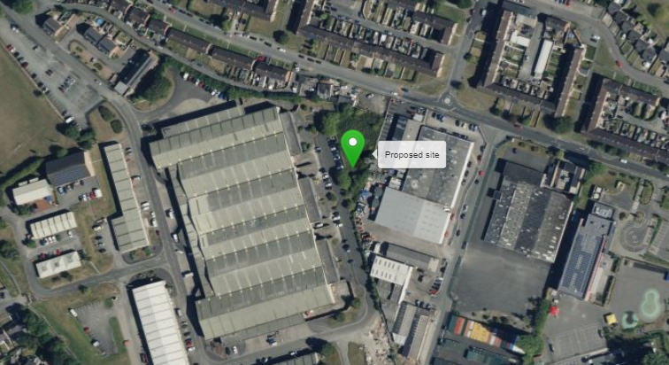

Figure 2:

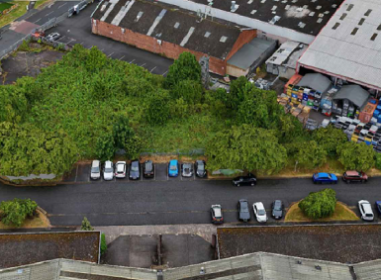

Site Ref | WRX078 | Site Address: | Whitegate Ind. Est., Whitegate Road, Wrexham, LL13 8UG

Local Planning Authority: Wrexham County Borough Council (CBC)

Development Plan: Wrexham UDP 1996-2011 (2005)
Site and its surrounds (LP Map Extract – reference only)
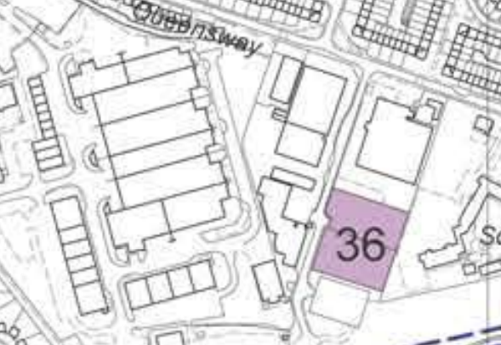

The site is designated as being within the settlement boundary, with industrial / commercial uses to the north, east, south and west. The site is designation is not a material consideration.

The proposed development is to replace an existing mast that is to be removed (following receipt of a ‘Notice to Quit’) that is approximately 14m to the east of this site.

Wrexham CBC Council does have a specific telecoms policy. This, together with Future Wales: The National Plan 2040 and Chapter 5 of Planning Policy Wales is of relevance. The National Planning Policy section of this supporting statement goes into detailed analysis of why this site is in compliance with the document titled ‘Future Wales: The National Plan 2040’ and Chapter 5 of Planning Policy Wales.

Policy Analysis:

Policy CLF8 reads:

“The development of telecommunications facilities and related infrastructure will be permitted, having regard to technical and operational considerations, where an appraisal has been carried out:-
a) firstly, of the potential for sharing other masts and sites; if there is no potential
b) secondly, of the potential to use existing buildings and structures; if there is no
potential
c) thirdly, of the potential to use other sites.

The siting of any development should minimise the impact on the local landscape / townscape, and should comprise measures of mitigation of any adverse impact, as appropriate.”
This proposed development at the site seeks to consolidate all requisite elements (for site sharing) into one location, minimised to ensure the scale and mass of the design is sympathetic to its surrounds, thus limiting visual impact on the wider character of the area (being comparable in scale and mass to the mast it is to replace / partially screened by trees). The proposal would be suitably distant from sensitive receptors, yet providing capacity to ensure that it would deliver the level of service needed in this location. In this regard the proposal would accord with the Development Plan.

In addition to the above, Paragraph 5.2.1 of Planning Policy Wales (February 2024) states:

Fast reliable connections are essential to meet the needs of businesses and other
organisations, and to those at home accessing digital services and working. The LPA should look to support this proposal as the equipment will bring “reliable communications” to the area.

Paragraph 5.2.14 states that

Wherever possible, use should be made of existing buildings and other structures to site new equipment and developers should engage with planning authorities and the community to identify possible locations that could bring additional benefits. Siting should allow for the greatest possible coverage while, so far as is practicable, minimising the impact on the amenity of a place and the external appearance of a building.

The discounted options section of this planning statement fully illustrates that all other potential masts, roof tops and other locations have been investigated. The proposed site is the optimum location from a planning and coverage perspective.

It is accepted the scheme would qualify as a visual change (albeit marginal, and comparable to the mast that is to be removed) but any perceived harm (to amenity or character of the area) would be materially outweighed by the tangible benefits the development would bring in terms of enhanced digital services to residents, businesses and visitors alike.

It fully accords with the requirements of Planning Policy Wales (February 2024).

Enclose map showing the cell centre and adjoining cells:
This can be emailed to the LPA on request

Type of Structure
Description:

Description: It is imperative to consider from a planning perspective that this is purely an upgrade to existing installation – The structure already exists.

TOP OF PROPOSED TOWER +20.00m AGL
C/L OF PROPOSED ANTENNAS +18.90m AGL
C/L OF PROPOSED DISHES +16.00m AGL

Proposed H3G GPS module to be installed on aperture support pole.
Proposed EE GPS module to be installed on aperture support pole.
Proposed 20.0m high Valmont monopole mounted on 5.2 x 5.2 x 1.4m deep reinforced concrete base c/w 6No. proposed antenna apertures and 4No. proposed Ø600 dishes.
Proposed RRUs, AND BOBs to be fixed to support poles below antennas
Proposed compound (8m x 8m) from 2.4m high standard ClearVu 22 fence c/w 3.0m wide double gate. Proposed 2No EE, 1No H3G and 1No shared Mk5B Link/AC cabinets and
overhead cable management within compound (Hidden behind trees and buildings)

Overall Height: +20.0m AGL
Height of existing building |  | N/A
Equipment Housing:
Length: |  | See Drawings
Width: |  | See Drawings
Height: |  | See Drawings
Materials
Tower/mast etc – type of material and external colour: | See Drawings
Equipment housing – type of material and external colour: | See Drawings

Reasons for choice of design:
The Operators always strive for the least visually intrusive solution whilst promoting and maintaining key coverage requirements. This proposal is a site share and the least visually intrusive mast that can be shared has been proposed.
12.13.6 Authorities should not question the need for the telecommunications system that the proposed development is to support, nor seek to prevent competition between different operators. The aim should be for the authorities and operators to work together to find optimum solutions to development requirements. Planning Policy Wales Chapter 12 Infrastructure.

- Technical Information

ICNIRP Declaration attached  ICNIRP public compliance is determined by mathematical calculation and implemented by careful location of antennas, access restrictions and/or barriers and signage as necessary. Members of the public cannot unknowingly enter areas close to the antennas where exposure may exceed the relevant guidelines.  When determining compliance the emissions from all mobile phone network operators on the site are taken into account. | Yes

Frequency: | This information can be emailed to the LPA on request
Modulation characteristics | As above
Power output (expressed in EIRP in dBW per carrier)  In order to minimise interference within its own network and with other radio networks, (EE Ltd) operates its network in such a way the radio frequency power outputs are kept to the lowest levels commensurate with effective service provision  As part of (EE Ltd)’s network, the radio base station that is the subject of this application will be configured to operate in this way. | As above
Height of antenna (m above ground level) | See Drawings

- Technical Justification

Reason(s) why site required
The site is required to provide replacement coverage for EE Ltd, 3UK and ESN.

- Site Selection Process – alternative sites considered and not chosen

Discounted Options
In accordance with the sequential approach outlined in TAN 19 following search criteria have been utilised. Firstly, consideration is always given to sharing any existing telecommunication structures in the area, secondly consideration is then given to utilising any suitable existing structures or buildings and thirdly sites for freestanding ground-based installations are investigated.

This sequential approach is outlined below:

- Mast and Site Sharing
- Existing Buildings Structures
- Ground Bases Installations

In compliance with its licence and the sequential approach outlined in TAN 19 attempts to utilise any existing telecommunication structures where they represent the optimum environmental solution have been employed. The Ofcom Site Finder mast register is always examined prior to the submission of an application.

Discounted Options

Site Type |  | Site Name and Address | NGR | Reason for not choosing
D1 -Greenfield |  | Fibrax Ltd | E: 334804, N: 349633 | Busy yard with no space for a 10m x 10m compound to the rear therefore discounted.
D2 - Greenfield |  | Lockstock | E: 334870, N: 349543 | Site full with containers, therefore no space for telecom compound.
D3 - Greenfield |  | Whitegate Pitches | E: 334516, N: 349664 | Telecom compound would encroach onto the football pitches. Industrial estate preferred.
D4 - Streetworks |  | Queensway SW | E: 334780, N: 349738 | Location would be directly outside residential property
NTQ |  | Delta Dance Academy | E: 334793, N: 349692 | SP planning to extend Dance Academy which will directly impact the telecoms site

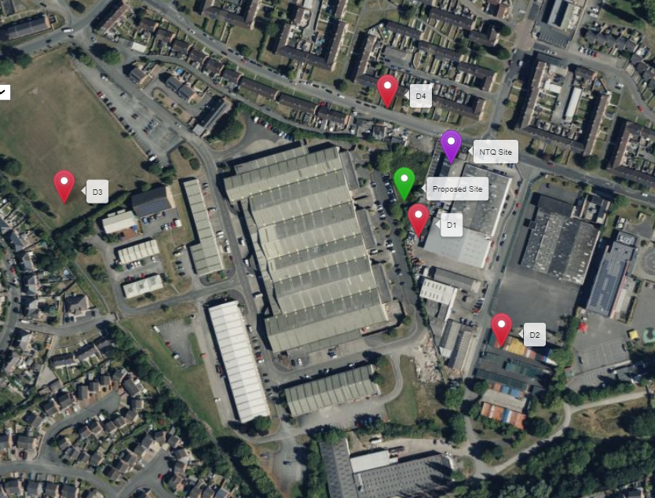

https://gridreferencefinder.com?gr=SJ3479349662|Proposed_s_Site|2,SJ3483249692|NTQ_s_Site|5,SJ3480449633|D1|1,SJ3487049543|D2|1,SJ3451649664|D3|1,SJ3478049738|D4|1&v=r&labels=1

If no alternative site options have been investigated, please explain why:

N/A

- Additional Relevant Information

Background to the Proposal
Mobile phone base stations operate on a low power and accordingly base stations therefore need to be located in the areas they are required to serve. Increasingly, people are also using their mobiles in their homes and this means we need to position base stations in, or close to, residential areas.

A further limiting factor is that the position has to be one that fits in with the existing network. Sites have to form a patchwork of coverage cells with each cell overlapping to a limited degree with the surrounding base stations to provide continuous network cover as users move from one cell to the other. However if this overlap is too great unacceptable interference is created between the two cells.

NATIONAL PLANNING POLICY

National policy with regard to Telecommunications development is found within Technical Advice Note 19: Telecommunications 2002 & Planning Policy Wales Edition 9 – November 2016 – Chapter 12 Infrastructure and Services

12.13.3 The Welsh Government attaches considerable importance to keeping the number of masts, and the number of sites for such installations, to the minimum consistent with the efficient operation of the network. The sharing of masts and sites is strongly encouraged where that represents the optimum environmental solution in a particular case. Use should also be made of existing buildings and other structures to site new antennas. Siting should, so far as is practicable, minimise the impact on amenity and the external appearance of the building. (Telecommunications 2002 & Planning Policy Wales Edition 9 – November 2016 – Chapter 12 Infrastructure and Services)

12.11.1 The Welsh Government recognises that widespread access to affordable, secure telecommunications infrastructure is important to citizens and businesses across Wales. It is important that the telecommunications infrastructure in Wales is able to meet this challenge, helping to build a thriving and prosperous Welsh economy. To this end, the Welsh Government is working with the telecommunications industry and the communications regulator Ofcom to share information on communications infrastructure issues, to understand regulatory, planning and economic barriers to investment and to inform future policy making in this area. (Telecommunications 2002 & Planning Policy Wales Edition 9 – November 2016 – Chapter 12 Infrastructure and Services)

This advises in Para 3 of TAN 19 that ‘This advice takes account of the growth of the telecommunications industry and technology, of the new social and economic demands for communications, and of the Welsh Assembly Government’s (the Assembly Government’s) environmental policies.’

The aim of telecommunications policy (as detailed in Para. 1) is therefore to ensure that people have more choice as to who provides their telecommunications service, a wider range of services from which to choose and equitable access to the latest technologies as they become available.

Para. 65 of TAN 19 states that ‘Siting and design concerns may centre particularly on the type of mast and its impact, particularly if located in a designated area. Its height, ancillary development and the scope for landscaping and screening will also be important considerations. But many antennas have special siting needs because they have a limited range or require line-of-site. Authorities should take full account of these needs’.

Para. 66 states that ‘Local planning authorities should ensure that they understand the constraints the operator faces, whether due to the nature of the technology or the legal requirement to provide a service.’

Para. 67 states that ‘In seeking to arrive at the best solution of an individual site, authorities and operators should consider the use of sympathetic design and camouflage to minimise the impact of development on the environment.’ Particularly in designated areas, the aim should be for apparatus to blend into the landscape encourages authorities and operators to “work together” and use sympathetic design and camouflage to minimise the impact of development on the environment. Particularly in designated areas the aim should be for apparatus to blend into the landscape. The telecommunications industry is encouraged to continue to develop innovative design solutions the materials and colouring (Para. 68 – TAN19). The design of the DSLAM cabinet has been shaped by the need to make it as small as possible to reduce its visual appearance. The cabinet is proposed to be painted green; however, the colour can be altered to fit the requirements of the LPA.

We consider that the development is complaint with the council’s policy and that in accordance of Part 24 of Schedule 2 of the Town And Country Planning (General Permitted Development) Order 1995, as amended by the Town And Country Planning (General Permitted Development) (Amendment) (Wales) Order 2014 and in accordance with the electronic communications code under the Telecommunications Act 1984 Schedule 2 as amended by the Communications Act 2003 permission should be granted for the installation.
We consider this development is fully compliant with the above policy guidance.

Conclusion

We consider the development complies with both central government and local planning policy guidance where the underlying aim is to provide an efficient and competitive telecommunication system for the benefit of the community while minimising visual impact.

Taking into account the factors of technical constraints, available sites and planning constraints we consider that this site and design clearly represents the optimum environmental solution.

On the basis of a recognised need to expand and promote telecommunications networks across the region, it is considered that the proposal fully accords with the requirements of Telecommunications 2002 & Planning Policy Wales Edition 9 – November 2016 – Chapter 12 Infrastructure and Services TAN19 and Local Plan Policies.

Julia Marshall
Planning Manager
j.marshall@whptelecoms.com

Contact Details

Name: (Agent) | Julia Marshall | Telephone:
Operator: | EE Ltd & H3G LTE | Fax no: | N/A
Address: | WHP  1a Station Court  Station Road  Guiseley  Leeds  LS20 8EY | Email Address: | j.marshall@whptelecoms.com
Signed: |  | Date: | 31st October 2024
Position: | Planning Manager | Company:  (on behalf of above operator) | WHP

The modulation method employed in GSM is GMSK (Gaussian Minimum Shift Keying) which is a form of Phase modulation The modulation method employed in UMTS is QPSK (Quad Phase Shift Keying) which is another form of Phase Modulation

