DESIGN AND ACCESS STATEMENT
for the development of the site
occupied by ex. church of St. dAvids,
Broad Street,
Rhosllanerchrugog.

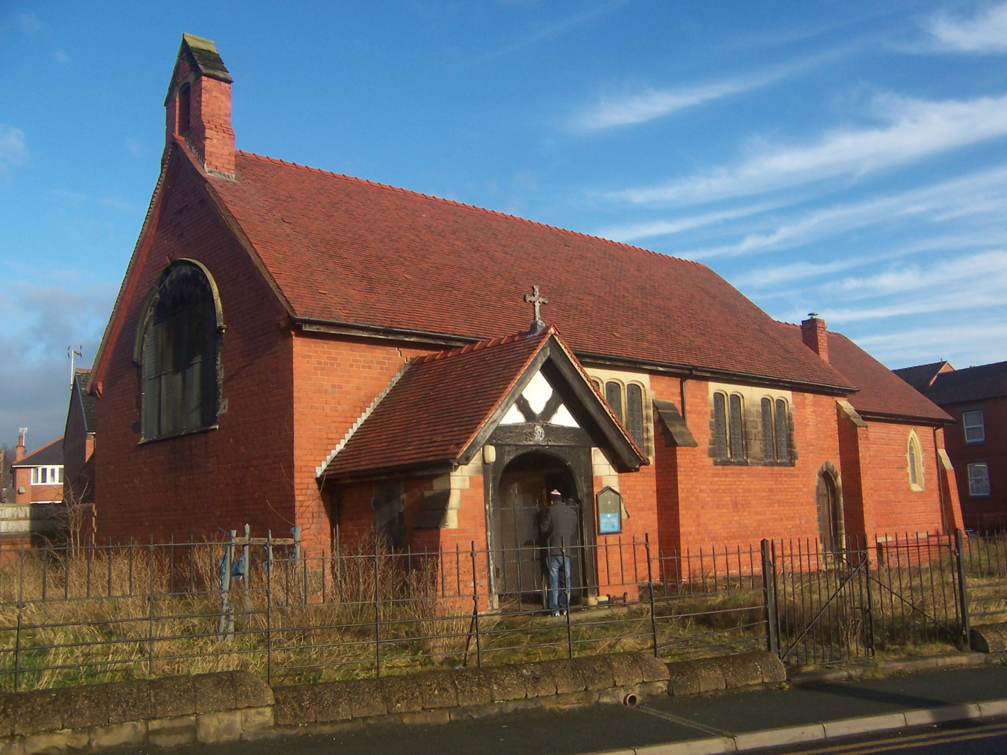

GENERAL - Planning permission is sought for the change of use of the grounds from ecclesiastical use to a car sales area.
This is a revised re-submission of the previous application which has been refused, application no. P/2024/1134.

General - The site has an existing brick under tile church building (St. Davids) which has been empty for several years – since at least 2016 and I believe de-consecrated. Unfortunately, the building has suffered from damage following subsidence and has since been condemned by a Structural Engineer.
The proposal is to demolish this building, level the site and provide spacing for 22 car sales spots.
Along with this, spacing for 7 customer car parking spaces is provided along with a scheme of planting suggested by “Enfys” Ecology. Surveys have been done for the presence of bats within the building and asbestos on site, both reports included with the application.

Alterations - Following the proposed demolition of the building, works are to be kept to a minimum.
- An underground cellar is to be filled in as part of the general levelling of the site.
- Existing fencing and gates to be retained and refurbished to provide both pedestrian and vehicular access to the site. There are no new access points proposed.
- A designated pedestrian pathway is to be marked out on site as shown on the drawing from the access gateway to the proposed pre-fabricated steel office cabin. There is to be a separate pre-fabricated steel wc connected to the existing foul water drainage on-site for the use of staff.
- There are to be a maximum of 4 employees not all being on site at the same time.
To improve the environment a scheme of planting along the northern and western boundaries is proposed as per the “Enfys” report.

Following the refusal notice it would be an idea to try and answer the refusal points individually.
1. It is the opinion of the Local Planning Authority that the demolition of the existing church would adversely impact upon the historic character of the site and surrounding area contrary to criterion i) of Policy DM1 of the Wrexham Local Development Plan.
As far as I’m aware, this is not latest in a long line of churches, built on the site of an early worshipping area. The church itself was built in 1892 and even if you wanted to worship on this site again is structurally unsafe. It has been condemned by a Structural Engineers both since purchase and at time of sale. The church itself has been closed down since at least 2016 – no-one wants to go to church here! How Wrexham Council can think that retaining the derelict building is useful for the community is surprising.
2. In the view of the Local Planning Authority, the use of the site for car sales would introduce a use incongruous to the residential setting, adversely impacting upon the character of the site and surrounding area. As such the proposal does not accord with criterion i) of Policy DM1 of the Wrexham Local Development Plan.
I think this is the crux of the matter and the reason for the refusal notice. The council doesn’t want a car sales area on this site and within this locale. Unfortunately, the council can’t tell you what they do want which would save a lot of time! Major changes have been made to the application to reduce the impact of the car lot on the locality of which the largest is the reduction of the application to 22 sales slots. I can only request that you look at the application again with new eyes and take into account the employment benefit both to the site and within the local area.
3. The application fails to demonstrate how Green Infrastructure has been considered and would be delivered in accordance with para 6.2.14 of Planning Policy Wales Ed 12.
It was part of the application but seemingly overlooked, but I’ve shown the proposed scheme of planting as proposed by “Enfys Ecology” on the main drawing. This is a significant proposal as the existing site shows rough grasses and little else.
4. The application fails to demonstrate how a net biodiversity benefit will be achieved through the development and as such fails to comply with the requirements of para 6.4.15 of Planning Policy Wales Ed. 12.
There has been little or no effort in the past in the 100 + year or so since the church was built or since its closure for the ecology of the area to be considered. The proposed scheme brings a well thought out framework of planting by “Enfys Ecology” to the fore with the ongoing benefits to wildlife in what is a very urban area. Short term development of the area will provide long term gain for plants and animals.
5. It is the opinion of the Local Planning Authority that the proposal does not provide adequate vehicle and pedestrian access which would result in highway safety impacts, contrary to criterion iv) of Policy DM1 and criterion iii) of Policy T1 of the Local Development Plan
The pedestrian access has been reinstated and proposed pathway to the sales office shown. Vehicular access is via the existing corner gates, which were presumably used by church goers in the past. I don’t see the pedestrian access being used much and I would think that it is extremely unlikely that the flow of traffic onto the site would fill the 7 car spaces located on site.

6. In the view of the Local Planning Authority, the development fails to provide adequate customer parking provision and is therefore contrary to criterion iv) of Policy DM1 and criterion iv) of Policy T1 of the Wrexham Local Development Plan.
The original parking provision of 6 car spaces has been increased to 7 spaces, although I would think it highly unlikely that 7 car spaces are being used at any one time.

In conclusion – all works would be retained on site. There is no reason to suggest that existing traffic flow would be altered as there would be ample on-site parking for visitors. The traffic of customers is likely to be in the ones and twos at various times of the working day with I think little to disturb the neighbours. The site is not a garage – there are to be no works carried out on the vehicles. Any necessary maintenance would be carried out off-site, perhaps locally and 4 jobs would be created.

