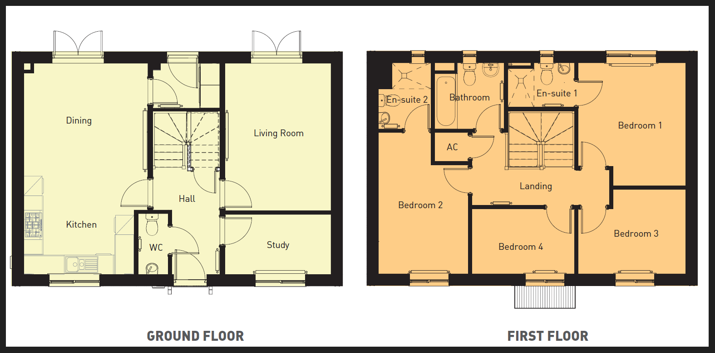
Sleep room for staff
Sleep room for staff

