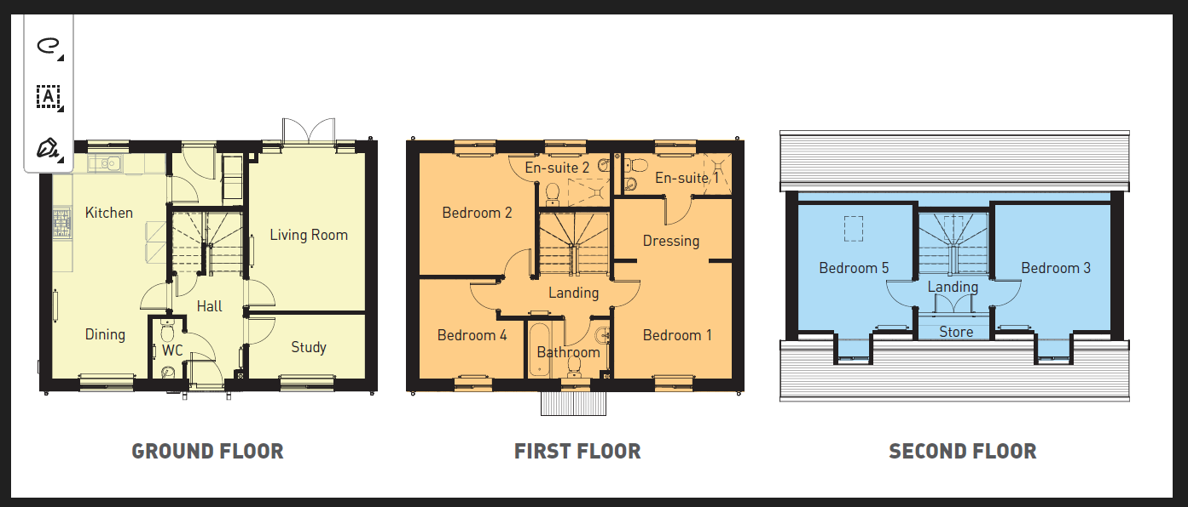
Sensory room
Office/sleep room

