Swyddog Cynllunio,
Gwasnaethau Cynllunio,
Cyngor Bwrdeisdref Sirol Wrecsam,
Neuadd y Dref,
Wrecsam,
LL11 1AY

 | Eich Cyf/Your Ref:  Ein Cyf/Our Ref:  Dyddiad/Date:  Gofynner am/Ask for:  Rhif Union/Direct Dial: | P/2023/0186  HLJ/80-000848-SLGEN8A  25/09/2023  Heather Jones  01286 662999

Annwyl 1Syr,  DEDDF CYNLLUNIO GWLAD A THREF 1990 - YMGYNGHORIAD  Mewn cysylltiad â’ch ymgynghoriad dyddiedig 21^{ain} medi 2023, mae adroddiad ein harchwiliad wedi ei atodi ynglŷn â’r cais PR/2023/0186.  Mae’r adroddiad ynglŷn â mynediad i gerbydau a cyflenwad dwr.  Os ydych angen gwybodaeth bellach, cysylltwch â’r Swyddog Cydymffurfiaeth.  Yn gywir | Dear Sir,  THE TOWN AND COUNTRY PLANNING ACT 1990 – CONSULTATION  With reference to your consultation dated 21st September 2023, attached is our inspection report in respect of application PR/2023/0186  The report refers to access for fire appliances and water supplies.  If you should require any further information, please do not hesitate to contact the Compliance Officer.  Yours faithfully
  EIDDO | TIR GER ST MARYS AVENUE OVERTON, WRECSAM
  PREMISES: | LAND OFF ST MARYS  AVENUE, OVERTON  WREXHAM
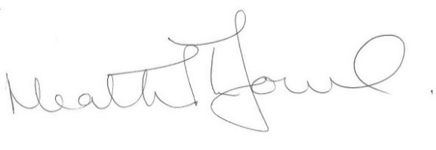

Ar ran Awdurdod Gwasanaeth Tân ac Achub Gogledd Cymru
On behalf of North Wales Fire and Rescue Authority

Cyfeirnod y Cais: PR/2023/0186 | Application reference: PR/2023/0186.
Cyfeiriad: TIR GER ST MARYS AVENUE OVERTON, WRECSAM | Address: LAND OFF ST MARYS  AVENUE, OVERTON  WREXHAM
MYNEDFA AR GYFER CERBYDAU TÂN  Mae’n ofynnol bod gan y Gwasanaeth Tân fynediad priodol ar gyfer unrhyw ddigwyddiad tân. Dylai unrhyw fynedfa fod yn unol a chyfarwyddiadau sydd o fewn y ddogfen Canllawiau ar reoliadau adeiladau:rhan B (diogelwch tân) Adran 17.  CYFLENWAD DŴR  Dylai cyflenwad dŵr ar gyfer y datblygiad fod yn unol a’r cyfarwyddiadau sydd o fewn y ddogfen Canllawiau ar reoliadau adeiladau:rhan B (diogelwch tân) Adran 16. |  | ACCESS FOR FIRE APPLIANCE  It is necessary to provide the Fire Service with appropriate access for any fire incident. Access should be in accordance with the directions within the Building Regulations Approved Document B (fire safety) Section 17.  WATER SUPPLIES  Water supplies for the development should be in accordance with accordance with the directions within the Building Regulations Approved Document B (fire safety) Section 16.

