Appendix 1: Green Infrastructure Statement and Net Biodiversity Benefit

Form completed by: | Andrew Ruscoe
Date: | 07.10.2024
Address of site: | Plas Kynaston Ln, Cefn-Mawr, Wrexham LL14 3PU
Grid reference: | SJ 28199 42119
Description of Proposal: | Replanting and planting additional plants & trees

- Details of all existing green infrastructure on site and approximate size:
Boundary 1: | Boundary 1: 128 metres  Green Infrastructure: Managed grassland bank, primarily composed of maintained grass with no significant trees or hedgerows.
Boundary 2: | Boundary 2: 121 metres  Green Infrastructure: Managed grassland with a Common Beech (Fagus sylvatica) hedgerow, interspersed with Bramble (Rubus fruticosus), and Sycamore (Acer pseudoplatanus) trees.
Boundary 3: | Boundary 3: 131 metres  Green Infrastructure: A mix of trees and shrubs, including Betula pendula (Silver Birch), Fraxinus excelsior (Ash), Corylus avellana (Hazel), and Prunus avium (Wild Cherry)
Boundary 4: | Boundary 4: 111 metres  Green Infrastructure: Similar to Boundary 3, this boundary consists of a mix of trees and shrubs, including Betula pendula (Silver Birch), Fraxinus excelsior (Ash), Corylus avellana (Hazel), and Prunus avium (Wild Cherry)
Front Garden: | N/A
Rear Garden: | N/A
Other: | NA/

- What green infrastructure features (trees, hedges, hedgebanks) have already been removed from site and/or require removal to facilitate the development (add lengths or areas)?
Boundary 1: | 0
Boundary 2: | 0
Boundary 3: | 20 tree removed & 15 trees were trimmed. 4 more to be removed.
Boundary 4: | 0
Front Garden: | N/A
Rear Garden: | N/A
Other: | N/A

- How are the retained features being protected during development (BS5837:2012)?
Boundary 1: | N/A
Boundary 2: | N/A
Boundary 3: | N/A
Boundary 4: | By a site plan to not touch trees that are not relevant.
Front Garden: | N/A
Rear Garden: | N/A
Other: | N/A

- What Green Infrastructure is being planted as mitigation for losses?
Boundary 1: | Wildflower flowers
Boundary 2: | Fruit Tress
Boundary 3: | Edible Wildflowers
Boundary 4: | Beech tress
Front Garden: | N/A
Rear Garden: | N/A
Other: | N/A

- Biodiversity enhancements
The enhancements do not need to be directly attached to the proposed new construction; they can be attached to the host dwelling or placed within the garden, but they do need to be on land within the red or blue line. The principle is that the enhancements should lead to a ‘net benefit’ for
biodiversity. The following biodiversity enhancements have also been added:

√ | Measure | Plan | Details
 | Boxes. (state type and number) Please make sure they are currently available to buy. | Submit a plan of location and photos of elevation if available. | Height or aspect
 | N/A | N/A | N/A
 | Hedgerow. Total new or restored length. | Submit plan of location. | Calculate number of each species using information in the guidance above. Ensure that you can easily purchase the species proposed.
 | New Hedgerows:  Length: Approximately 100 meters  Species: Includes 150 Common Beech trees and 100 whips of various native British species along the roadside. | The new hedgerow will primarily run along:  Roadside: Extending the existing hedge to enhance privacy and habitat.  Railway Side: Restoring and enhancing the existing hedgerow with additional native species. | Common Beech (Fagus sylvatica)  Quantity: 150  Purchase Availability: Common Beech is widely available at garden centers and online nurseries.  Ilex (Holly)  Quantity: 50  Purchase Availability: Ilex is commonly sold in nurseries and can be purchased as young plants or whips.  Euonymus europaeus (Spindle)  Quantity: 50  Purchase Availability: Euonymus europaeus is available at most garden centers and can also be found in online plant suppliers.
 | Tree/orchard planting. Number of trees. | Submit planting plan. | Size of tree (at time of planting), species (full latin name) and any proposed protection measures.
 | - Common Beech Trees (Fagus sylvatica)  - Quantity: 150  - Location: Along the roadside to extend the hedge.  - Juglans (Walnut)  - Quantity: 20  - Location: Along the railway side of the land.  - Corylus avellana (Hazel)  - Quantity: 50  - Location: Along the railway line side of the ground.  - Gooseberry (Ribes uva-crispa)  - Quantity: 4  - Location: Roadside area of the ground.  - Dwarf Apple Trees (Malus domestica)  - Quantity: 3  - Location: Roadside area of the ground.  - Damson Trees (Prunus domestica subsp. insititia)  - Quantity: 1  - Location: Roadside area of the ground.  - Plum Trees (Prunus domestica)  - Quantity: 3  - Location: Roadside area of the ground.  - Gage Trees (Prunus domestica subsp. italica)  - Quantity: 2  - Location: Roadside area of the ground. | Common Beech  Along the roadside  3 meters apart  150  Juglans (Walnut)  Along the railway side  5 meters apart  20  Hazel  Along the railway side  2 meters apart  50  Dwarf Apple  Roadside area 2 meters apart  3  Damson  Roadside area  2 meters apart  1  Plum  Roadside area  2 meters apart  3  Gage  Roadside area  2 meters apart  2  Gooseberry  Roadside area  1 meter apart  4 | Common Beech  Fagus sylvatica  1.5 - 2.0 meters  Tree guards or tubes; mulch around base  Walnut  Juglans regia  1.5 - 2.0 meters  Tree guards or tubes; mulch around base  Hazel Corylus  avellana  - - 1.5 meters  Tree guards or tubes; mulch around base  Dwarf Apple  Malus domestica  - - 1.5 meters  Tree guards or tubes; mulch around base  Damson  Prunus domestica 1.0 - 1.5 meters  Tree guards or tubes; mulch around base  Plum  Prunus domestica 1.0 - 1.5 meters  Tree guards or tubes; mulch around base  Gage  Prunus domestica  - - 1.5 meters  Tree guards or tubes; mulch around base  Gooseberry Ribes uva-crispa  0.5 - 1.0 meter  Mulch around base
 | Wild flower grassland (area in m2). | Submit plan of location. | Species mix and site preparation details. Confirm that appropriate management is achievable.
 | Wildflower Grassland Area  Area: 170 m² (calculated as 85 m × 2 m)  This area will be planted with wildflowers at a density of 3 plants per meter², totalling 510 wildflowers | Along the Plaskynaston Bank | Wildflower Species Mix  Veronica (Speedwell) - Veronica spp.  Dianthus (Dwarf Carnation) - Dianthus deltoides  Malva - Malva sylvestris  Primula veris (Cowslip) - Primula veris  Vialo - Vialo  Stellaria (Chickweed) - Stellaria media  Campanula (Bellflower) - Campanula spp.  Geranium (Cranesbill) - Geranium spp.  Stachys (Woundwort) - Stachys spp.  Wild Garlic - Allium ursinum  Bluebell - Hyacinthoides non-scripta  Site Preparation and Management  The site preparation will involve clearing the area of any debris and invasive species to create a suitable environment for the wildflowers. The following steps will be taken to ensure successful establishment:  Site Clearance: Remove any existing weeds and debris from the planting area.  Soil Preparation: The soil will be turned over to aerate it and improve drainage.  Seed Bed Preparation: A fine seedbed will be created to ensure good seed-to-soil contact.  Wildflower Planting: The wildflower seeds will be sown at the appropriate density, aiming for three seeds per meter for an area of 85m x 2m squared.  Management and Maintenance  Our groundsman, Huw Parry, will be responsible for the ongoing maintenance of the wildflower area.  This will include regular watering during dry periods, monitoring for weeds, and controlling any invasive species to ensure the success and longevity of the wildflower planting.  If you need any further adjustments or additional details, feel free to ask!
 | Pollinator shrub planting. Area in m2. | Submit plan of location. | Species proposed (latin names)
 | N/A | N/A | N/A
 | Wildlife ponds. Number of. | Submit plan to scale including cross-section. | Details on lining or any proposed planting.
 | N/A | N/A | N/A
 | Hibernacula. Number of. | Submit plan of location. | Brief description of materials proposed.
 | N/A | N/A | N/A
 | Any other measures.
 | N/A | N/A | N/A

- Management and maintenance.
Any information on the long term management and maintenance of the enhancements.

Long-Term Management and Maintenance
1. Routine Monitoring and Assessment
Regular monitoring will be conducted to evaluate the health and growth of the newly planted species. This will involve assessing plant vitality, identifying any signs of disease or pest infestations, and ensuring that all species are thriving in their respective habitats.
2. Maintenance Responsibilities
Huw Parry, the Grounds Maintenance Officer for Cefn Community Council, will oversee the ongoing maintenance of the site. His responsibilities will include:
- Watering: Ensuring that all newly planted trees, shrubs, and wildflowers receive adequate water, especially during dry periods, to promote successful establishment.
- Weed Control: Implementing regular weeding practices to reduce competition for nutrients and water among young plants.
- Mulching: Applying mulch around the base of plants to retain moisture, suppress weeds, and improve soil quality.
3. Community Engagement
In collaboration with local schools, a Forest School initiative will be established to involve students in the maintenance and care of the area. This will include:
- Hands-On Learning: Students will participate in activities such as planting, weeding, and monitoring plant growth, fostering a sense of ownership and responsibility for their environment.
- Workshops: Educational sessions will be organized to teach students about the importance of biodiversity and sustainable practices.
4. Sustainability Practices
The management plan will focus on sustainable practices to minimize environmental impact. This will include:
- Native Plant Selection: Utilising native species that are well-adapted to the local environment, requiring less water and maintenance.
- Pest Management: Employing integrated pest management strategies to minimize chemical use and promote natural pest control methods.
5. Long-Term Commitment
The Cefn Community Council is committed to the long-term success of the biodiversity enhancements. Regular reviews and adjustments to the management plan will be made based on feedback from the community and the results of ongoing monitoring efforts.

- Conclusion
Based on the information provided above, this development will result in a Green Infrastructure and Net Biodiversity Benefits upon completion.

Based on the information provided, the development at Plaskynaston MUGA will significantly enhance the site's Green Infrastructure and contribute to Net Biodiversity Benefits upon completion. The introduction of 510 wildflowers, 150 Common Beech trees, and various other native species is designed to create a vibrant and sustainable ecosystem that supports local wildlife and enhances the community's connection to nature.

The planned mitigation measures, including the replacement of trees and hedgerows at a ratio of 5:1, demonstrate a commitment to responsible environmental stewardship and the preservation of biodiversity. By integrating these enhancements with the ongoing community engagement initiatives, such as collaboration with local schools through the Forest School program, we aim to foster environmental awareness and stewardship among residents, particularly youth.

Furthermore, the long-term management and maintenance strategies, led by our dedicated Grounds Maintenance Officer, ensure that the improvements will be sustained, and that the ecosystem will continue to thrive in the years to come. This holistic approach not only addresses the ecological impacts of the development but also promotes community well-being and resilience.

In conclusion, this project represents a significant step toward creating a greener, more biodiverse, and ecologically balanced environment at Plaskynaston MUGA, ultimately benefiting both the local ecosystem and the community.
4o mini

- Sketch plan (Insert plan showing the features of the development site):
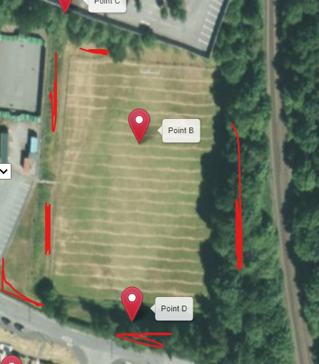

- Site photos (as required)

The bank where the wildflowers will be going
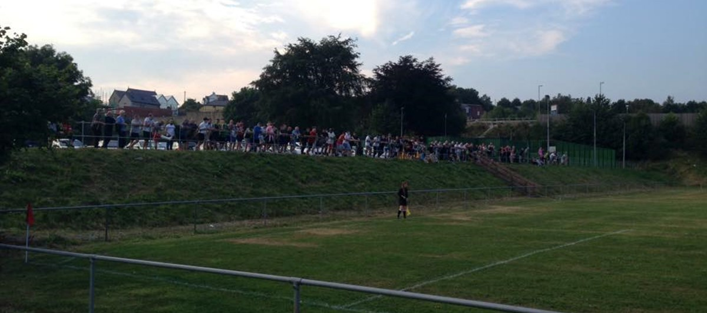
The areas where the Wild garlic and fruit trees will be going
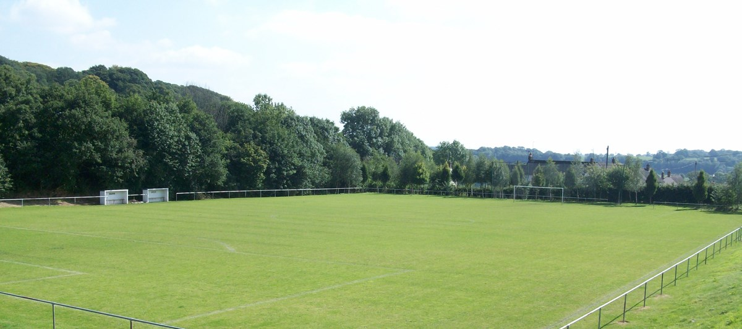

The area where the new beech is going.
