

GREEN INFRASTRUCTURE STATEMENT & NET BIODIVERSITY BENEFIT FORM
Complete the boxes in the form in Appendix 1 and include with your planning application

Q. What is a Green Infrastructure (GI) Statement?
A Green Infrastructure Statement describes how the green infrastructure of a site (trees, hedges, and SuDS etc.) has been incorporated into the development proposal.

Q. Why do I need a Green Infrastructure Statement?
A Green Infrastructure Statement is required on all developments, following Planning Policy Wales - PPW12 and the Environment (Wales) Act 2016 Section 6 duty, to show that development has a net benefit to biodiversity and green infrastructure. This information is not appropriate to seek ‘retrospectively’ by way of a condition and must be provided as part of the planning application process.

Q. What detail is required in the Green Infrastructure Statement?
A Green Infrastructure Statement is to be proportionate to the scale and nature of the development. In the case of minor development such as householder applications, PPW12 states that this should not be an onerous requirement for applicants.

Q. What is Net Biodiversity Benefit?
PPW12 requires development to provide a net benefit for biodiversity (NBB) i.e. a better outcome than if the site was left undeveloped. Failing to provide such a benefit is a valid reason for refusal.

Every application regardless of size must not only mitigate any negative impacts of the development, but also have a positive benefit for biodiversity which will be in place for the lifetime of the development. Enhancements should be onsite, proportional to the size of development, tailored towards features valuable in the area or providing linking habitats GI plan

Q. How do I provide the information?
To assist in providing the information that this authority requires, the form in Appendix 1 can be completed to provide the specific Green Infrastructure details and net Biodiversity Benefit that relate to each step of your proposed development.

Q. What measures could provide Net Biodiversity Benefit?
The following information provides examples on what could be provided

Examples of Net Biodiversity Benefit Measures
- Bird Boxes
Wherever possible bird boxes should be built into new builds or new extensions, rather than attached externally. Woodcrete boxes (such as those built by Vivara or Schwegler) provide the most longevity and best conditions, wooden boxes should only be used in specific circumstances when woodcrete is not suitable.

- Bird boxes should be a minimum four metres up a tree or a wall.
- Unless there are trees or buildings which shade the box during the day, face the box between north and east, thus avoiding strong sunlight and the wettest winds.
- Make sure that the birds have a clear flight path to the nest without any clutter directly in front of the entrance. Tilt the box forward slightly so that any driving rain will hit the roof and bounce clear.
- House sparrows and starlings will readily use nest boxes placed high up under the eaves. Since these birds nest in loose colonies, two or three can be sited spaced out on the same side of the house. Keep these away from areas where house martins normally nest.
- Within a housing development a minimum of 75% of properties should have a bird nesting feature built in. For a single house, either an integral bird or bat feature can be chosen.

Boxes suitable for buildings -
House Sparrow terrace
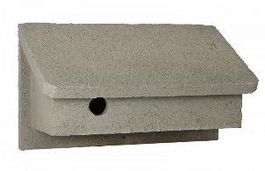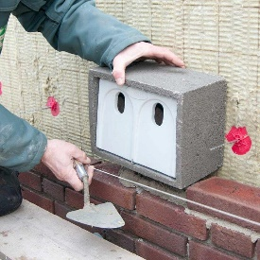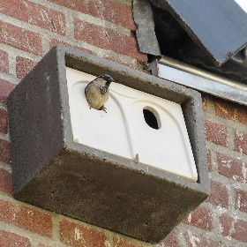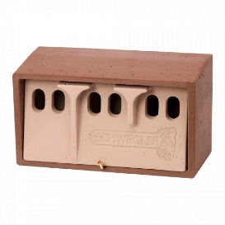

Swift
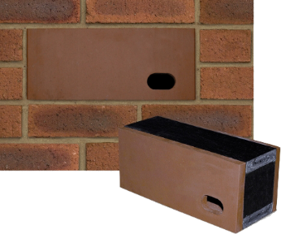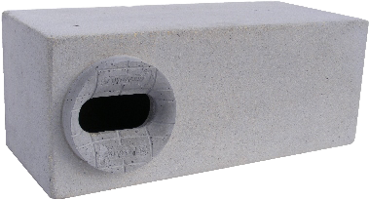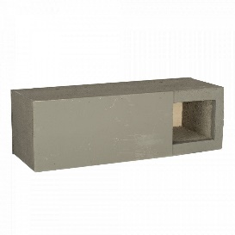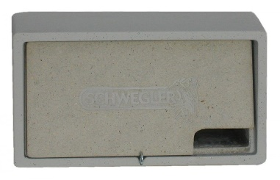

House Martin
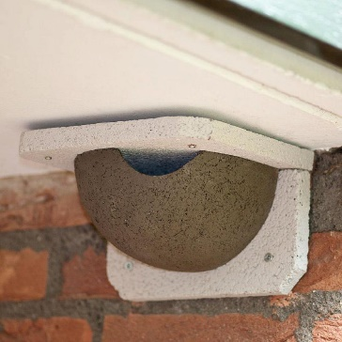

Swallow (in garages/log stores/lean-to)
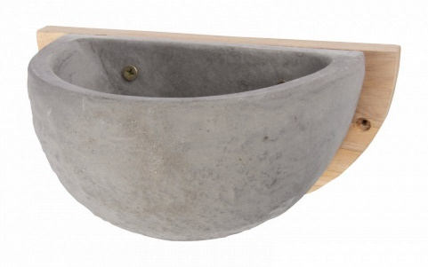

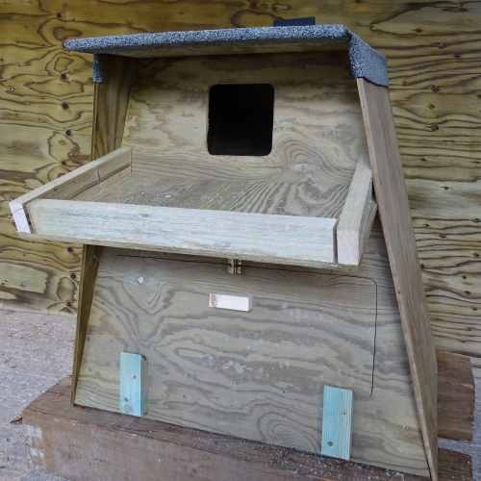
In agricultural sites, provision of a barn own nest box on a hedgerow tree or pole is appropriate. Good quality wooden boxes are available from the Barn Owl Trust. Commercially sold boxes very massively in quality, only pressure treated or marine ply are suitable materials.

- Bat boxes
There is a preference for integrated bat boxes and tubes which can be matched and built into the walls and facade of a building, for instance Green & Blues Bat Block, Vivara pro build-in and Schwegler woodstone bat tube. They have the advantage of offering a secure, permanent space for bats with little maintenance and potentially better thermal properties. If integral boxes cannot be used boxes should be long-lasting woodcrete such as Schwegler 2F or Beaumaris.

Bat boxes are more likely to be used if they are located where bats are known to feed. Ideally, several boxes should be put up facing in different directions on sunny aspects to provide a range of warm conditions. Boxes should be put as high as possible to try and avoid predation from cats on the ground or nearby structures. On buildings, boxes should be placed as close to the eaves as possible. Bats use dark tree lines or hedgerows for navigation, so putting boxes near these features could help bats find the box.

The use of raised ridge tiles or access to roof spaces is only acceptable if the roofing membrane is a non- fibrous traditional bitumen based one. Breathable membranes can cause entanglement issues for bats which is damaging for both the bats and the roof.
Within a housing development a minimum of 30% of properties should have a bat roost feature built in. For a single house, either an integral bird or bat feature can be chosen.
Locate boxes:

- Where bats are known to feed and navigate (close to hedges and tree lines);
- Ideally at least 4m above the ground (where safe installation is possible);
- Away from artificial light sources (to protect them from predation); and
- Sheltered from strong winds and exposed to the sun for part of the day (usually south, south-east or south-west).
- Wildflower Grassland
Many of our pollinating insects are in decline with figures suggesting a loss, over the past 40 years, of around 70% of our native bee population alone.

Installing an area of wildflower grassland creates an attractive floral display and immediately increases the food source for a wide range of pollinating insects, birds, amphibians and mammals. It can also reduce management costs through reduced mowing.
Seed
Seed should be native and from a trusted and reputable supplier such as Wild Flower Habitat Seed Mixes | 100% UK Native Wildflower Seed - Landlife Wildflower or Mixtures | Emorsgate Seeds – (01553) 829 028 (wildseed.co.uk) where mixes can be bought for various sites and soil conditions.

Supplier’s advice on ground preparation should be followed or general instructions can be found; Wildflower meadow: establishment / RHS Gardening

Turfs
In some circumstances turfs can be purchased and give a more instant result. However, these are expensive and many are backed with plastic to hold the turfs together. Like any turf, they will require regular watering until established.

Management
Management of wildflower grassland is key, and this should be given appropriate consideration prior to installation. Grasslands should be cut a maximum of twice per year (early March and mid-late August) and then all arising removed to reduce fertility and provide improved conditions for wild flowers. For this reason it is difficult to maintain wildflower grassland on slopes or bunds.

- Trees
Native trees and woodland provide habitat for a variety of plants and animals as well as storing carbon which helps to combat climate change. Tree planting in groups is especially valuable.
Native trees which are considered to have biodiversity benefits are listed below.
- Alder, Beech, Birch (silver or downy), Blackthorn, Black poplar, Cherry (bird or wild), Crab apple, Dog wood, Field maple, Hawthorn, Hazel, Holly, Lime (common or small leaved), Oak (English or sessile), Rowan/mountain ash, Wild service, Willow (grey or goat) and Wych elm.
- The tree planting season is considered to be from November to March.
- Trees should be protected from damage from livestock or rabbits by fencing or guards if necessary.
- Watering may be required in periods of dry weather.
- The size and species of any trees should be clearly marked on plans.
Orchards
Traditional orchards are havens for biodiversity. They offer both food and shelter to thousands of species some of which have high conservation priority. A traditional orchard which contains fruit species such as apple, pear, plum, cherry and damson can make an excellent contribution to biodiversity.

Information on how to plant and manage an orchard is available from PTES Planting fruit trees - People's Trust for Endangered Species (ptes.org)

Urban Tree Planting
Planting trees in urban areas is particularly valuable in terms of reducing pollution and mitigating the impact of climate change. Due to the complexity of urban tree planting it is suggested that applicants approach a professional who can recommend particular species that will fit in the available space and prepare a plan to protect the rooting area of the new trees to ensure they have a long lifespan.

- Native Hedgerows
Hedges are a better choice of boundary for wildlife than fences or walls, especially if native trees and shrubs are used. Hedges allow wildlife to move about between gardens and other spaces, and provide feeding and breeding opportunities. If hedges exist but are patchy (defunct) hedgerow restoration is an option including some fencing as protection.

Choosing the Right Species
- Take a look at other hedgerows in the local area and choose species that you can see to retain local distinctiveness.
- Use a minimum of 5 species.
- Blackthorn (Prunus spinose) combined with Hawthorn (Crataegus monogyna) should make up 80-85% of your species, these can be integrated with any three from:
- 5-15% Hazel (Corylus avellana) and/or Field Maple (Acer campestre); and
- 0-5% of Holly (Ilex aquifolium), Field Rose (Rosa arvensis), Gooseberry (Ribes uva-crispa), Bird Cherry (Prunus padus) and Dog Rose (Rosa canina).
- Choose 60cm+ bare-rooted transplants or pot grown for some species such as Holly

Preparation
- The best time for planting is late autumn, after mid-November, although anytime between October and March is acceptable, provided the ground is not frozen or flooded.
- Create a 1m wide, weed free strip either by ploughing, digging or in limited cases, treating with a systemic herbicide.
- Ensure the bare roots of the plants do not dry out before planting.

Planting
- Plants should be supplied in accordance with the Horticultural Trade Association’s National Plant specification and be sourced from a nursery that is a Member of the Horticultural Trades Association Nursery Certification Scheme.
- Plant in trenches large enough to take full spread of roots (20cm depth x 40cm width). Back fill with a previously prepared mixture of topsoil excavated from the pit, together with suitable compost and additional topsoil as required.
- Plant in a double staggered row approximately 30cm apart.
- Set out plants evenly using the plan below as a guide, 6 plants per m.
- The base of the hedge should be mulched with a 50-75mm layer of composted bark to stop weed growth and retain moisture in the soil.
- Where necessary, protect plants from damage and grazing by using protective tubes or spiral guards.

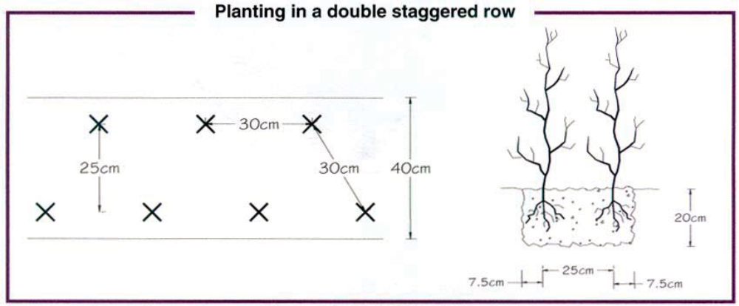

Maintenance
- Water the hedge for the first summer or any dry period in the 1st 12 months.
- Maintain weed control for at least 2 seasons.
- Replace any stock that dies within the first year.
- To encourage wildlife, trim the hedgerow no more than every 2nd year. This allows the shrubs and trees to produce more flowers, nuts and berries.
- Never trim the hedgerow between the beginning of March and the end of August when it would be harmful to invertebrates and nesting birds. The ideal time to trim the hedgerow is between January and February.

- Pollinator shrub planting
In urban areas provision of trees may be difficult. In these situations carefully chosen flower/shrub species which are used by insects are appropriate. IMPORTANT these non-native horticultural or ornamental plants can be good sources or nectar or pollen but should not be used in semi-natural habitats or farmlands.
There is a preference for perennial plants which are a better source of pollen than annuals and are more cost and resource effective.

Ground preparation – soil should be well drained not compacted, a slow release fertiliser and organic (peat free) compost can be added. March and April are the best months for planting and all newly planted shrubs must be watered during dry periods.

Suitable species can be found at the following web link: Wales Biodiversity Partnership - Guides to help (biodiversitywales.org.uk)

- Wildlife Ponds
Wrexham County Borough is classed as an important pond landscape due the soils and geology providing excellent conditions. Previous farming techniques have resulted in field systems with a pond density far greater than the national average.

As part of an application it may be possible to restore an old pond, enhance an existing pond or provide a new wildlife pond.

Guidance on the above can be found at - Ponds - Freshwater Habitats TrustFreshwater Habitats Trust

- Pollinator Shrub Planting
In urban areas provision of trees may be difficult. In these situations carefully chosen flower/shrub species which are used by insects are appropriate. IMPORTANT these non-native horticultural or ornamental plants can be good sources or nectar or pollen but should not be used in semi-natural habitats, farmlands or rural fringe.
There is a preference for perennial plants which are a better source of pollen than annuals and are more cost and resource effective.
Ground preparation – soil should be well drained not compacted, a slow release fertiliser and organic (peat free) compost can be added. March and April are the best months for planting and all newly planted shrubs must be watered during dry periods.
Suitable species can be found at the following web link:
Wales Biodiversity Partnership - Guides to help (biodiversitywales.org.uk)

- Green Roofs, Green Walls, Rain Gardens.
Redevelopment of the city centre provides opportunities for both economic growth and environmental enhancement through supporting objectives on air quality, climate resilience and biodiversity. Projects where green or blue infrastructure are added to urban buildings or streets are sometimes complex but can have enormous benefits. There is guidance available on-line, with the Green Roof Organisation producing a Code of Best Practice available with supporting documents at Green Roof Organisation | Not for profit trade association.
Biodiverse green roofs are designed to provide a particular native vegetation type or bespoke habitat for particular species of wildlife. These green roofs typically have deeper soils than sedum roofs, may or may not be irrigated and tend to have wider variety of plant types. Information on more biodiverse projects Living Roof Projects - Buglife
- Reptile or Amphibian Hibernacula
Hibernacula are underground chambers that amphibians and reptiles use throughout the winter to protect themselves from the cold. They can be installed in relatively small spaces, but should only be used in close association with existing ponds or reptile populations.
Hibernation FAQs | Amphibian and Reptile Conservation (arc-trust.org)

- Butterfly Banks or Scrapes
There are areas around Wrexham (particularly Wrexham Industrial Estate) which are exceptionally important for rare species of butterfly namely dingy skipper and grizzled skipper. The creation of a bank approximately 60cm high in the correct location can provide a sunny sheltered strip in which the butterfly’s food plants can be added. A combination of plugs and seed from some of the following species Common Bird's-foot-trefoil (Lotus corniculatus), Agrimony (Agrimonia eupatoria), Creeping Cinquefoil (Potentilla reptans), Wild Strawberry (Fragaria vesca), Barren Strawberry (P. sterilis), Tormentil (P. erecta) and Salad Burnet (Sanguisorba minor) should be added to subsoil for optimal results.
Habitat Creation | Butterfly Conservation (butterfly-conservation.org)

Appendix 1: Green Infrastructure Statement and Net Biodiversity Benefit

Form completed by: | Chris Meredith
Date: | 19/07/2024
Address of site: | Weir At, Felin Puleston, Wrexham, LL13 7RE
Grid reference: | Easting: 332565 Northing: 349298
Description of Proposal: | To remove concrete weir and hard bank revetment with associated works to benefit river connectivity and restore naturalness of the River Clywedog.

- Details of all existing green infrastructure on site and approximate size:
Boundary 1: | The site is bounded to the north by native deciduous woodland, the south by a species poor semi improved meadow, and east and west by the river.
Boundary 2:
Boundary 3:
Boundary 4:
Front Garden: | n/a
Rear Garden: | n/a
Other:

- What green infrastructure features (trees, hedges, hedgebanks) have already been removed from site and/or require removal to facilitate the development (add lengths or areas)?
Boundary 1: | A small number of trees need to be removed to allow works to be carried out, these were determined as not of significance by the tree report and survey submitted. The only that will be removed are crack willow, oak, hawthorn and alder. A small amount of the species poor grassland will be removed to enable the widening of the river banks.
Boundary 2:
Boundary 3:
Boundary 4:
Front Garden:
Rear Garden:
Other:

- How are the retained features being protected during development (BS5837:2012)?
Boundary 1: | Trees to remain will have a root protection area the size of their canopy left untouched by the development.
Boundary 2:
Boundary 3:
Boundary 4:
Front Garden:
Rear Garden:
Other:

- What Green Infrastructure is being planted as mitigation for losses?
Boundary 1: | Once the banks have been regraded, the bare soil will have a native grass mix seeded to help stabilise in the short term, and trees will be planted on both banks. Trees will be planted to match those species found in the existing woodland and riparian zone, including crack willow, alder, oak, and hawthorn.
Boundary 2:
Boundary 3:
Boundary 4:
Front Garden:
Rear Garden:
Other:

- Biodiversity enhancements
The enhancements do not need to be directly attached to the proposed new construction; they can be attached to the host dwelling or placed within the garden, but they do need to be on land within the red or blue line. The principle is that the enhancements should lead to a ‘net benefit’ for
biodiversity. The following biodiversity enhancements have also been added:

√ | Measure | Plan | Details
 | Boxes. (state type and number) Please make sure they are currently available to buy. | Submit a plan of location and photos of elevation if available. | Height or aspect
 | Hedgerow. Total new or restored length. | Submit plan of location. | Calculate number of each species using information in the guidance above. Ensure that you can easily purchase the species proposed.
 | Tree/orchard planting. Number of trees. | Submit planting plan. | Size of tree (at time of planting), species (full latin name) and any proposed protection measures.
/ | Approximately 100 trees total | See below | 25 x Quercus robur 60-90cm  25 x Alnus glutinosa 60-90cm  25 x Crataegus monogyna 60-90cm  25 x Salix fragilis (cuttings taken from trees on site)  Tree guards will be used to protect from rodent damage. They will be tied to stakes to ensure they are not lost during flood events.
 | Wild flower grassland (area in m2). | Submit plan of location. | Species mix and site preparation details. Confirm that appropriate management is achievable.
 | Pollinator shrub planting. Area in m2. | Submit plan of location. | Species proposed (latin names)
 | Wildlife ponds. Number of. | Submit plan to scale including cross-section. | Details on lining or any proposed planting.
 | Hibernacula. Number of. | Submit plan of location. | Brief description of materials proposed.
 | Any other measures.

- Management and maintenance.
Any information on the long term management and maintenance of the enhancements.

The long term management of features will be carried out by the National Trust alongside their management of the existing grassland and woodland.

- Conclusion
Based on the information provided above, this development will result in a Green Infrastructure and Net Biodiversity Benefits upon completion.

- Sketch plan (Insert plan showing the features of the development site):
A plan of the works has been submitted as part of the planning application and is copied here. Those areas marked orange will be seeded with grass seed and the hatched area planted with native tree species, including willow spp, alder, oak and hawthorn. Ash will not be planted. 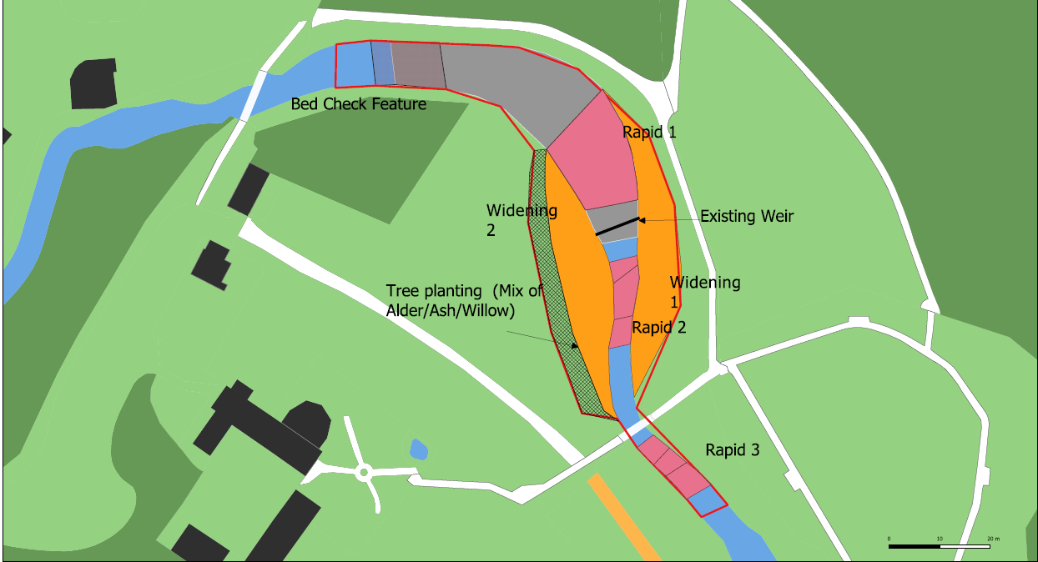

- Site photos (as required)

