BS.3998 (2010) TREE CONDITION SURVEY
On behalf of
Trustgreen Ltd
Unit 7, Portal Business Park,
Eaton Ln, Tarporley
CW6 9DL

For
Bryn-Y-Groes
Chester Road
Gresford
LL12 8TZ
March 2022
(Revision 1 Jan 2024)

Report Prepared By:
M J Boardman BSc (Hons) PGDip MSc MICFor
Martin Boardman & Associates
1 Whalley Drive
Rushton
Tarporley
CW6 9AW
T: 07760 177307
MBAtrees@yahoo.com
8.0 Tree Survey Summary
8.1 A total of 21 individual trees and 1 woodland group were identified and surveyed within the site.
8.2 The trees varied in age from semi mature to fully mature and the condition varied from fair to good.
8.3 The tree quality is shown as a solid circle on the map using the following key:

Tree Condition |  | Map Key
Good | Tree displaying good vigour, vitality, only very minor defects
Fair | Tree showing some signs of stress, minor defects present
Poor | Tree showing signs of major die back, major defects – intervention needed
V.Poor | Tree showing signs of excessive die back and defects urgent intervention needed
Dead | Tree no longer alive

8.4 The trees are generally of fair quality, there is little evidence of historical tree maintenance.
8.5 The trees have been recorded in the tables below. Please see the appendix for keys. Trees that require immediate intervention, - these have been classified as high (red) and should have the recommended work carried out as soon as practically possible.
8.6 The tree works have been classified upon work priority and phased accordingly.
The survey has identified trees that require work in varying timescales, these are identified as:

Work Priority | Time Scales | Map Key
Very High | Urgent – Works required within 7 days
High | Works required within 3 months
Medium | Work required within 6 months – 1 year
Low | Works required within 1 -3years
No Work Required. (NWR) | No target

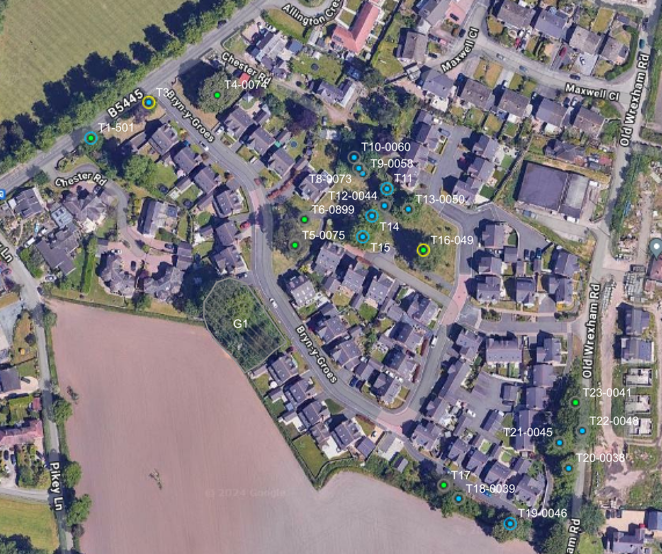
9.0 Site Plan

Key
T1-001 | Tree report Number- Tag Number
Tree Condition |  | Work Priority
Good |  | V.High
Fair |  | High
Poor |  | Medium
V.Poor |  | Low
Dead |  | No Work Required

10. Trees identified with moderate priority; work required within 6 months – 1 year = 2
Tree/Tag Number | Tree Species | Work Required | Date Work Completed
T3 | Lime | Twin stem at 3 m large amount of basil, epicormic growth prevents full inspection, remove Branch at 3 m west, reduce overall height by five metres inspect annually
T16-049 | Atlantic cedar | Very prominent tree within landscape, good form, minor deadwood throughout crown concurrent of species and age, remove snapped hanging branch @10m SE, inspect annually

11. Trees identified with Low priority; work required 1-3 years if budget allows =5
Tree/Tag  Number | Tree Species | Work Required | Date Work  Completed
T1-501 | Lime | Minor Deadwood throughout canopy, concurrent of species and age, large amount of basal, epicormic growth, remove growth over foot path to achieve 2.5 m clearance inspect annually
T11 | Lime | Small amount of basal epicormic growth prevents full inspection minor deadwood throughout crown concurrent of species and age, reduce height by 5 m reduce two small, snapped limbs inspect annually
T14 | Lime | Large amount of basal, epicormic growth prevents full inspection. Minor deadwood throughout crown, concurrent, species, and age, remove, deadwood, inspect annually.
T15 | Lime | Large amount of epicormic growth prevents full inspection minor Deadwood throughout crown, concurrent of species and age, remove deadwood, inspect annually
T19-0046 | Horse chestnut | Triple stemmed with 4th junction @1m. Minor deadwood throughout crown with broken and snapped limbs, re cut broken limbs to BS3998 standard

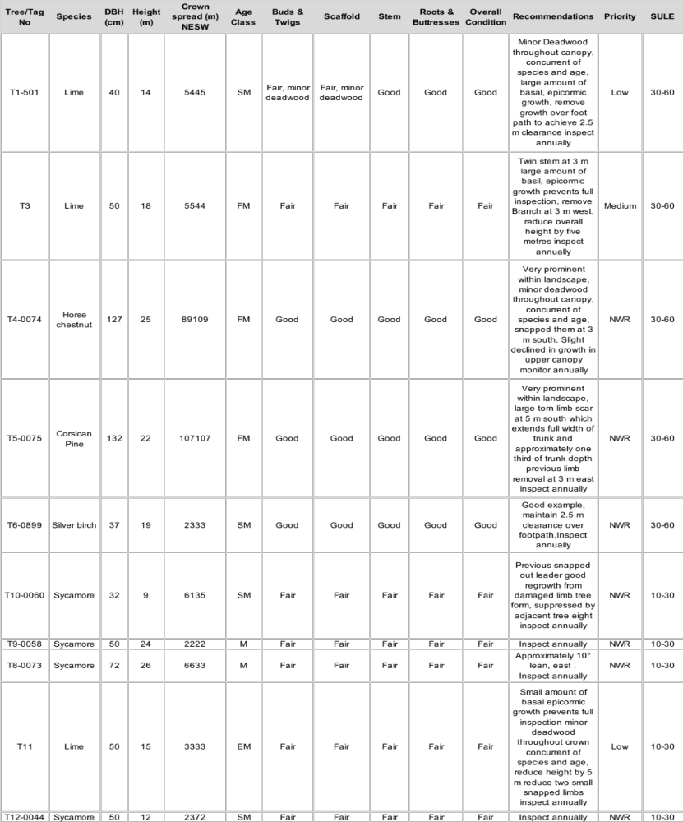12.0 Tree Survey
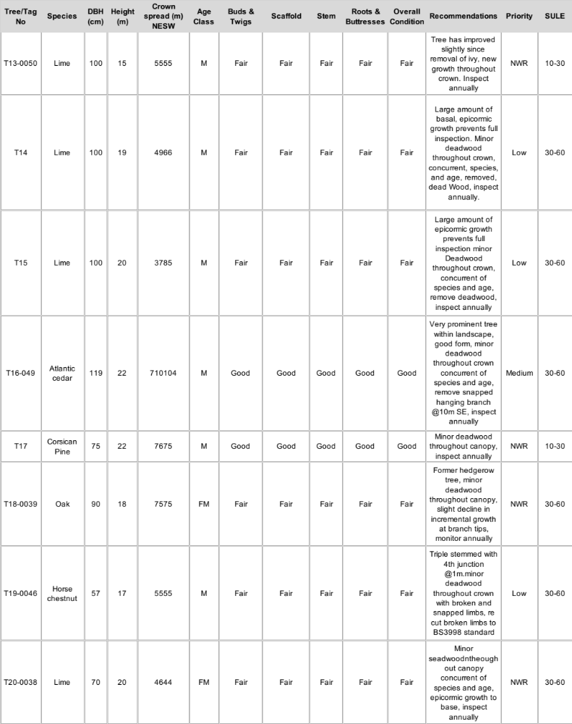
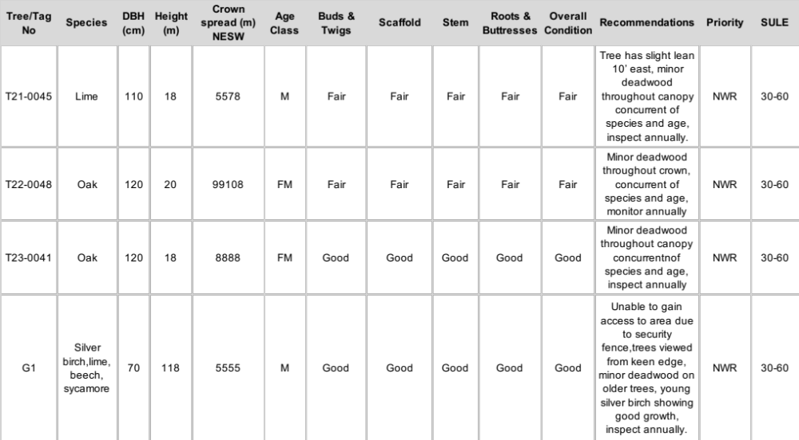

13. Glossary
Tree/Tag Number
Refers to the tree as numerical identified on the site plan. Each tree has been identified with a circular metal tag, these are placed approximately 1.5m from the ground on a clear section of trunk.
Species
Common and vernacular name of the tree – Vernacular- Latin names displayed in small italics.
DBH
Diameter at Breast Height (1.5m) in metres.
Height
Approximate height of the tree from base to the tips of the crown.
Crown Spread
Measurement in metres of the extent of the tree crown on four cardinal points
Age
The appearance of at what stage of life the tree may be in:
Young (Y) Out-planted trees that have not yet established. Semi-Mature (SM) Established trees up to 1/3 of expected height and crown. Early Mature (EM) Between 1/3 and 2/3 of expected height and crown. Mature (M) Between 2/3 and full expected height and crown. Fully Mature (FM) Full expected height and crown. Over Mature (OM) Crown beginning to break-up and decrease in size. Senescent (S) Crown in advanced stage of break-up.
Overall Condition
Consider structural condition in relation to vitality, including pest and diseases.
Tree Condition
Excellent | Tree in excellent condition with good vitality and no defects present
Good | Tree in displaying good vigour, vitality, only very minor defects
Fair | Tree showing some signs of stress, minor defects present
Poor | Tree showing signs of major die back, major defects – intervention needed
Dead | Tree no longer alive

Recommendations
Recommend tree work to reduce risks to an acceptable level during a pre-determined inspection period. Such recommendations will be made to procure a trees vitality and longevity as well as future safety.
Work Priority
Trees given a priority should have the recommendations carried out within the time-scales assigned. Denoted by the attached key.
Work Priority
Very High | Urgent – Works required within 7 days
High | Works required within 3 months
Moderate | Work required within 6 months – 1 year
Low | Works required within 1 -3years
Very low | Low priority – within 3 + years
None | No target

SULE
In years, a subjective estimate of Safe Useful Life Expectancy of the tree.


M J Boardman BSc (Hons) PGDip MSc MICFor

February 2nd 2024

Disclaimer
The tree(s) referred to in this report are living entities and are therefore subject to natural processes. They will also be subject to changes to their environment caused by human’s activities and to exceptional weather conditions. The inspection undertaken by our qualified staff relies on visual attributes of tree health and structure which can be assessed from a ground based inspection. Hidden defects which are not readily visible may not be detected. We therefore cannot wholly guarantee the condition and safety of the trees inspected beyond what can be reasonably assessed from the procedure used. We would recommend that the trees are regularly inspected and our staff will advise on the suitable frequency of these inspections.

