For the Attention of: Amy Brittain – Case Officer
Wrexham County Borough Council

[By Email: planning@wrexham.gov.uk]

21st December 2023

Dear Ms Brittain

PLANNING APPLICATION: P/2023/0630

OUTLINE APPLICATION FOR ERECTION OF UP TO 6 DWELLINGS (ALL MATTERS RESERVED); Land Opposite Royal Oak Cottages, Brynydd, Ponciau, Wrexham – 2nd Re-consultation

Thank you for your consultation notification of 11 December 2023 seeking the further views of The Coal Authority on the above planning application.

The Coal Authority Response: Material Consideration

The Coal Authority previously objected to this application in a letters to the LPA dated 7th and 28th November 2023 as no relevant Coal Mining Risk Assessment was submitted by the applicant to support the application.

We are pleased that this application has now been accompanied by a Coal Mining Risk Assessment report (A5744/23/CMRA) prepared by Earth Environmental & Geotechnical, dated 8th December 2023. The report has been based upon a review of Coal Authority Data, geological information and intrusive investigations in the locality. The report acknowledges the presence of the recorded mine shaft reference 329346-259 within or in close proximity to the site. The report also acknowledges a potential risk posed to the development area from historic shallow coal mining activity.

The Coal Authority welcomes recommendations in the report for the undertaking of ground investigations on site in order to establish the extent of any shallow mine workings and to inform any remedial works and mitigation measures needed to ensure the site is safe and stable.

The report also recommends that site investigations to prove/disprove the shafts positon on site. The Coal Authority is of the opinion that building over, or within the zones of influence, of mine entries should be avoided wherever possible, even after they have been treated, in line with our adopted policy which can be found at:
https://www.gov.uk/government/publications/building-on-or-within-the-influencing-distance-of-mine-entries

The report does not refer to our adopted policy and does not confirm that the indicative layout of built development as shown on the Development Outline Plan has been informed by the plotted positon of the shaft and its potential zone of influence. Nevertheless, we acknowledge that the applicant is seeking to establish the principle of residential development at the site and, as such, the detailed layout is not currently under consideration.

In light of the above, the Coal Authority considers that the recommended intrusive investigations are required prior to the formulation of a detailed site layout, in order to establish whether shaft 329346-259 is present within the site, to establish its potential zones of influence and to inform any necessary treatment works to remediate/stabilise this features, if found. Should the shaft not be located and be assumed to lie off-site, consideration should be given to any mitigation measures required within the application site to address the potential implications of a future off-site collapse of the shaft adjacent to the northern site boundary.

Any subsequent reserved matters application seeking the approval of a detailed site layout should include a plan identifying the shaft position, where located, and an appropriate ‘no-build’ zones around this feature. This plan should demonstrate to the LPA that the layout of development has been suitably informed by the presence of this feature.

The applicant should note that Permission is required from our Permit and Licensing Team before undertaking any activity, such as ground investigation and ground works, which may disturb Coal Authority property. Any comments that the Coal Authority may have made in a Planning context are without prejudice to the outcomes of a Permit application.

Mine Gas
It should be noted that wherever coal resources or coal mine features exist at shallow depth or at the surface, there is the potential for mine gases to exist. These risks should always be considered by the LPA. The Planning & Development team at the Coal Authority, in its role of statutory consultee in the planning process, only comments on gas issues if our data indicates that gas emissions have been recorded on the site. However, the absence of such a comment should not be interpreted to imply that there are no gas risks present. Whether or not specific emissions have been noted by the Coal Authority, local planning authorities should seek their own technical advice on the gas hazards that may exist, and appropriate measures to be implemented, from technically competent personnel.

SuDS
Where SuDS are proposed as part of the development scheme consideration will need to be given to the implications of this in relation to the stability and public safety risks posed by coal mining legacy. The developer should seek their own advice from a technically competent person to ensure that a proper assessment has been made of the potential interaction between hydrology, the proposed drainage system and ground stability, including the implications this may have for any mine workings which may be present beneath the site.

The Coal Authority Recommendation to the LPA

The Coal Authority concurs with the recommendations of the latest Coal Mining Risk Assessment report; that coal mining legacy poses a potential risk to the proposed development and that investigations are required, along with possible remedial measures, in order to ensure the safety and stability of the proposed development.

As such, should planning permission be granted for the proposed development, we would recommend that the following conditions are included on the Decision Notice:

- Prior to the submission of any Reserved Matters application seeking approval of a detailed layout of development, a scheme of intrusive investigations shall be been carried out on site to establish the risks posed to the development by past coal mining activity, including that posed by recorded mine entry 329346-259. These works shall be carried out in accordance with authoritative UK guidance.

- Any application seeking approval of a detailed layout of development, shall be accompanied by: the findings of the intrusive site investigations (required by condition 1 above); a proposed layout plan which identifies the position of the recorded mine entry if located, the extent of its potential zones of influence, and a suitable ‘no build’ zones around these features.

- Prior to commencement of development, any remediation works and/or mitigation measures to address land instability arising from coal mining legacy, as may be necessary, shall be implemented in full in order to ensure that the site is made safe and stable for the proposed development. These works shall be carried out in accordance with authoritative UK guidance.

- Prior to the first occupation of the development, a signed statement or declaration prepared by a suitably competent person confirming that the site has been made safe and stable for the approved development shall be submitted to the Local Planning Authority for approval in writing. This document shall confirm the completion of any remedial works and/or mitigation necessary to address the risks posed by past coal mining activity.

The Coal Authority therefore withdraws its objection to the proposed development subject to the imposition of the above conditions. This is our recommendation for condition wording. Whilst we appreciate that you may wish to make some amendment to the choice of words, we would respectfully request that the specific parameters to be satisfied are not altered by any changes that may be made.

Should planning permission be granted for this proposal, we also request that the following wording is included as Informative Notes on any decision notice:

1 - Ground Investigations
Under the Coal Industry Act 1994 any intrusive activities which disturb or enter any coal seams, coal mine workings or coal mine entries (shafts and adits) require the prior written permission of the Coal Authority since these activities can have serious public health and safety implications. Such activities could include site investigation boreholes, excavations for foundations, piling activities, other ground works and any subsequent treatment of coal mine workings and coal mine entries for ground stability purposes. Failure to obtain permission to enter or disturb our property will result in the potential for court action. Application forms for Coal Authority permission and further guidance can be obtained from The Coal Authority’s website at: www.gov.uk/get-a-permit-to-deal-with-a-coal-mine-on-your-property

2 - Shallow coal seams
In areas where shallow coal seams are present caution should be taken when carrying out any on site burning or heat focused activities.

Please do not hesitate to contact me if you would like to discuss this matter further.

Yours sincerely,

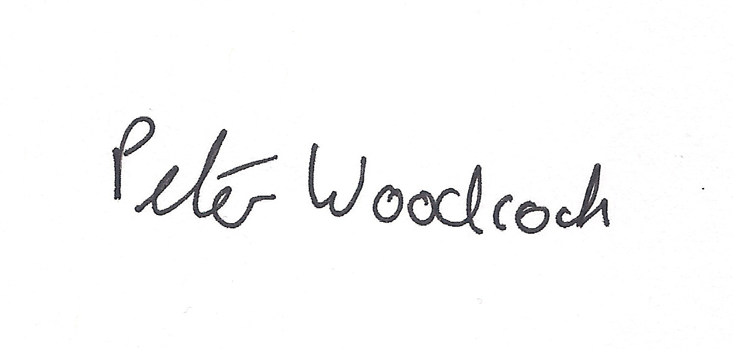
Peter Woodcock | BSc (Hons)
Assistant Planning and Development Manager

Disclaimer

The above consultation response is provided by The Coal Authority as a Statutory Consultee and is based upon the latest available data on the date of the response, and electronic consultation records held by The Coal Authority since 1 April 2013. The comments made are also based upon only the information provided to The Coal Authority by the Local Planning Authority and/or has been published on the Council's website for consultation purposes in relation to this specific planning application. The views and conclusions contained in this response may be subject to review and amendment by The Coal Authority if additional or new data/information (such as a revised Coal Mining Risk Assessment) is provided by the Local Planning Authority or the Applicant for consultation purposes.

In formulating this response The Coal Authority has taken full account of the professional conclusions reached by the competent person who has prepared the Coal Mining Risk Assessment or other similar report. In the event that any future claim for liability arises in relation to this development The Coal Authority will take full account of the views, conclusions and mitigation previously expressed by the professional advisers for this development in relation to ground conditions and the acceptability of development.

