Blueprint Architectural Services Ltd
Office 3K4, Redwither Business Tower, Redwither Business Park, Wrexham. LL13 9XT
Tel: 01978 356500
design@blueprintarchitectural.com
www.blueprintarchitectural.com

Heritage Impact Statement

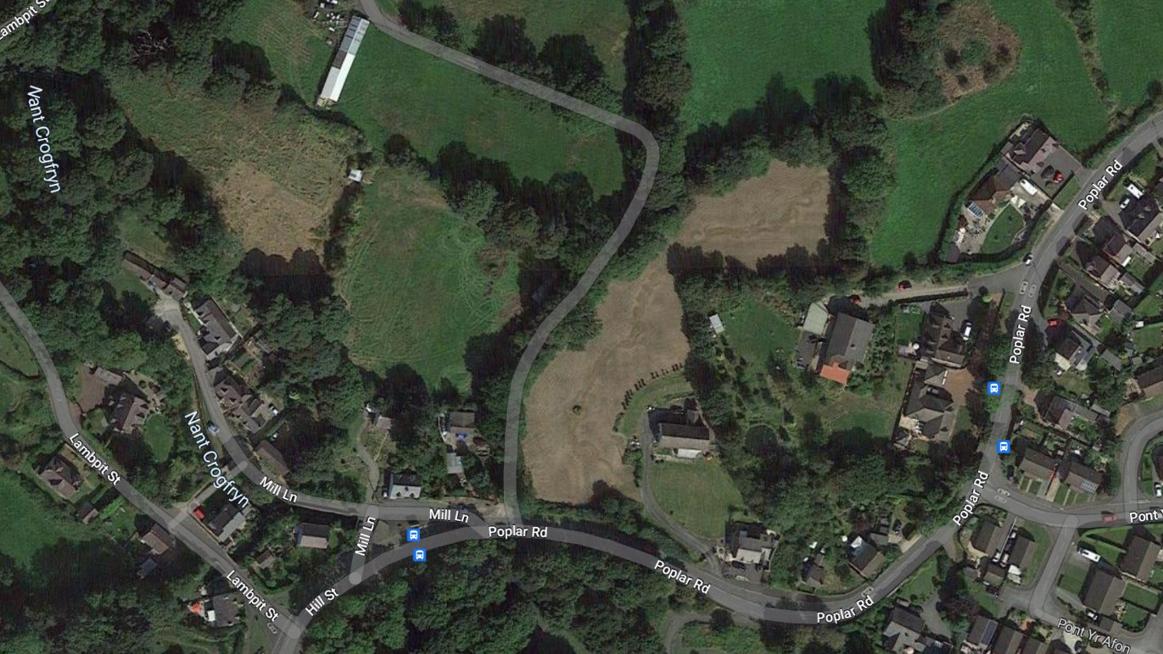

Statement prepared for:

Statement required for:

Proposed residential development which includes detached two storey dwelling, and detached bungalow on land adjacent to 10 Poplar Road, Penycae, Wrexham. LL14 2PY.
Explaining Objectives

Our client’s main objective with this project is to develop the land within their ownership to create 2 additional family homes within a central village location. The single storey property is designed to suit our client’s needs, with other examples of bungalows within the conservation area it is considered this addition will add to the interest and character of the conservation area.

With the knowledge that No: 10 Poplar Road is located within the Penycae Conservation Area; the main goal is to ensure the proposal is delivered in the manner documented within our plans and statements to support the application. Without any doubts the proposals put forward will significantly improve the interest and character of the area.

No:10 occupies a significantly large plot which extends to approximately 2.15 acres, this in many respects in unmanageable and maintaining a plot of this size poses difficulties in terms of the equipment needed.

The opportunity to develop the land which does sit within the settlement boundary of Penycae provides opportunity to segregate the land into more manageable plots something that is apparent and has been done in the area.

Our aim in terms of developing schematic drawings for the proposal put forward was to introduce gable roof features as prominent designs to the properties respecting the traditional character of the area, it was also key to use traditional materials to respect the conservation area setting but also consider the future maintenance of the properties.

The pattern of residential properties in the area does appear rather unorthodox, which is a clear characteristic of the conservation area. Something we are aiming to replicate as part of the development.

Properties appear to have been constructed to suit the topography of the immediate area which has created the pattern of development we mention above, this in our view appeals to the visual impact of the area and creates an interesting street scene.

Understanding Significance

Penycae was first designated as a conservation area in 1976 and its boundary amended and reduced in January 2003 and June 2011. The special character of Penycae Conservation Area derives from several features: Topography, Nant-Y-Crogfryn and Trefechan Brooks and Bridges, Boundary Walls. Contribution by Trees and Open Space.

The Penycae conservation area is crucial to retaining the historical character and architecture of the area to preserve the historic core of the village. The conservation area assessment and management plan help outline critical aspects of the area that should be perpetuated in new design proposals, as well as aspects that are detrimental to the character and therefore, possible means of mitigating these aspects.

The present parish of Penycae was formed in 1879 from the parishes of Ruabon, Rhosymedre and Rhosllanerchrugog. The Conservation Area covers the oldest section of the village known as Pentre Cristionydd. It is believed a small settlement existed here in the 7th century.

Historically the area of Pentre Cristionydd was the primary economic resource for Penycae throughout the 17th century due to the stone built Pentre Mill that was powered by water from the adjacent running Nant-y-Crogfyn brook. The mill industry was an important aspect of the early history of Penycae, however, the mill was demolished in 1978 and is now part of the garden for The Mill pool building.
The industrial revolution had a profound impact on the village as it saw the introduction of copper and iron works to the village. The iron industry was particularly successful for the village and saw the construction of an iron furnace in 1760 that was sold for £6050. The furnace was built in the Copperas area and therefore is the eponym of Copperas. The place name’s presence signifies that the iron industry was significant.

The rapid expansion of the village in the 19th century is attributed to the coal industry which was very prevalent throughout the villages to the West of Wrexham. The parish of Penycae possessed up to eight coal mines that were much smaller, likely family run, than that of the neighbouring mines in Ruabon and Wynnstay.

These industries have since declined and left the village far more serene with a lack of employment options for the local people. As a result the village is primarily a residential hub that has traces of the varied history dispersed around the area.

Unlike other Conservation Areas in the County Borough Article 4 has not been adopted meaning homeowners are able to alter their properties under what is deemed as permitted development rights. This direction is designed to control all perspective projects by means of a formal planning application. As this direction isn’t present it does allow homeowners to extend and alter their properties without the requirement of a formal permission providing it complies with PD rights.

As documented within the Penycae Conservation Area Assessment and Management Plan the adjacent property No:10 is mentioned, the property is noted as being in an elevated open location makes the property an unfortunate obvious feature within the wider views of the conservation area.
This is stipulated due to the additions that have been incorporated into the property that was formally known as Berwyn View, which dates back to the 19th Century. According to historic maps which are part of the adopted Assessment and Management Plan the original property would have been constructed between 1874 & 1899.

Modern extensions and alterations made to No:10 have had a negative impact to its character and appearance, the alterations made specifically to principal elevation are typical of a 50-70s flat roof addition, alterations during this period took little account of the existing character of a property, a side extension have respected the form and footprint of the original dwelling.

Number 9 Poplar Road in our clients ownership as noted within the site and location plan submitted as part of this application, the prominent roadside location draws attention to the property, the completed dwelling has added some real interest to the Conservation Area.

Although a modern design the property succeeds in fitting into its surroundings, the choice of facing brick and concrete tile roofing is key to this. Numerous properties throughout the conservation area possess a masonry brick finish similar to that of this proposal therefore the proposed dwellings are not hindering the character of the area and are preserving the character with match materials. The stepped ridgelines and lower dormers add interest to the street scene and match the style of the surrounding properties that have influenced the design stage of this proposal, therefore continuing to invest in the Character of this recognised Conservation Area.

The use of cement render is apparent throughout the conservation area and is particularly prevalent in properties surrounding the site location. This has been deemed to be detrimental to the conservation area as it has often been used to envelop traditionally constructed buildings that originally possessed a sandstone external finish that was conducive with the traditional architecture of the area.

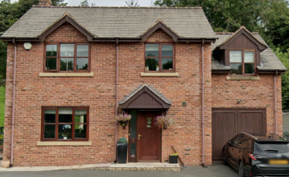
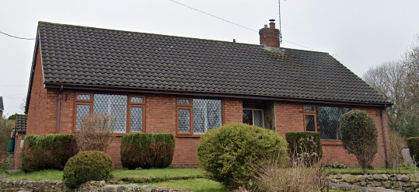
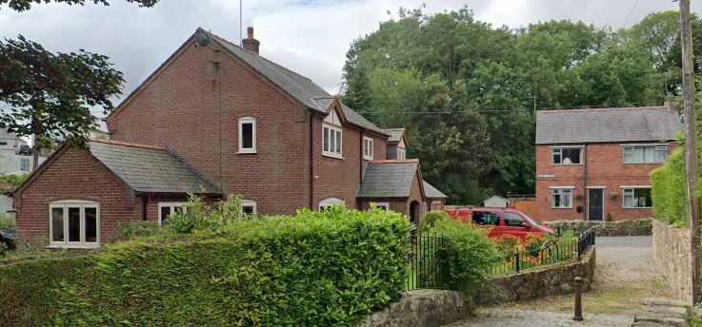

2. Example Properties within the Conservation Area

Identifying Proposed Changes including Assessing the Impact and Reasoning

The objective to this proposal is to provide two additional homes on land that is within the ownership of our clients, the properties include for a single storey and two storey detached dwelling.

The single storey property is aimed at addressing our clients’ requirements and adding to the characteristics of the conservation. This addition to the street scene will add interest to the street scene and inject the area with additional character reducing the prominence of No:10 on the Conservation Area.

Segregation of the oversized plot will make maintenance more manageable and will be a clear better use of land available within a central village location. Plot 2 is aiming to replicate the positive impact No:9 has had on the Conservation Area.

Choice of materials has been a careful consideration; the use of brickwork and slate roofing tiles will respect the area by using matching materials and materials that respect the tradition of the area. Window choices were specifically discussed with the clients due to the understanding of the site being set within a Conservation Area. In our view due to other alteration made to dwellings within the conservation area (replacement windows) it was felt the proposed installation of Heritage 9 windows which have Conservation Area consent in parts of the borough.

The use of this product as part of the development will keep maintenance of the property to a minimum whilst retaining the appearance of a timber window. It is suggested windows within the new properties are installed as grey units to differentiate to older properties within the area.

Stone headers and cills have also been introduced to the window openings to add interest to the elevation treatment of each property, this method of adding interest to the proposed dwellings has again been taken from the modern addition to the conservation area no:9.

The boundary treatment for the proposal will consist of natural hedgerows that coincide with the rural character of the area and would divide site in a manner that would not negatively impact the area but potentially reduce the impact of the palisade fencing adjacent to the site, which is a damaging feature to the conservation area and runs along Poplar road, by shifting focus towards the site views and providing an alternative natural boundary treatments for the site. To define site boundaries prior to the growth of the hedge, three rail timber fences shall be erected to match fencing surrounding the property No. 9 poplar road, this will retain the visual quality of the street.

The proposal will reduce focus on the neighbouring No. 10 Poplar Road, that according to the CAAMP, has had its traditional character destroyed and therefore, is detrimental to the conservation area and currently an obvious feature.

The proposed dwellings have been positioned to respond to the varied and staggered layout of existing properties meaning that the properties are set back from the highway similar to that of property No. 10 and as a result will be partially concealed from views due to existing greenery which is a consistent theme throughout the conservation area.

The highways authority will require a minimum of 5m of tarmac therefore, up to the front gates of the proposed dwellings will be tarmacked to comply, beyond this will be a gravel driveway to prevent overuse of tarmac in the proposal.

As indicated in the street scene elevation the proposed dwellings do not exceed the height of the existing No.10 dwelling that neighbour’s the site meaning the existing backdrop of land up the hill and dominant treeline is therefore not impeded.

Due to the topography of the site there will be the requirement of some retaining structures to support driveways/cut and fill of the plots to create a plateau for the proposed dwellings. It is thought the driveway walls adjacent to the main highway will be clad in stone with boundary walls and fences for the dwellings to be brickwork and three rail timber post fences.

The property No. 9 Poplar road has arguably the biggest impact on the surrounding site and highway being the closest property to the street and at the forefront of the plot. This property alongside many other modern additions to the conservation area possess a red brick external finish, similar to the proposed dwellings therefore, the character of the area is being retained.

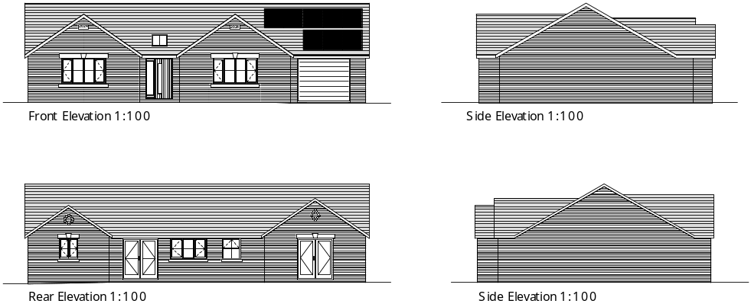

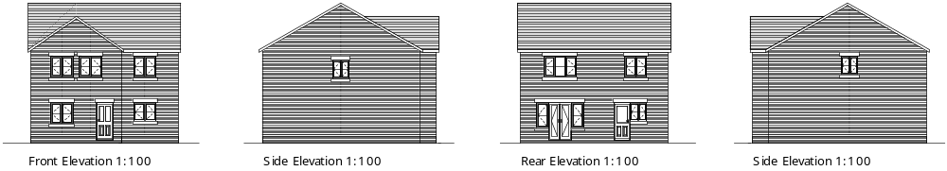
3. Proposed Elevations of Dwellings

Conclusion

Justification has been provided within this document and the design and access statement to ensure the local authority are provided with information to support our proposal.

As stated within this document, the proposed dwellings will inject character and interest into the Conservation Area while respecting its surroundings. Furthermore, the proposed dwellings will detract focus from the existing No. 10 property that is a detrimental aspect of the site and the conservation area due to lack of consideration when altering the property.

The proposal uses materials such as red brick and concrete tiles that are conducive with many other recent builds in the conservation area, therefore, the dwellings have been designed to ensure that they do indeed respond to the character of the conservation area based on the precedent of currently existing proposals of similar appearance.

The equally important massing, scale, positioning and orientation have been assessed to ensure minimum impact on the views and overall site providing it is considered a key view within the conservation area. The site plan and street scene elevation demonstrate how we have considered the existing site and surroundings to inform the design in these regards by ensuring that the proposal does not impede on the nature and views of the site and its rural character.

The segregation of this oversized plot to provide more manageable areas that will be kept by means of occupants of private residential dwellings will have a positive impact on the Conservation Area.

The use of traditional materials and the proposed installation of Riverdale Heritage 9 windows or similar will keep maintenance to a minimum, the use of good quality products will ensure no detrimental effect on the vicinity.

Document Prepared by:
Dafydd John Edwards ACIOB
Senior Architectural Technician
on behalf of Blueprint Architectural Services Ltd

Document Amended By:
Luke Oliver Fowles
Architectural Technician
on behalf of Blueprint Architectural Services Ltd

