Proposed Construction of

2 Double Garages at

5 and 6 Ffordd Gerwyn

Wrexham LL13 7DX

Planning Ref P/2024/0085

Green Infrastructure Statement

Prepared by Ian Stockdale Ltd
7 Pendragon Court
Hermitage Park
Wrexham LL13 7GY
June 2024

- Introduction
  - This Statement has been prepared on behalf of Mary Kane and Rachel Spur to accompany a Planning Application for the construction of 2 double garages on land at The Ithens Wrexham following a request for additional information.
  - The purpose of this Statement is to act as a supporting document for the above Planning Application and to indicate the philosophy of revised Chapter 6 of the Planning Guidance document November 2023.
- The Application
  - Demolition of an existing double garage and the construction of 2 more double garages in a different location.
  - In terms of the Infrastructure Statement we consider the site to be ‘minor’.
- Site Description
  - The site occupies 2 residential plots at the head of a cul-de-sac known as Ffordd Gerwyn.
  - The access road is already in place.
  - Currently the road frontages are open.
  - Current use is residential.
- Areas for Consideration
  - Having read the content of the new document there are several areas where we believe we can improve the green infrastructure of our proposal. These are:
    - Rainwater Harvesting.
    - Permeable surfaces.
    - Rain gardens – at the foot of slopes and fed from rainwater butts and adjacent kerbs.
    - We did consider planter boxes but considered this to be inappropriate to this site.
  - Action
    - Due to the ‘minor’ nature of this project we propose to install rainwater butts to collect rainwater for reuse.
    - Although there is a large area of National Trust woodland adjacent to the site, it is proposed to install bird boxes on each gable of the garages.

- Proposed Site Plan
  - Attached is a marked up copy of the proposed site plan indicating these opportunities.
- Conclusion
  - We believe that these measures will provide a valuable addition to the green infrastructure of this site and support the application.

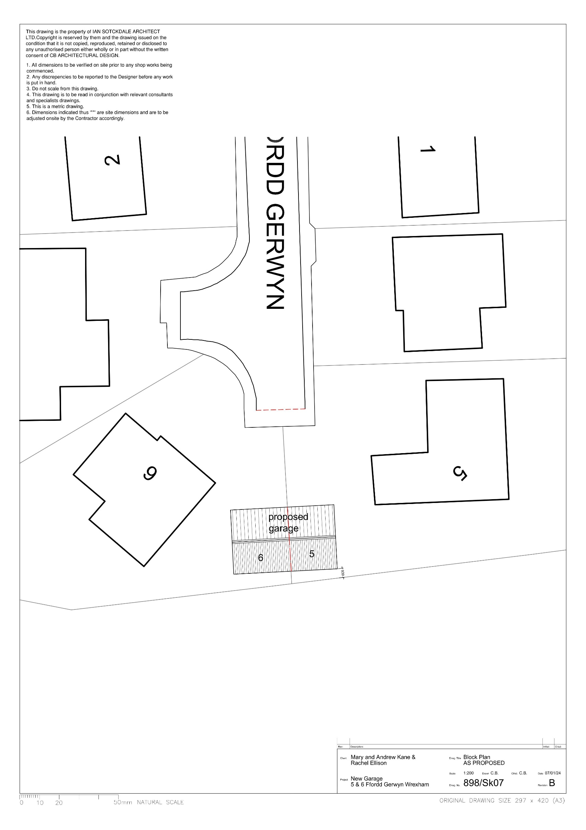
O - Rainwater Butt
B - Bird Box
O
B
B
O

