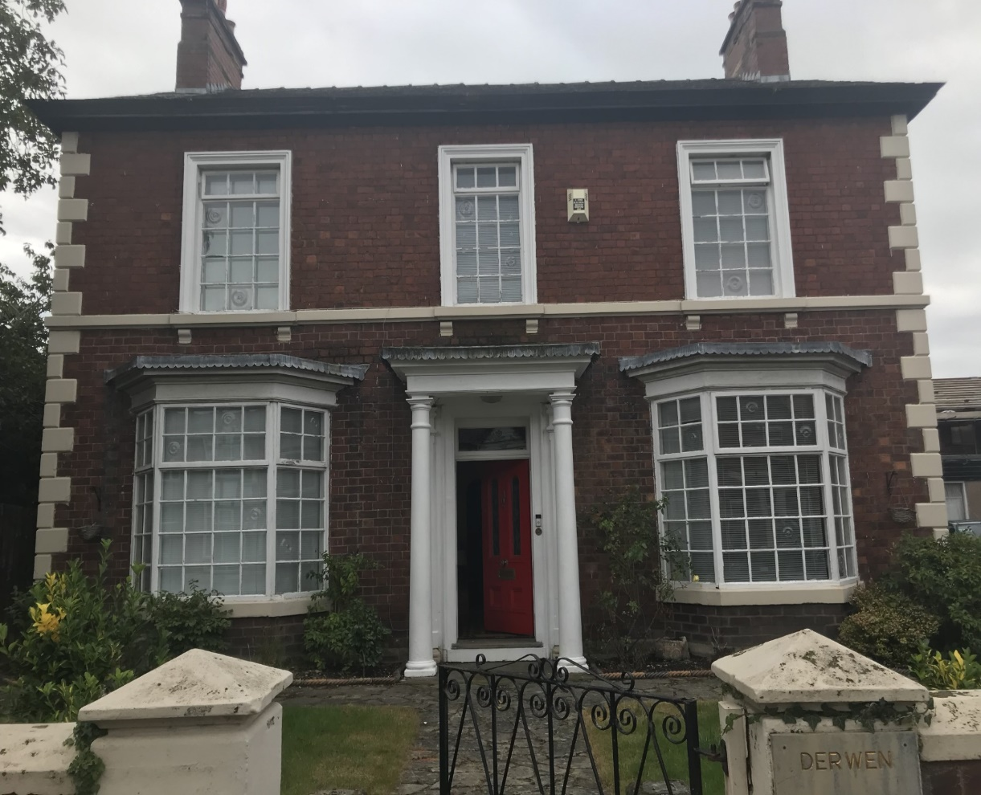
Front elevation
43 Ruabon Road

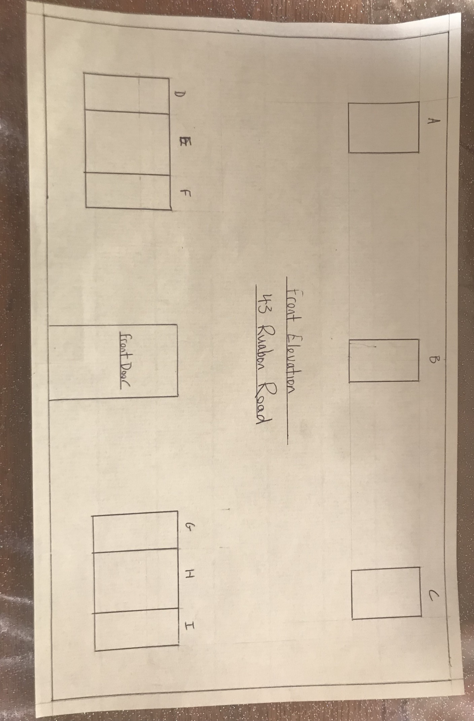

Windows to be replaced | Width (mm) | Height (mm) | Width Scale 1:50 (mm) | Height Scale 1:50 (mm)
A | 1080 | 1810 | 21.6 | 36.2
B | 930 | 1810 | 18.6 | 36.2
C | 1080 | 1810 | 21.6 | 36.2
D | 800 | 2040 | 16 | 40.8
E | 1320 | 2040 | 26.4 | 40.8
F | 800 | 2040 | 16 | 40.8
G | 800 | 2040 | 16 | 40.8
H | 1320 | 2040 | 26.4 | 40.8
I | 800 | 2040 | 16 | 40.8

All windows will be replaced with casement windows with front openers as existing. They will be made to the same measurements as existing windows and double glazed.

