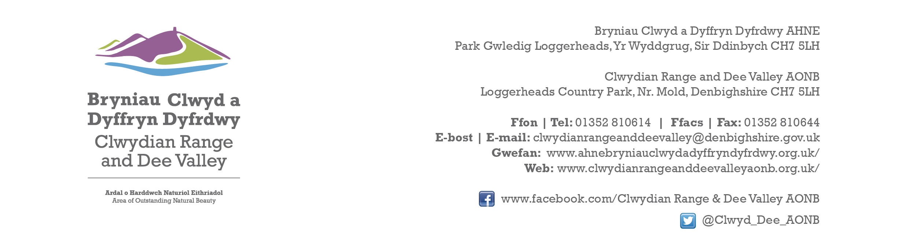

Ref P/2023/0881
Dyddiad | Date: 31th January 2024

Gwyn Humphreys
Economy and Planning
Wrexham County Borough Council
Guildhall
Wrexham
LL11 1AY

Dear Gwyn,

PROPOSAL: Conversion of Building to 2 Dwellings

LOCATION: Bryn Yr Eos Chapel, Whitehurst, Chirk

Thank you for consulting with the Joint Committee on this application. The following observations are submitted on behalf of the Joint Committee.

In view of the limited changes to the external appearance of the building the proposed development will not have any adverse impact upon the character and appearance of the AONB. The Joint committee therefore raise no objections

I would be grateful if you could take account of the committee’s views when deciding this application.

Yours sincerely,

Dave Williams
AONB Planning Advisor
For the Clwydian Range and Dee Valley AONB Joint Committee

