BRIEF JUSTIFICATION STATEMENT IN SUPPORT OF APPLICATION FOR CHANGE OF USE OF EXISTING VILLAGE HALL TO A RESIDENTIAL DWELLING

ERBISTOCK VILLAGE HALL, ERBISTOCK LL13 0DW

INTRODUCTION

The property comprises a red facing brick structure with a slated roof of traditional construction believed to have been constructed in the early 1900’s

The original structure also includes a lean-to single storey structure to the rear south west elevation, which appears to be part of the original traditionally constructed structure

A further flat roofed extension has been constructed to the rear south west elevation to provide toilet and kitchen facilities and this extension is believed to have been constructed mid to late 1990’s

The property is sited in a generous plot in a small hamlet of residential properties

The original structure of the property has some good quality detailing and design and is worthy of retention

LOSS OF COMMUNITY FACILITY

The local community in this small hamlet does not have sufficient population to support the use of the village hall which has declined in use to the point whereby its use has ceased altogether

If community facilities were required by any residents, then such facilities are readily available and sustainable in nearby larger communities of Overton on Dee, Bangor on dee and Ruabon. Such facilities are sustainable in those communities due to larger populations, better highway infrastructure etc and such facilities are only a short drive away

The fact that use of the village hall has declined to a point whereby it has closed altogether some years ago, is clear evidence that the use of the village hall is not sustainable, and an alternative use must be found to ensure sustainability of this attractive rural building

The evidence from Jones peckover (who also have personal knowledge of the village hall site at erbistock) supports the contention that the current use is not viable or sustainable

PLANNING PREFERENCE FOR ALTERNATIVE USE FOR EMPLOYMENT

The location in a rural hamlet served by relatively poor highway infrastructure, in the opinion of very experienced and well- respected marketing experts, renders the site unsuitable for marketing for employment purposes

There are also many other sites available for employment purposes in more suitable locations serviced by much better highway infrastructure in Overton on Dee, Bangor on Dee and Ruabon

For these reasons the marketing professionals have assessed the village hall as not being viable for marketing for an employment use and therefore the site is neither suitable or viable for employment use

Please see submitted letter from Jones Peckover

STRUCTURAL SUITABILITY FOR CONVERSION

The property is clearly suitable for conversion and is in good overall structural condition

Please see submitted structural appraisal

PLANNING HISTORY

The proposal submitted for change of use to a residential dwelling has previously been granted planning consent, (planning approval reference P/2018/0288) but unfortunately that approval has now lapsed

The proposed scheme now submitted is the same as that previously approved and we believe there has not been any fundamental change to planning policy in the intervening period

MERITS OF THE PROPOSAL FOR CONVERSION

the building has traditional architectural and historic features which merit retention and are retained as part of the scheme;
the residential use of the building and curtilage provides adequate privacy and space around dwellings, and does not have an unacceptable effect on the character and appearance of the surrounding area, by virtue of its siting, scale, design, form, use of materials and landscaping; The proposal introduces green landscaping which enhances the visual appearance of the site and does not impact on the traditional appearance of the building
Very good standards of residential amenity are provided by the proposal.
Evidence has been provided to demonstrate that the existing site is redundant and not viable as a community facility or for any alternative commercial use. The proposal for residential conversion therefore accords to planning policy

ACCESS

The proposal utilises the existing vehicular access and will generate less traffic movements than could be expected if the village hall was in use as such, or for an alternative employment use (which isn’t viable as explained previously)

The proposal accords to required parking standards

SUMMARY

For the reasons stated above and supported by evidence of compliance with the requirements of policies CF1 and HSG7, we have concluded that the proposal for residential use accords to the requirements and objectives of the stated policies, which will protect and safeguard this attractive rural building

EXTRACT OF POLICIES – APPENDIX A

CF1 Retention of Existing Facilities
The demolition or change of use of community facilities for other purposes will be permitted only if:
- there is no longer a demand for the existing facility; and
- suitable alternative provision exists or can be provided as part of the proposed development.
17.5It is important that viable community facilities particularly in rural areas are not lost as a result of commercial or other pressures. However, where the Council are satisfied that the facilities are no longer meeting a significant local need, or suitable alternative provision is available elsewhere in the locality, then appropriate re-use of the site or buildings will be permitted.

HSG7 Change of Use to Residential Outside Settlement Boundaries
The change of use to a dwelling of an existing non-residential building outside settlement boundaries will only be permitted where:
- if suitable for employment use, the building has been advertised at a reasonable price for sale or lease for an employment generating use, for a period of at least one year without success; or
- residential conversion is a subordinate part of a scheme for business re-use;or
- the resultant housing would contribute to an identified need for affordable housing to meet local needs.
provided that:
- the building is structurally sound and capable of conversion without significant extension, extensive rebuilding, or external alteration. A detailed independent structural survey will be required as evidence in support of the application;
- the building has traditional architectural and historic features which merit retention and are retained as part of the scheme;
- the residential use of the building and curtilage provides adequate privacy and space around dwellings, and does not have an unacceptable effect on the character and appearance of the surrounding area, by virtue of its siting, scale, design, form, use of materials and landscaping; and
- reasonable standards of residential amenity are provided by the proposal.
11.66The Council will give sympathetic consideration to the change of use of existing buildings of architectural or historic merit to residential uses rather than allow their deterioration. Due to the need to exercise strict control on new housing development outside settlement boundaries only buildings with worthy architectural or historic interest will be considered for conversion under this policy. If other buildings of no architectural or historic interest were considered it would lead to the proliferation of new dwellings in the open countryside which the Plan and National Planning Guidance seek to avoid. Many older traditional buildings are inherently attractive and because of the use of natural materials such as stone and slate they blend in with their natural surroundings.
11.67National Planning Guidance gives preference to the conversion of rural buildings to employment related rather than residential uses except where residential conversion is a subordinate part of a scheme for business re-use, or is contributing to an identified need for affordable housing. This policy seeks to distinguish between rural buildings which have an existing economic use whose conversion to residential may have a detrimental effect on the local economy, and those buildings which have ceased to have an economic use. However, due to the need to diversify the rural economy, proposals must be supported by a statement from the applicant of the genuine efforts made to advertise the property for sale or lease as an employment related use, with recognised estate agents and/or in appropriate property journals, at a reasonable price, for a minimum period of one year. This will only be required when the building is considered suitable for employment generating uses having regard to the characteristics of the building, the site and surroundings, and the vehicular access and local highway network.
11.68Not all buildings will be suitable for a change of use. Those radically altered since their original construction or of insufficient architectural merit may not be worthy of retention or too small to adapt without significant extension. The original building must be structurally sound, or capable of being made so, by works that are not tantamount to rebuilding. A structural survey will be required with all proposals to verify the condition of a building. It must also be capable of accommodating the new use without significant extensions which might destroy its character or lead to overdevelopment. The emphasis should be on retaining existing openings with only minor extensions which complement the scheme of conversion and do not detract from it. Division to more than one residential unit will depend on the size and available space around the building and its suitability for multiple adaptation. All schemes should conform to the Council’s “Space About Dwellings” standards to ensure adequate space between existing and proposed new dwellings.
11.69In all cases, every effort must be made to ensure the stability of the building during conversion works. The full or partial collapse of the building, whatever the cause, will render the planning permission null and void.

PHOTOGRAPHIC ILLUSTRATIONS – APPENDIX B
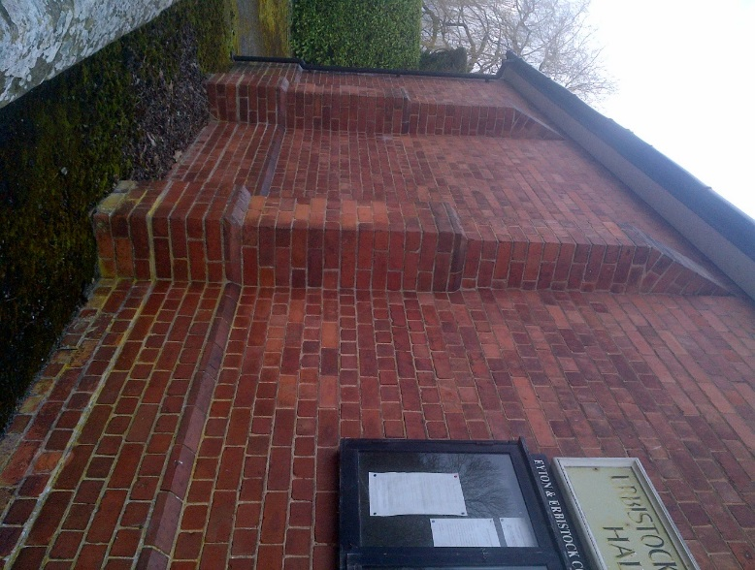
Figure 1 ROADSIDE ELEVATION
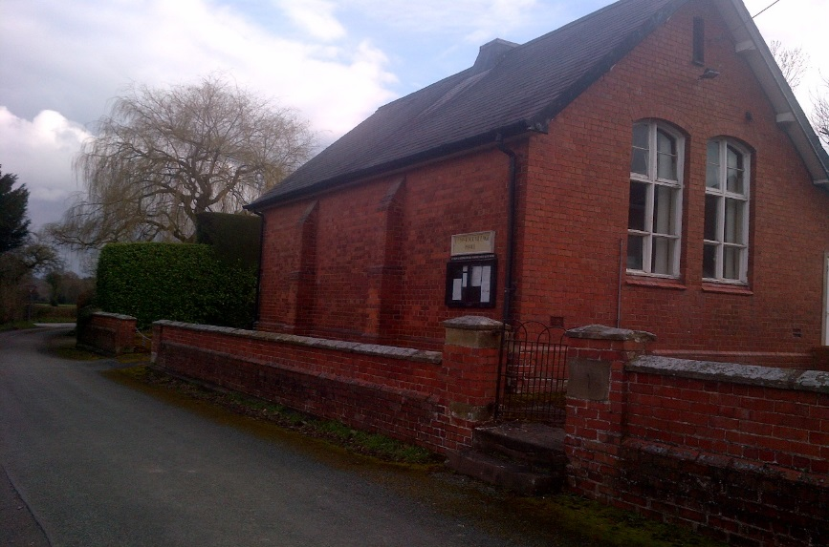
Figure 2 VIEW FROM HIGHWAY
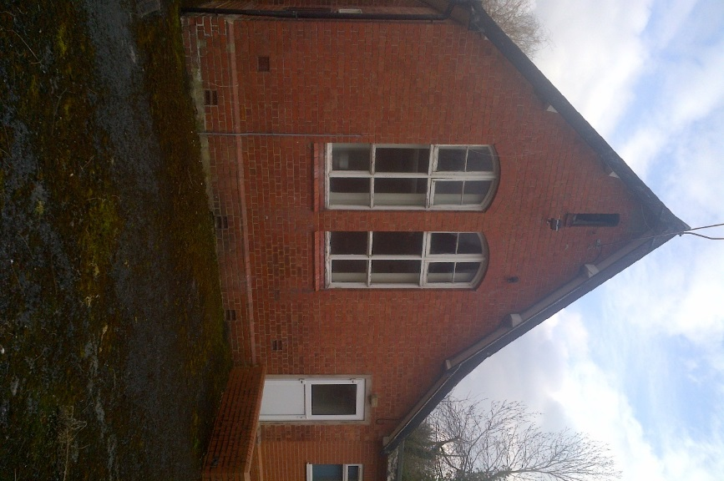
Figure 3 SOUTH EAST ELEVAION
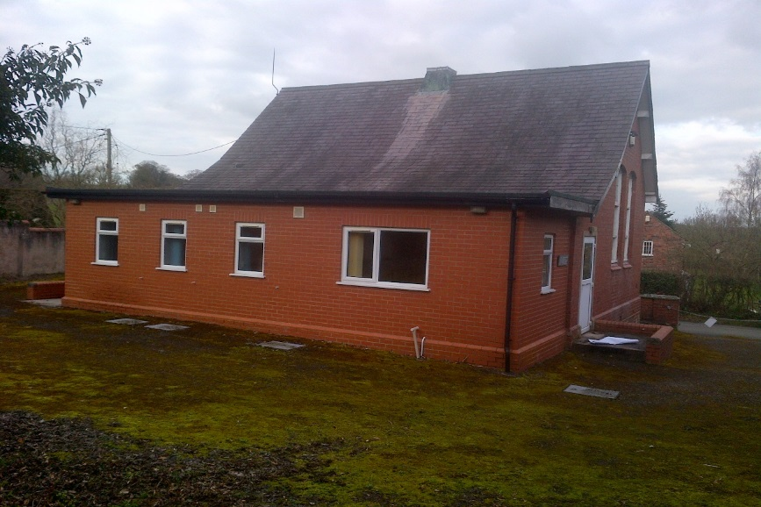
Figure 4 - REAR ELEVATION
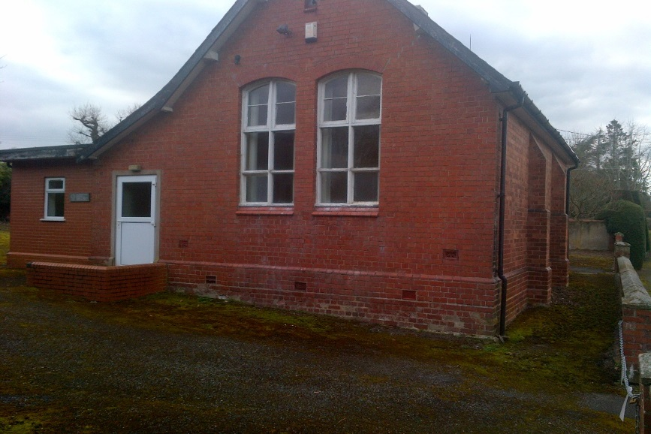
Figure 5 SOUTH EAST ELEVATION
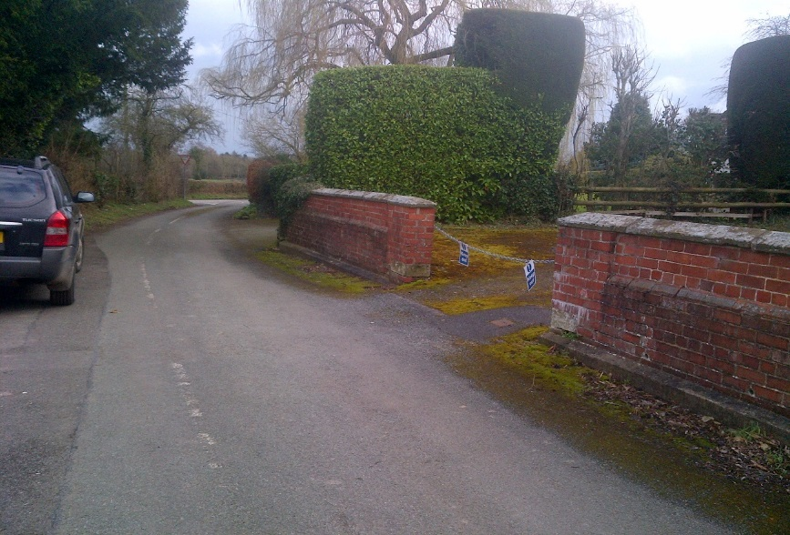
Figure 6 EXISTING VEHICULAR ACCESS
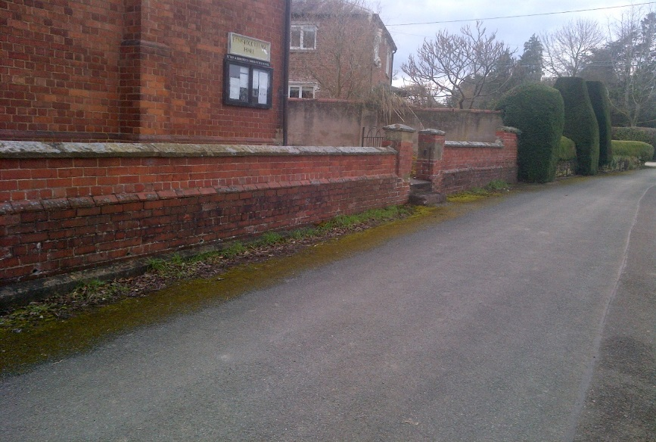
Figure 7 EXISTING PEDESTRIAN ACCESS GATE
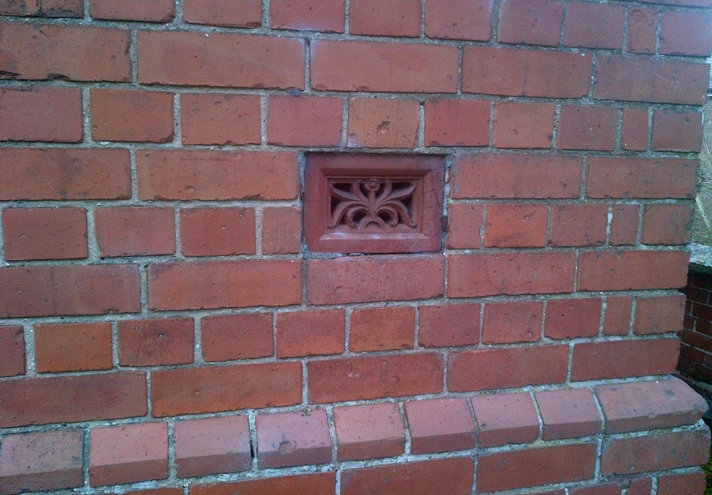
Figure 8 EXAMPLE OF FEATURE AIR BRICK (TO BE RETAINED)
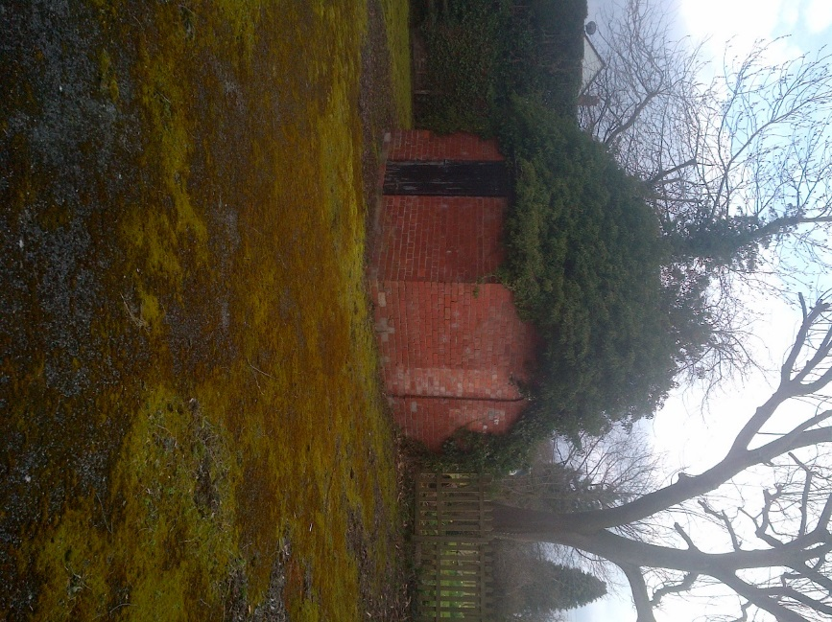
Figure 9 EXISTING OUTBUILDING

