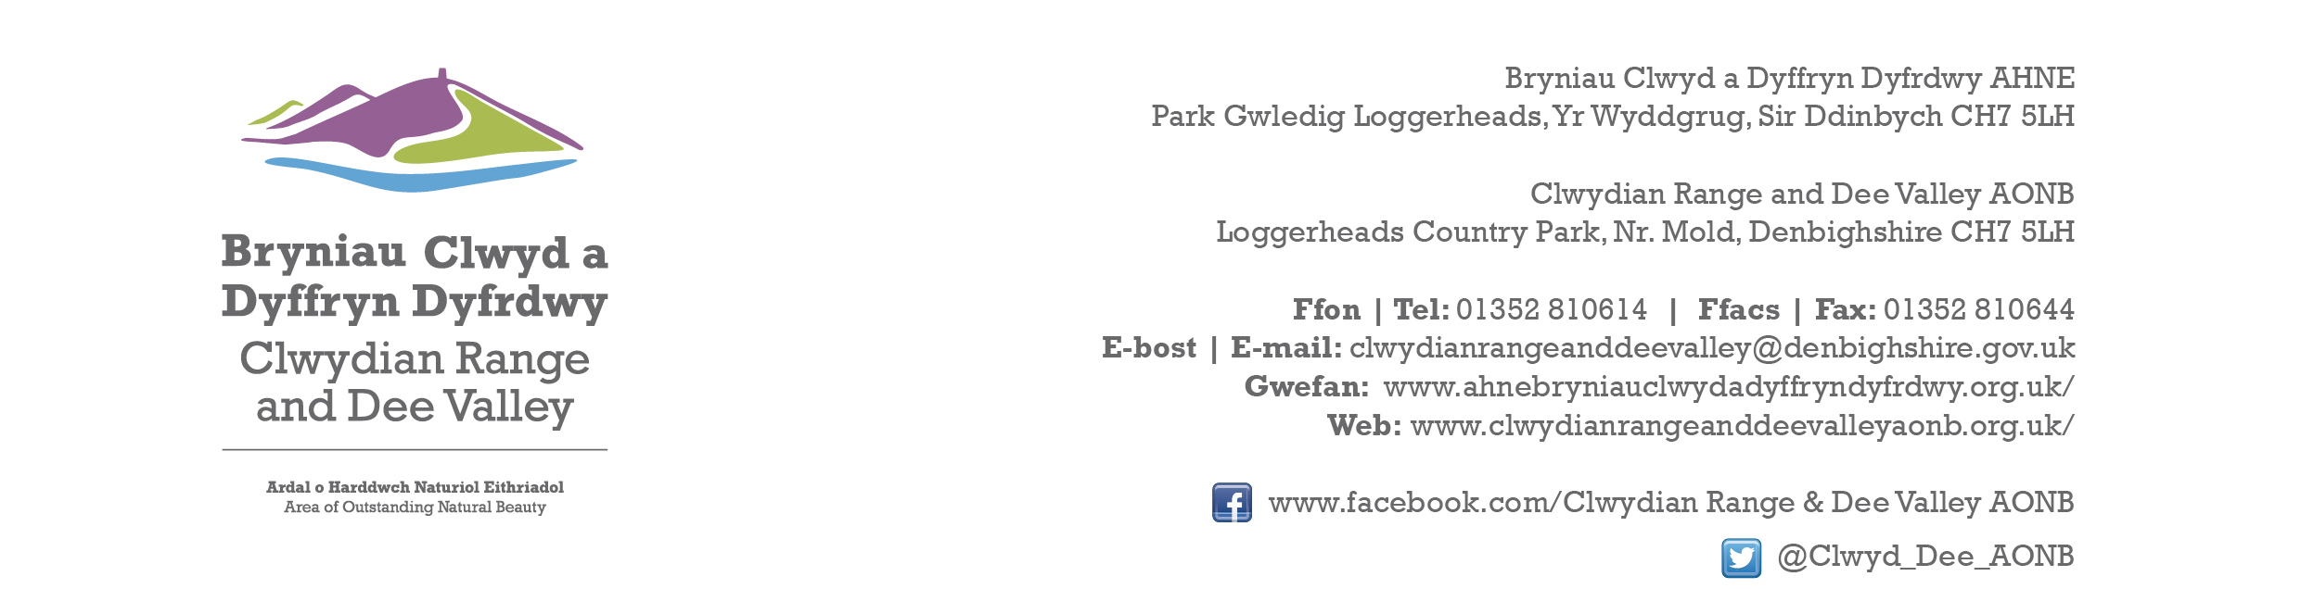

Ref P/2024/0068
Dyddiad | Date: 22nd February 2024

Simon Greenland
Economy and Planning
Wrexham County Borough Council
Guildhall
Wrexham
LL11 1AY

Dear Simon,

PROPOSAL: Partial Demolition of Store and Erection of Replacement Office/Store

LOCATION: Bryntirion, Penygraig, Froncysyllte

Thank you for consulting with the Joint Committee on this application. The following observations are submitted on behalf of the Joint Committee.

Given the location the proposed development will not have any adverse impact upon the character and appearance of the AONB. However, it is requested that all external finishes use recessive colours and non-reflective materials. Subject to an appropriate condition to address the above the Joint Committee raise no objections.

I would be grateful if you could take account of the committee’s views when deciding this application.

Yours sincerely,

Dave Williams
AONB Planning Advisor
For the Clwydian Range and Dee Valley AONB Joint Committee

