Design and Access Statement for replacement windows in a conservation area

Replacement to be made at 43 Ruabon Road Wrexham LL13 7PL

Application Outline

- This application is for replacement of the current front windows at 43 Ruabon Road which is a detached property built in the early Victorian period.

- The property is within the conservation area and not listed.

- The proposal is to replace all the windows shown on the front elevation with casement windows. The windows will be painted in the same colour.

- The windows are the same dimensions as the windows they’re replacing.

- The design specification for all windows has already been supplied

- The current windows were replaced in the early 1980s, are single glazed with timber frames.

- The frames have been repaired a number of times with wood filler and are now in very poor condition with some windows cracked.

- Being in the conservation area, planning has insisted on timber frames as this would be in keeping with the property and the conservation area.

- The replacement windows have been designed to match the style of the existing windows.

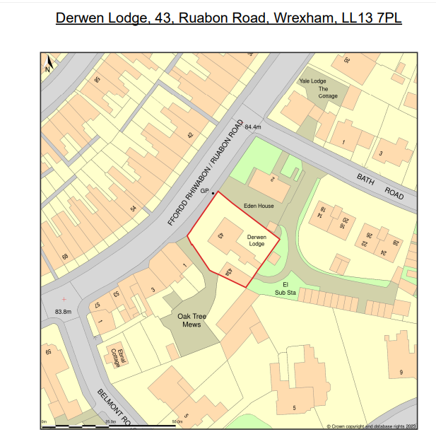
Property for which planning permission has been sought shown in red. Access can be gained via the side of the property which has its own driveway.

Front Elevation

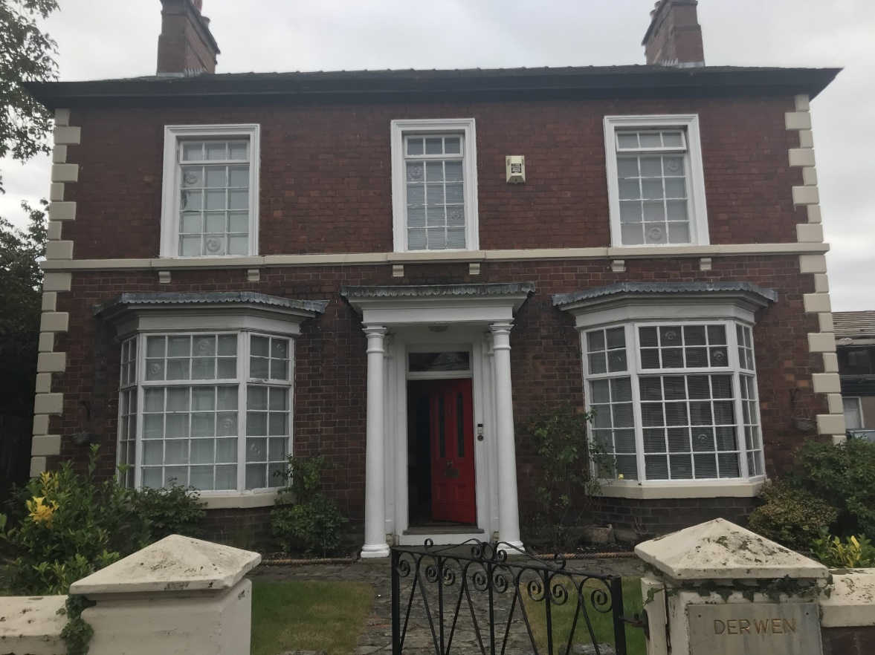

View of front of property from Ruabon Road

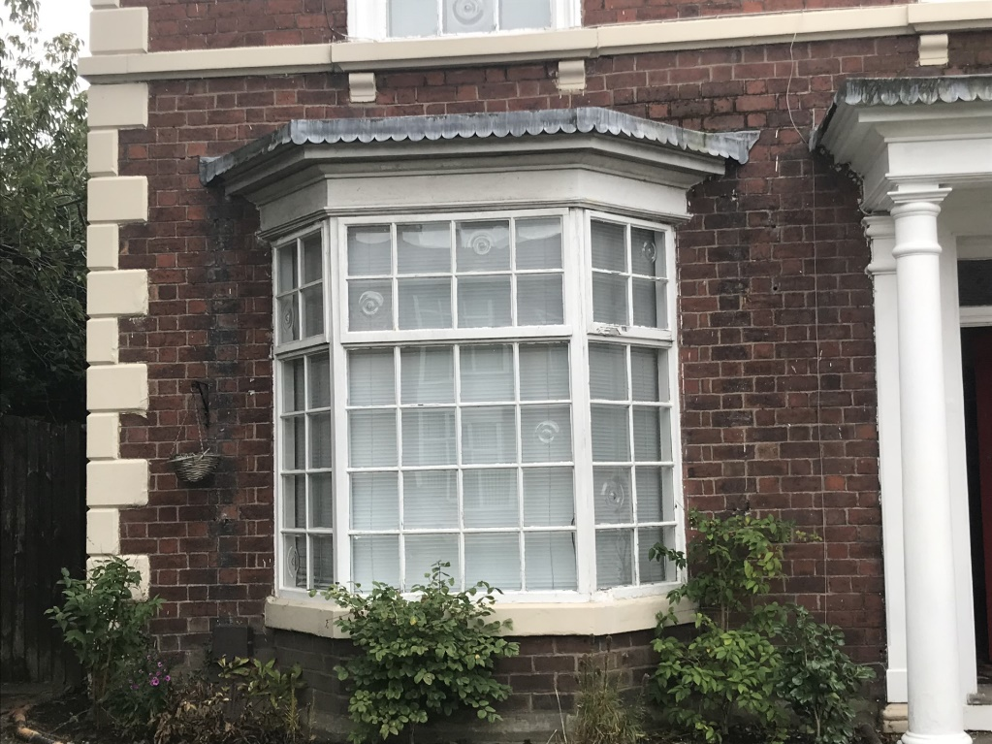

Left side bay window

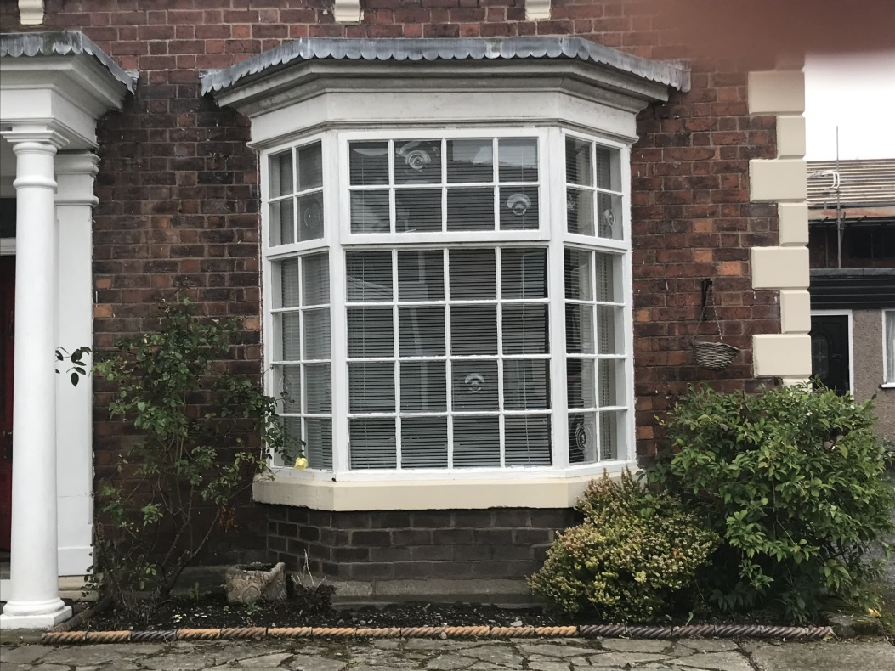

Right side bay window

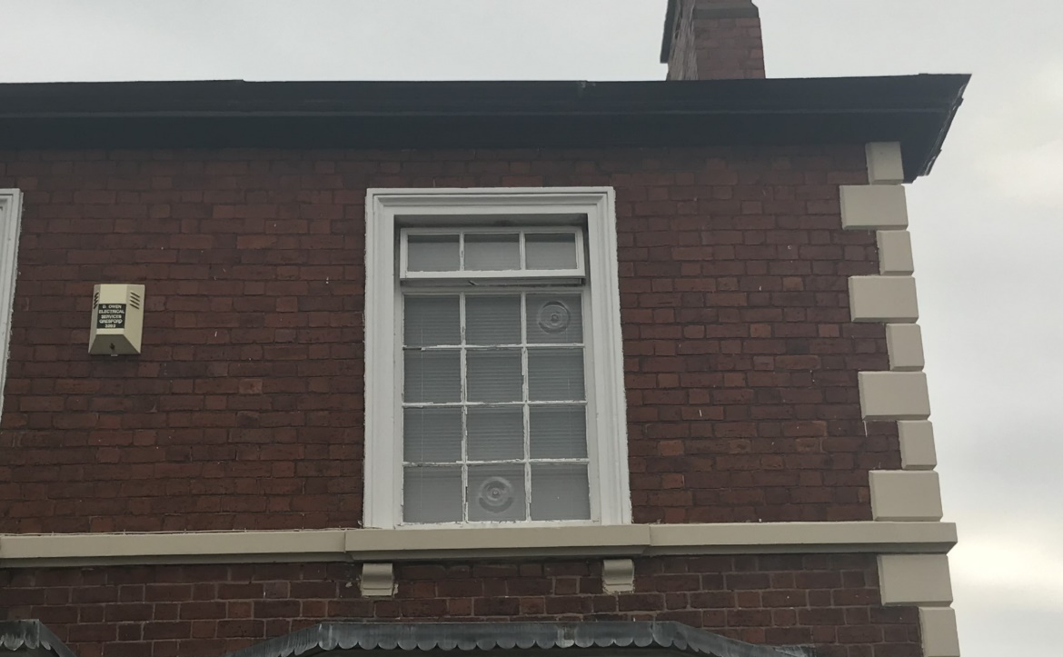
Right side upper window

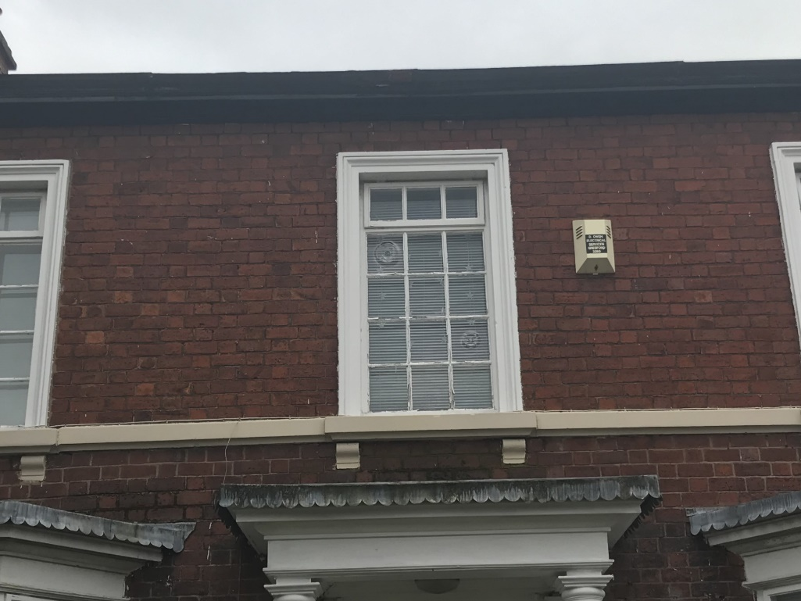

Left side upper window

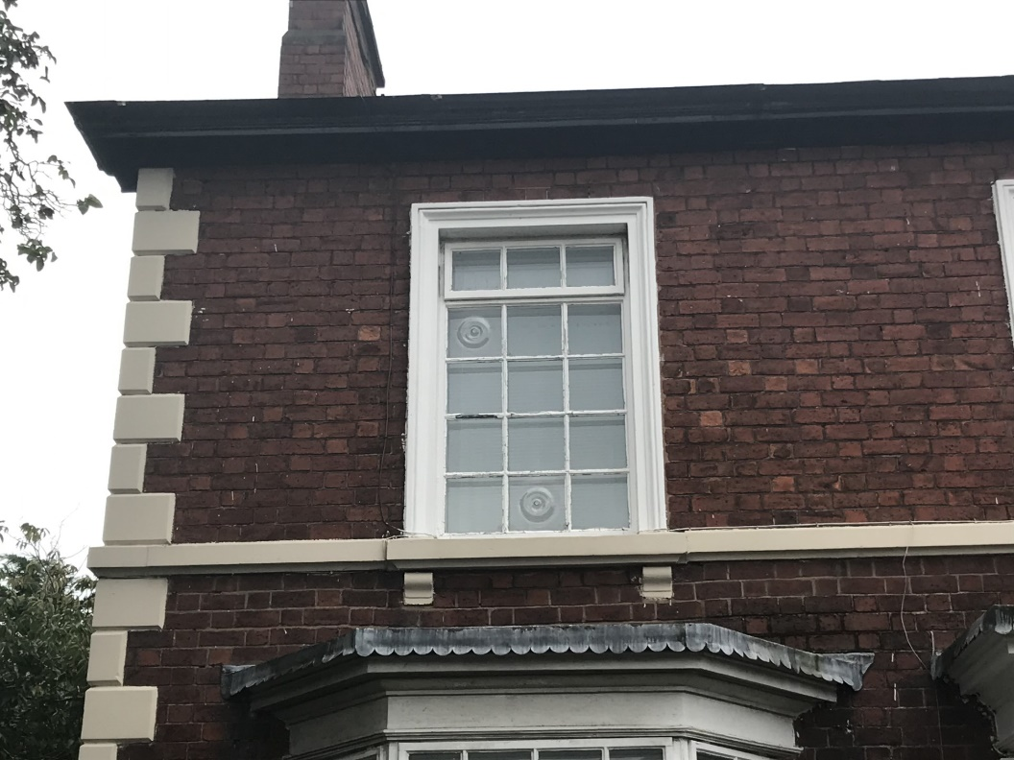
Middle upper window

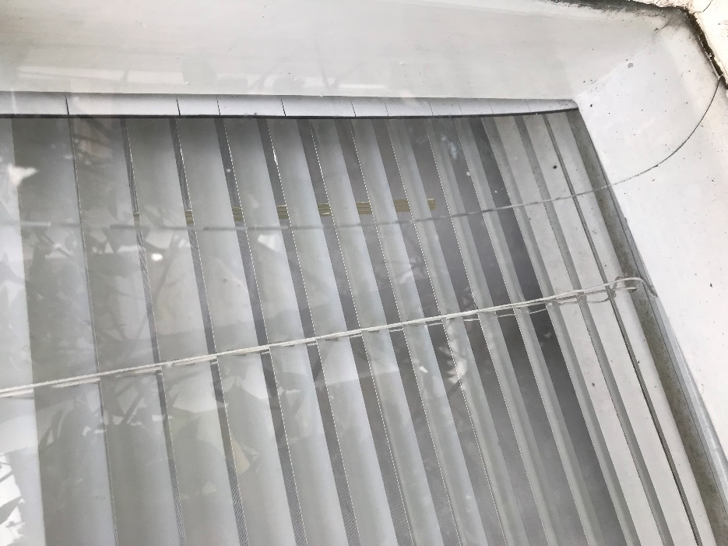
Current state of windows
Cracked window

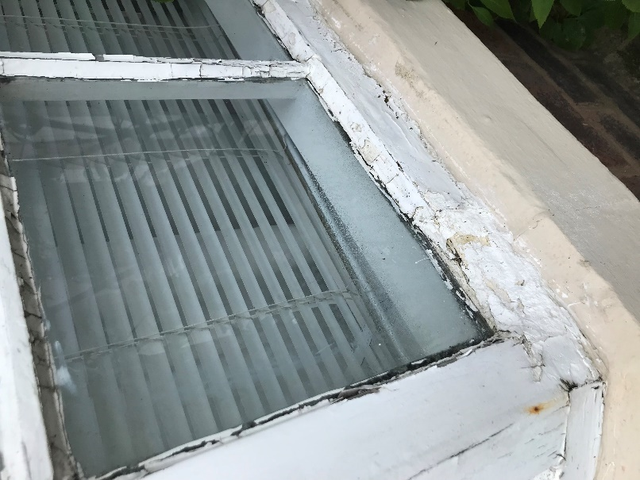
Rotten window frame

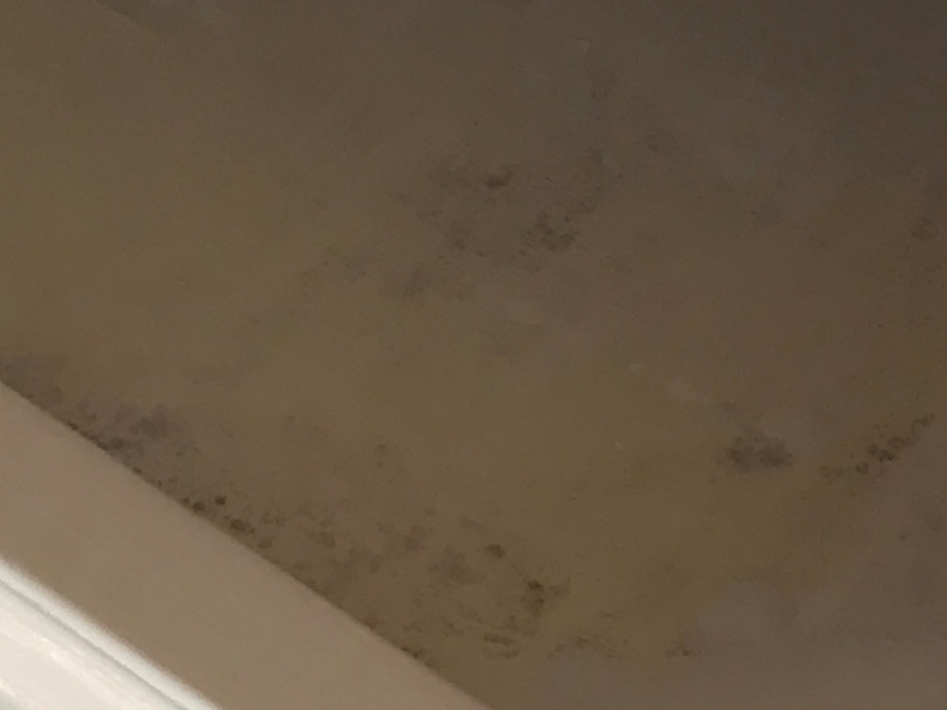
Mould on internal walls below window

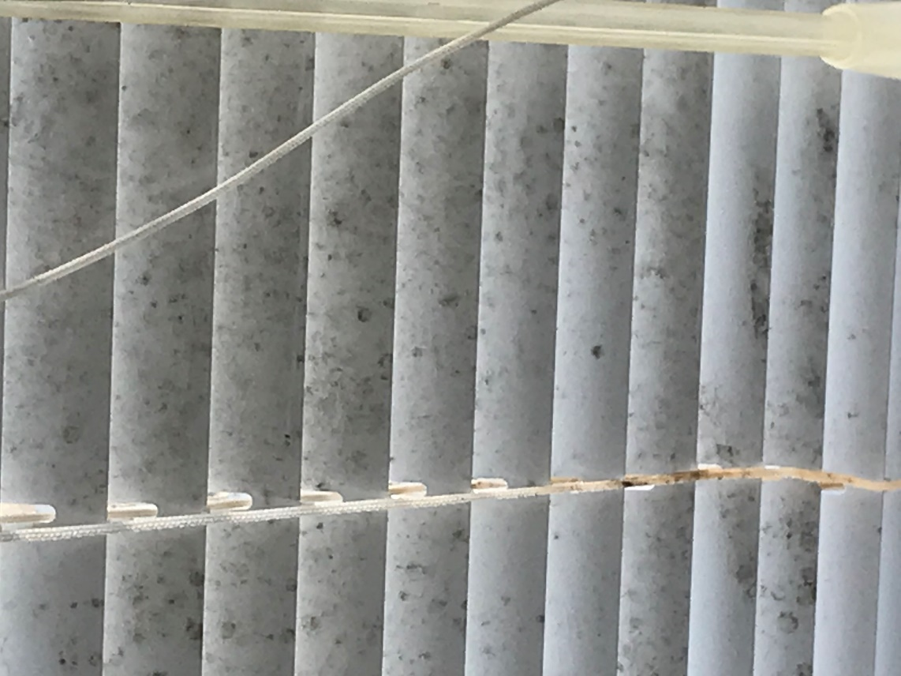
Mould on blind in spite of constant cleaning

- Front openers no longer open leading to moisture in the air becoming trapped and mould developing on walls.

- In the winter the dehumidiyer is on 24 hours a day and has recorded a moisture level of 80% in the living room.

- Rotten frames let in moisture when it rains and this, together with condensation has led to a great deal of mould around the blinds and on the wall under the window.

- The existing single glazed windows have a poor thermal performance. Double glazed windows will be much more energy efficient and help reduce gas used for heating the property

- Replacement of existing windows will enhance the overall look of the property and improve environmental impact.

