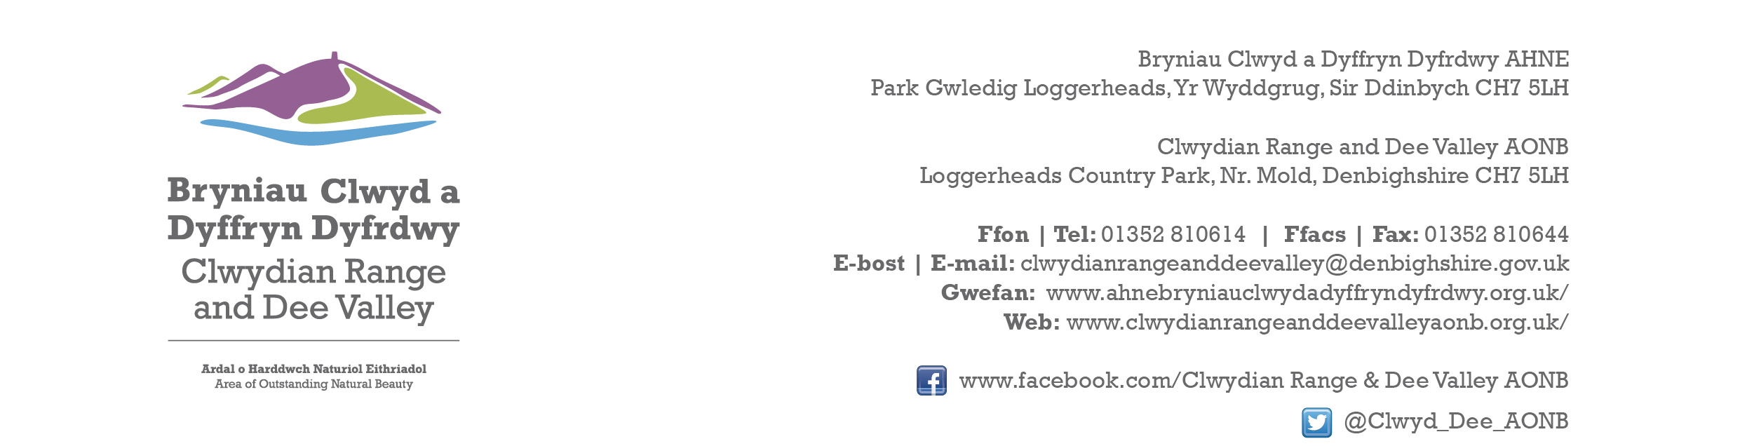

Ref P/2023/0874
Dyddiad | Date: 10th January 2024

Jenni Perkins
Economy and Planning
Wrexham County Borough Council
Guildhall
Wrexham
LL11 1AY

Dear Jenni,

PROPOSAL: Single Storey side and rear extension ans extension of existing balcony

LOCATION: Aqueduct Inn, Gate Road, Froncysyllte

Thank you for consulting with the Joint Committee on this application. The following observations are submitted on behalf of the Joint Committee.

The proposed development will not have any adverse impact upon the character and appearance of the AONB. However, it is requested that the use of a recessive colour and non-reflective materials are used as the structure will be visually prominent from Gate Road.

I would be grateful if you could take account of the committee’s views when deciding this application.

Yours sincerely,

Dave Williams
AONB Planning Advisor
For the Clwydian Range and Dee Valley AONB Joint Committee

