Internal and External photographs of charging point location

Photo A + B Showing current location of where charge point to be located:

A – Please note steam outlet (highlighted via arrow) corresponds with upper border of boiler in photo B.
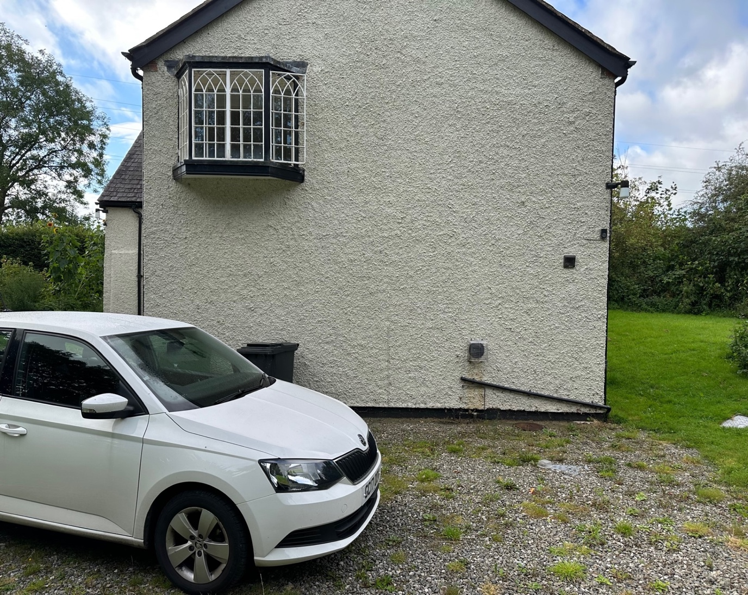

B – Please note distribution board located in cupboard on the floor in foreground, and boiler located against wall. Tip of steam outlet visible behind boiler.
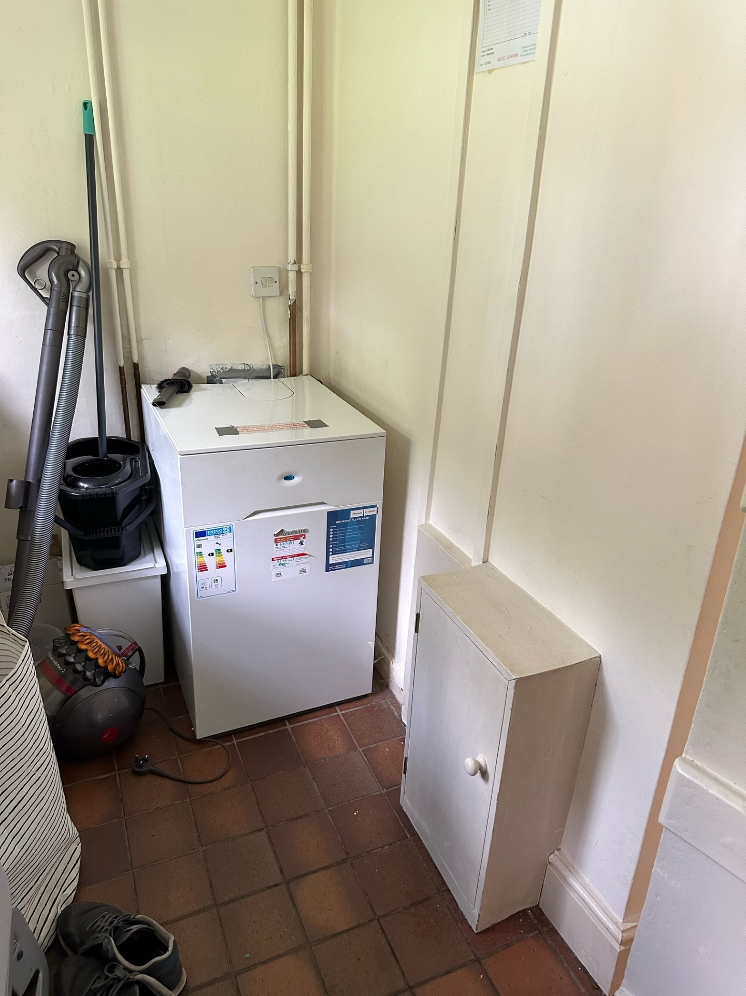

Plan of wiring run from distribution board to EVC

Photo C – Please note the red line represents the wiring run from the distribution board. The cable is 6mm and 5 cable clips will be required to secure cable along wall which will involve 5no 6mm holes drilled internally.

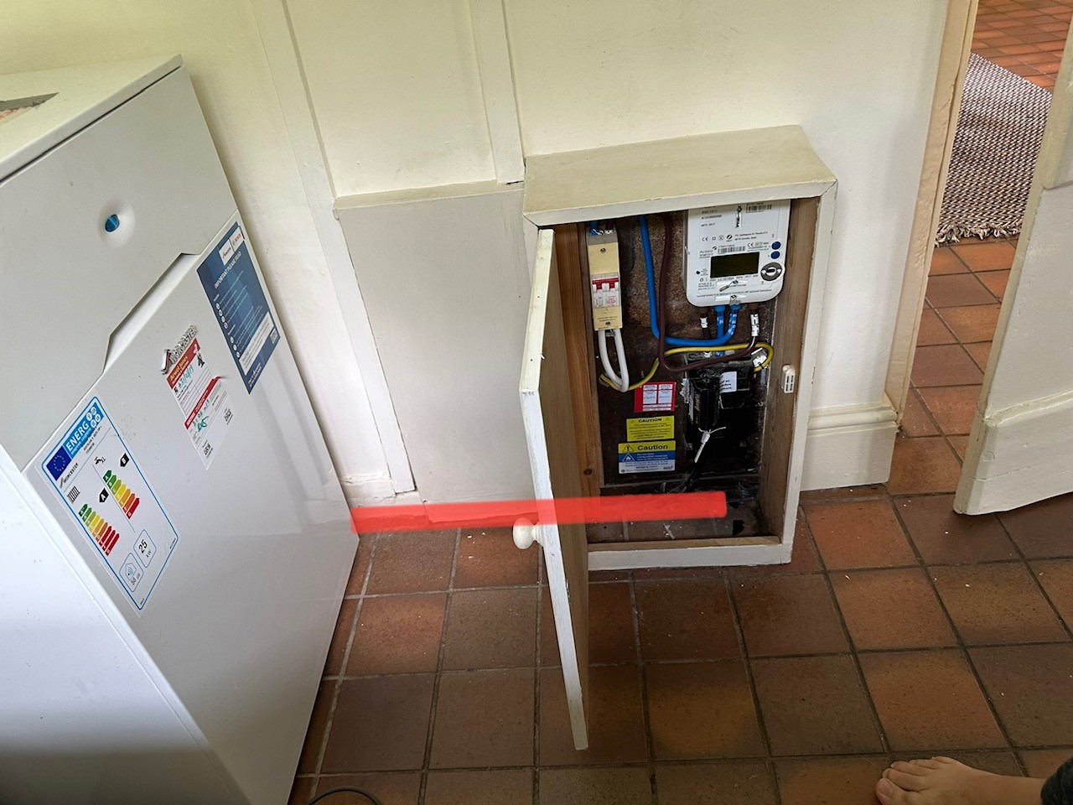

Photo D – This shows the continuation of the wiring run. Please note the size of wiring line used here is for easy clarity of wiring run. It does not represent size of cable which is 6mm.
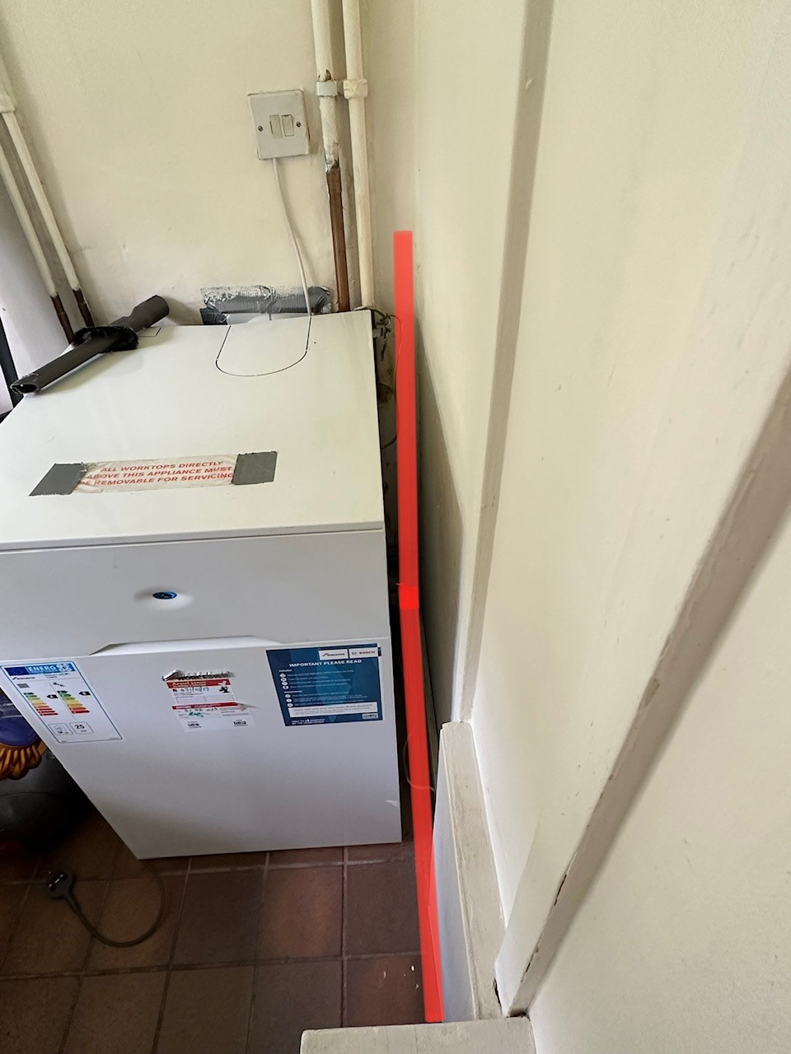

Photo E – The red mark shows the position of proposed EVC charge point and the space taken by finished EVC charge point.

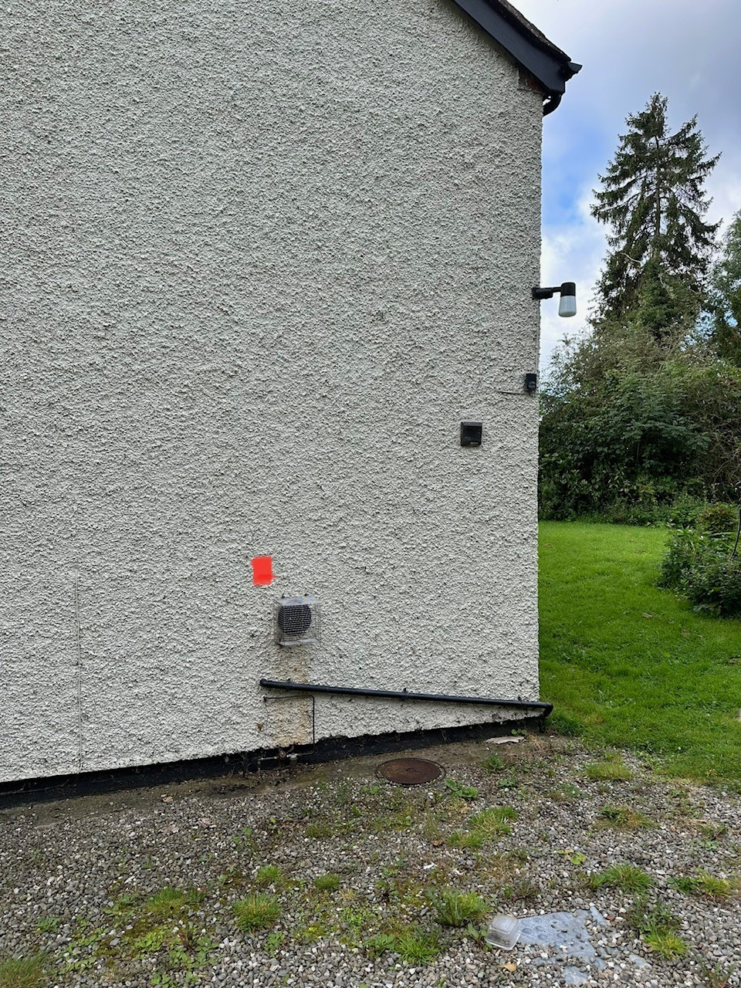

Fixing the EVC to the building
• As aforementioned - Run a 6mm supply cable no longer than 2m in length. 5 cable clips will be required to secure cable along wall which will involve 5no 6mm holes drilled internally.
• Drill a 22mm hole through the gable wall and pass the cable directly through it.
• Attach the charging unit on the external gable wall directly over the cable allowing back entry. This would be secured with 4no screws requiring us to dril 4no 6mm holes to fix the charger to the wall.

