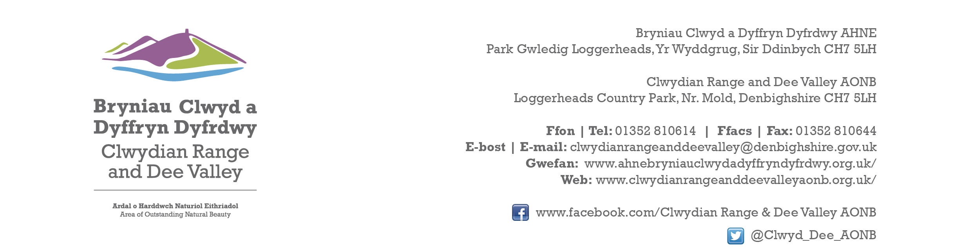

Ref P/2022/1080
Dyddiad | Date: 15th February 2024

Gwyn Humphries
Economy and Planning
Wrexham County Borough Council
Guildhall
Wrexham
LL11 1AY

Dear Gwyn,

PROPOSAL: Construction of New Access Road, Lorry Park, Weighbridge and Building, Car Park, Facilities block, Roundwood storage areas, 132 KV Substation and Ancillary works

LOCATION: Kronospan Ltd, Holyhead Road, Chirk, Wrexham

Thank you for re-consulting with the Joint Committee on this application. The following observations are submitted on behalf of the Joint Committee.

The Joint Committee’s objection to this application remains unchanged. The additional off-sit planting and proposed Woodland Management Plan and Conservation Plan do NOT address the Joint Committee’s previous concerns. Whilst the environmental/amenity benefits of an alternative new northern access are acknowledged, the scale of the extension into the open countryside is hugely disproportionate to what is required.

The extended area does not form a logical extension to the existing settlement limit. It is neither rounding off, or does it follow a natural physical form/feature/boundary and constitutes an unnatural spur of development into the open countryside. It would be seen as incongruous and would establish an undesirable precedent, increasing the vulnerability of land to the west of Afon Bradley ( closer to the AONB & WHS ) to further industrial development in future.

Whilst the existing Kronospan site is extremely large scale, it is nevertheless relatively well contained within the existing landscape setting. Approving this application would significantly compromise the existing relationship by adding an unnatural spur of development at the entrance to the village.

Had a scheme with minimal intervention been submitted for a new access road/lorry park with accompanying landscaping, the Joint Committee may well have supported it. As previously stated the application site area needs to be reduced by re-positioning the new roundabout closer to the village, reducing the incursion into open countryside. This would result in a more proportionate extension, creating a more natural rounding off of the settlement, with more opportunities for planting and more natural mounding, helping to assimilate the development into the landscape. At the very least the red outline of the application site boundary should be reduced to the new highway edge and any land immediately adjoining for screening purposes.

Leaving the application boundary as proposed will only encourage further incremental encroachment of industrial/storage development beyond the proposed lorry park down as far as the roundabout as currently shown on the submitted plans.

I would be grateful if you could take account of the committee’s views when deciding this application.

Yours sincerely,

Dave Williams
AONB Planning Advisor
For the Clwydian Range and Dee Valley AONB Joint Committee

