Arosfa
Fron Isaf
Chirk
Wrexham
LL14 5AH
Planning application reference: CHI P/2023/0344

Dear Sirs
Our recent application for retrospective planning permission for alterations made to the above property prior to our purchase of it in March this year was granted on 30th August subject to the condition that we submit a plan to provide net benefit for biodiversity to the Local Planning Authority.
The planning application related to works carried out between 2019 and 2022 by the previous owner and included significant landscaping of the garden, as was shown in the contrasting pictures from the 2019 and 2022 sales particulars supplied in the Heritage Impact Statement. The garden is set on a slope and has been arranged in three tiers. When we bought the property in March this year it had small lawned areas in each of the upper two tiers with flower beds and borders heavily planted with shrubs and flowering plants, a thick hedge mainly of hazel at the bottom, a couple of wooden raised beds and two overgrown fenced areas that had been used for keeping chickens. There is a concreted patio area next to the house and a concrete path separating the top two tiers, with stone walls edging the paths and the flower beds, brick steps leading down past the old stone shed and grassed pathways in the bottom section. There is also a separate small plot of land belonging to the property below the car parking area, which had been gravelled over for further parking.
On our arrival the garden was already well planted with flowering plants, bushes and trees and was well populated with wildlife. During the seven months we have lived here we have sought to improve this biodiversity by digging a nature pond, setting up two bird feeding stations, placing an insect hotel, enlarging the composting area at the foot of the garden, and returning the gravelled area to grass and planting seven young fruit trees. Whilst we have cleared weeds in some areas, we have left ‘wild’ patches around the edges of the garden with plenty of nettles and ivy due to their benefits to wildlife, and have allowed most weeds to stay at least until they have finished flowering. We also refuse to use any pesticides, weed killers or other chemicals, instead removing anything unwanted by hand, and using companion planting and netting to protect our vegetables. In the additional plot of land we will allow the grass to grow into a meadow for our new little orchard, and as the weeds die back along its bank we plan to clear most of it and plant a grass and wildflower mix in the spring, while leaving a comfrey, nettle and bramble hedge at the top. We have planted only native plants in and around our pond, made sure there is a shallow end for getting out, created a boggy area at one side and placed a small pile of logs for shelter.
We have seen the following birds in the garden so far: sparrows, goldfinches, blue tits, great tits, coal tits, robins, dunnocks, blackbirds, jackdaws, woodpigeons, chiffchaffs, wrens, great spotted woodpeckers, nuthatches, chaffinches, greenfinches, siskins, one blackcap, one magpie and on a couple of occasions a sparrowhawk. All through the spring and summer there have been several broods of fledgling sparrows, tits and goldfinches, plus at least a couple of juvenile woodpeckers, and some of the sparrows nest under the eaves of the house. Most evenings at dusk we see a couple of bats flying up and down outside the house, and we think they may be living in the roof.
For butterflies we have recognised small & large whites, orange tips, small tortoiseshells, peacocks, red admirals, commas, painted ladies, speckled woods, plus around May-June large numbers of scarlet tiger moths. We have had large numbers of bees of many types - although we are not competent at identifying species we have noticed lots of red-tailed and white-tailed bumbles bees – plus other pollinators, and have large patches of lavender and mint in particular which have been covered in them all through the summer. We have also seen hedgehogs, wood mice, a frog, a couple of toads, and grey squirrels (of course) in the garden, and a female emperor dragonfly by the pond.
The large garden and the beauty of the area were our strongest motivations for moving here, and we intend to do all we can to encourage wildlife and improve biodiversity within the garden. There have been no internal alterations that would negatively impact local biodiversity, while externally the garden had been much improved from the relatively barren area that it had been formerly, and we have sought to build on that. Additionally we are returning the extra plot of land from a relatively dead area to a nature-rich and wildlife-friendly zone, and hope that by next summer this will be well under way. If there is more that you feel we could do, please do not hesitate to let us know.

Yours faithfully,
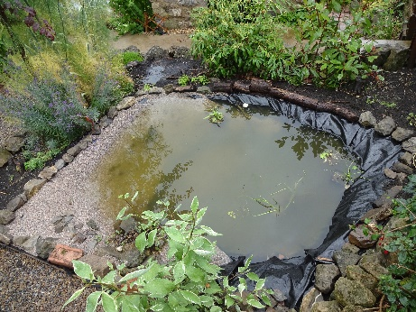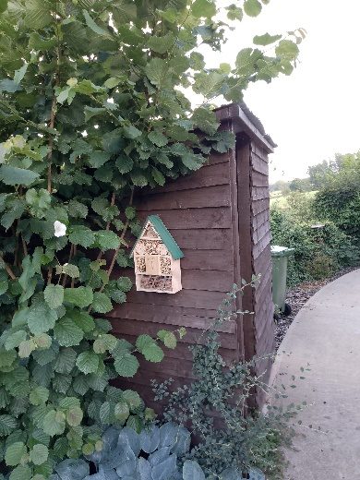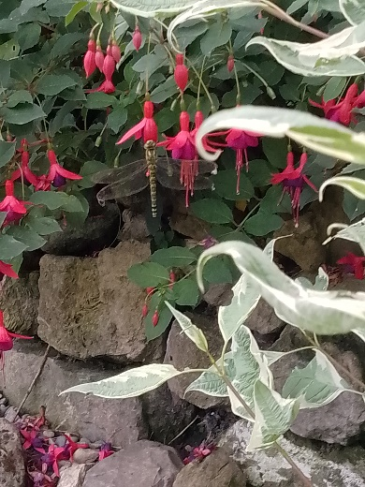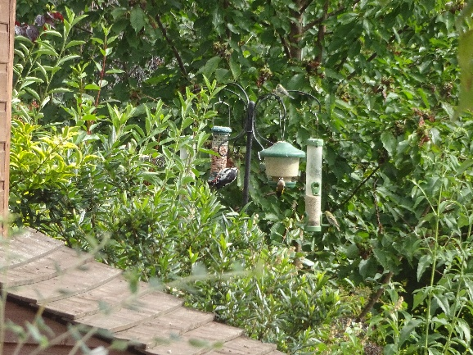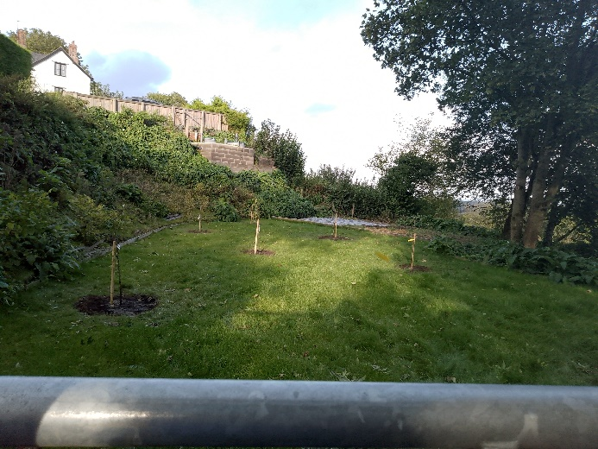
Pond; Bug Hotel: Dragonfly above pond; Bird feeders; Orchard area

