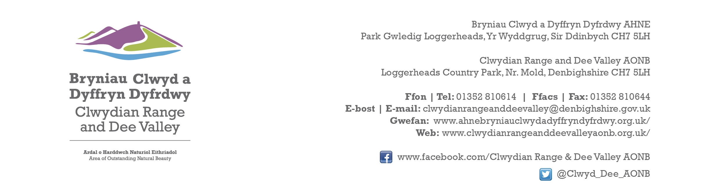

Ref P/2022/1080
Dyddiad | Date: 7th August 2023

Jenni Perkins
Economy and Planning
Wrexham County Borough Council
Guildhall
Wrexham
LL11 1AY

Dear Jenni,

PROPOSAL: Construction of Roof over existing sheep handling system.

LOCATION: Plas Yn Fron, Bronwylfa

Thank you for consulting with the Joint Committee on this application. The following observations are submitted on behalf of the Joint Committee.

The Joint Committee raise no objections to this application. The existing building lies within close proximity of other large agricultural buildings and the erection of a roof will be seen within the same visual context of the existing farm complex. Given these circumstances the proposed development will not have any adverse impact upon the character and appearance of the AONB. However, it is requested that the use of a recessive colour and non-reflective material be used.

I would be grateful if you could take account of the committee’s views when deciding this application.

Yours sincerely,

Dave Williams
AONB Planning Advisor
For the Clwydian Range and Dee Valley AONB Joint Committee

