For the Attention of: Amy Brittain – Case Officer
Wrexham County Borough Council

[By Email: planning@wrexham.gov.uk]

7th November 2023

Dear Ms Brittain

PLANNING APPLICATION: P/2023/0630

OUTLINE APPLICATION FOR ERECTION OF UP TO 6 DWELLINGS (ALL MATTERS RESERVED); Land Opposite Royal Oak Cottages, Brynydd, Ponciau, Wrexham

Thank you for your consultation notification of 17 October 2023 seeking the views of The Coal Authority on the above planning application.

The Coal Authority is a non-departmental public body sponsored by the Department of Business, Energy & Industrial Strategy. As a statutory consultee, The Coal Authority has a duty to respond to planning applications and development plans in order to protect the public and the environment in mining areas.

The Coal Authority Response: Fundamental Concern

I have reviewed the site location plans, the proposals and the supporting information submitted and available to view on the LPA website. I can confirm that the site falls within the defined Development High Risk Area.

The Coal Authority records indicate that there is a recorded mine entry reference 329346-259 and its potential zone of influence located within the northern part of the site. We hold no treatment details for any of this feature and its recorded position may be subject to significant departure. Untreated mine entries also pose a potential risk to surface stability and public safety.

The Coal Authority records that the site is in an area of historic recorded and likely unrecorded coal workings at shallow depth. Voids and broken ground associated with such workings can pose a risk of ground instability and may give rise to the emission of mine gases.

We note that this application is accompanied by a Mining Investigation Report (1714) prepared by Nkc Geotech Ltd, dated 29th June 2017; however, we do not consider that this adequately addresses the impact of coal mining legacy on the proposed development and we therefore object to the proposal.

We must highlight that the report has been produced to inform a residential development proposal on a separate parcel of land to the west of Bryndd Road, beyond the current applications site. It clearly does not relate to the location of development currently proposed.

In light of the above and in accordance with the agreed risk-based approach to development management in the defined Development High Risk Areas, the applicant should be informed that they need to submit a site and development specific Coal Mining Risk Assessment Report to support the current planning application proposal. This assessment should be prepared by a suitably qualified person. Without such a risk assessment, the Coal Authority does not consider that the LPA has sufficient information to determine this planning application.

We take this opportunity to highlight that the Coal Authority is of the opinion that building over, or within the zones of influence, of mine entries should be avoided wherever possible, even after they have been treated, in line with our adopted policy which can be found at:
https://www.gov.uk/government/publications/building-on-or-within-the-influencing-distance-of-mine-entries

It should be considered by the applicant and their technical consultants that the proposed development for up to 6 dwellings can be accommodated on the site taking account of the potential location of the mine entrie and its potential zones of influence.

Please do not hesitate to contact me if you would like to discuss this matter further.

Yours sincerely,

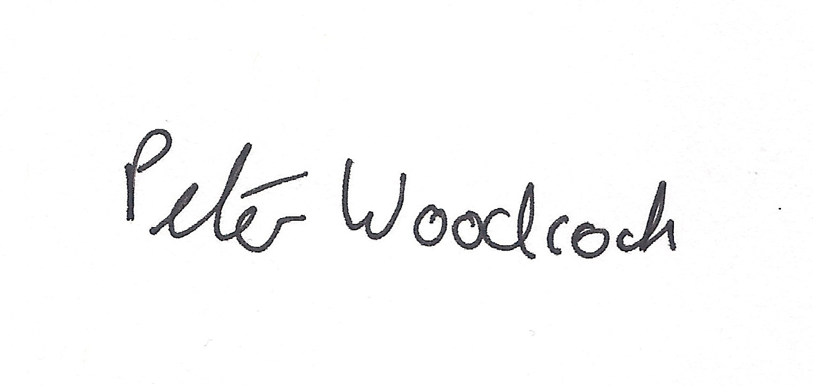
Peter Woodcock | BSc (Hons)
Assistant Planning and Development Manager

General Information for the Applicant

A variety of Coal Mining Report products which provide baseline information on coal mining legacy risks are available from www.groundstability.com. A Coal Mining Risk Assessment should then take the information contained in the Coal Mining Report and interpret the risks identified specifically in relation to the proposed development.

This coal mining information you obtain from a Non-Residential Coal Mining Report, an Enviro-All-in-One Report or other factual report should then be used to assess whether or not past mining activity poses any risk to the development proposal and, where necessary, propose mitigation measures to address any issues of land instability. This could include further intrusive investigation on site to ensure that the Local Planning Authority has sufficient information to determine the planning application.

The Coal Mining Risk Assessment should be prepared by a “competent body”. Links to the relevant professional institutions of competent bodies and guidance on how to produce a Coal Mining Risk Assessment can be found at:
www.gov.uk/planning-applications-coal-mining-risk-assessments

Under the Coal Industry Act 1994 any intrusive activities which disturb or enter any coal seams, coal mine workings or coal mine entries (shafts and adits) require the prior written permission of the Coal Authority since these activities can have serious public health and safety implications. Such activities could include site investigation boreholes, excavations for foundations, piling activities, other ground works and any subsequent treatment of coal mine workings and coal mine entries for ground stability purposes. Failure to obtain permission to enter or disturb our property will result in the potential for court action. Application forms for Coal Authority permission and further guidance can be obtained from The Coal Authority’s website at: www.gov.uk/get-a-permit-to-deal-with-a-coal-mine-on-your-property.

Any form of development over or within the influencing distance of a mine entry can be dangerous and has the potential for significant risks if not undertaken appropriately. For more information with regard to this issue, the Coal Authority’s adopted policy, Development and Mine Entries, can be found here:
www.gov.uk/government/publications/building-on-or-within-the-influencing-distance-of-mine-entries

Disclaimer

The above consultation response is provided by The Coal Authority as a Statutory Consultee and is based upon the latest available data on the date of the response, and electronic consultation records held by The Coal Authority since 1 April 2013. The comments made are also based upon only the information provided to The Coal Authority by the Local Planning Authority and/or has been published on the Council's website for consultation purposes in relation to this specific planning application. The views and conclusions contained in this response may be subject to review and amendment by The Coal Authority if additional or new data/information (such as a revised Coal Mining Risk Assessment) is provided by the Local Planning Authority or the Applicant for consultation purposes.

In formulating this response The Coal Authority has taken full account of the professional conclusions reached by the competent person who has prepared the Coal Mining Risk Assessment or other similar report. In the event that any future claim for liability arises in relation to this development The Coal Authority will take full account of the views, conclusions and mitigation previously expressed by the professional advisers for this development in relation to ground conditions and the acceptability of development.

