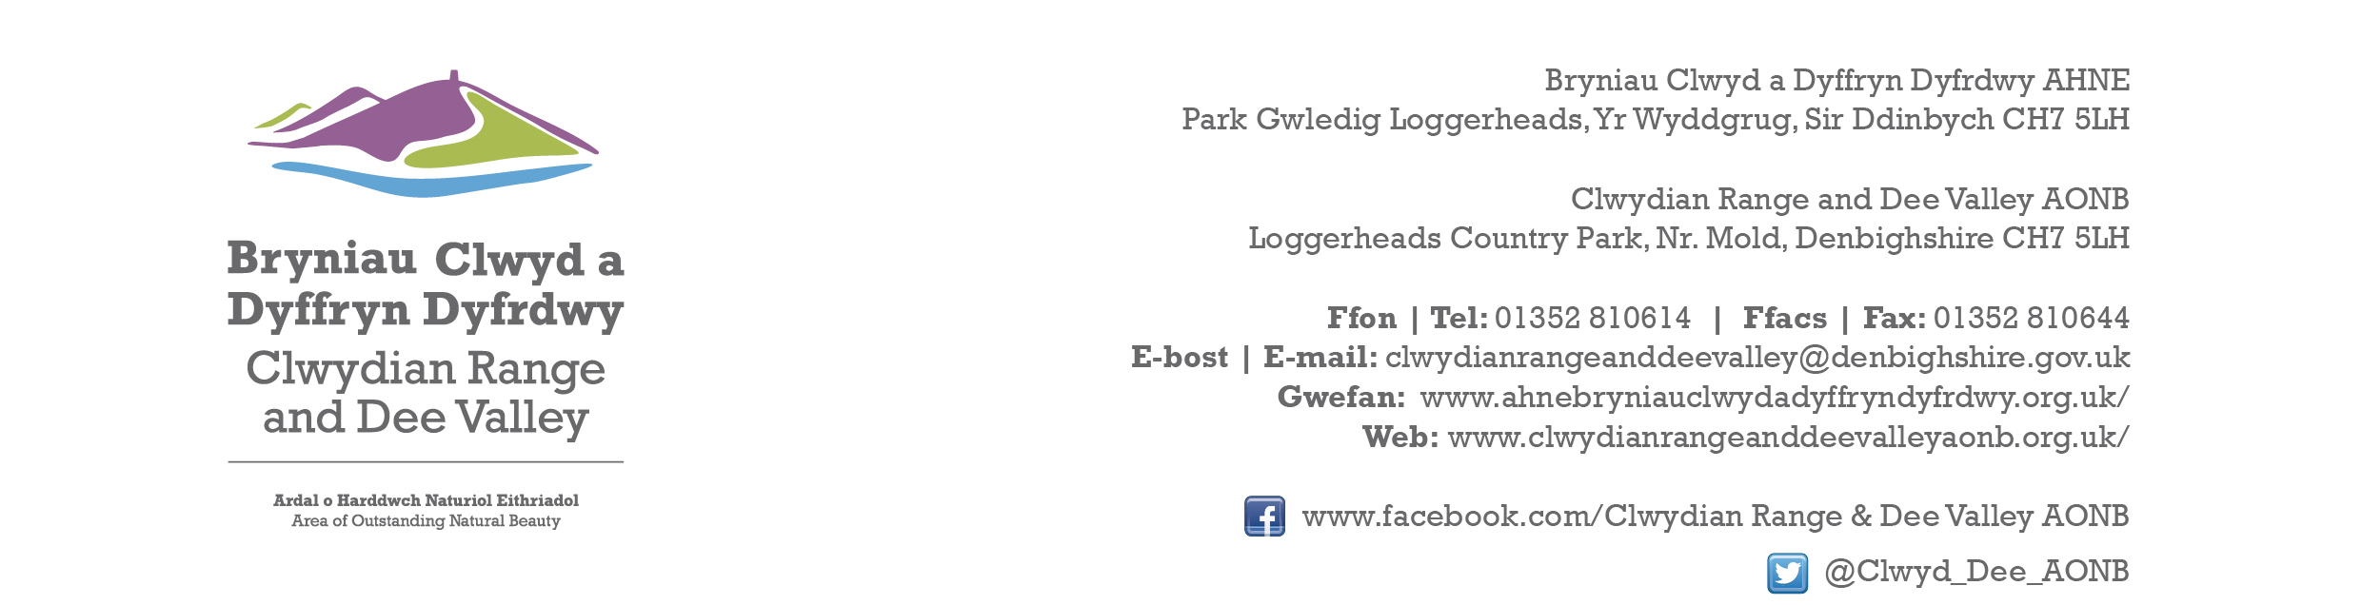

Ref P/2024/0008
Dyddiad | Date: 24th January 2024

Tyler Fox
Economy and Planning
Wrexham County Borough Council
Guildhall
Wrexham
LL11 1AY

Dear Tyler,

PROPOSAL: Installation of 1 Ground Mounted Solar Panel

LOCATION: Lyndene, Blackwood Road, Garth, Wrexham

Thank you for consulting with the Joint Committee on this application. The following observations are submitted on behalf of the Joint Committee.

The proposed development is relatively small scale and will not have any adverse impact upon the character and appearance of the AONB. The site is well screened from elevated viewpoints, but a condition should be imposed to retain the existing hedge at an appropriate height to mitigate the visual impact at lower levels.

Given that permission was granted and has since lapsed for an identical application in 2015, and that there have been no change in circumstances, the Joint Committee raise no objections.

I would be grateful if you could take account of the committee’s views when deciding this application.

Yours sincerely,

Dave Williams
AONB Planning Advisor
For the Clwydian Range and Dee Valley AONB Joint Committee

