
MEMORANDUM

From: Ian Jones To: Mathew Philips
Public Protection Service Manager Planning Control Manager

Our Ref: Your Ref: P/2023/0570

Date: 19-10-23

Town and Country Planning Act 1990
Town and Country Planning (General Development Procedure) Order 1996
Re: P/2023/0570, 5 Church Street, Wrexham, LL13 8LS
CHANGE OF USE FROM A1 TO A3 TO PROVIDE EXTENSION TO RESTAURANT.

A34N - FOOD HYGIENE REGULATIONS

You are advised that the premises should comply with the relevant Food Hygiene Legislation, and you are advised to contact Council's Food & Farming Team on foodandfarming@wrexham.gov.uk or 01978 298989 for further advice and information.

ZP05 - NOISE GENERATION - NOISE LEVEL CONDITION

The rating level of any noise generated by reason of this development shall not exceed the pre-existing background level at any time. The noise levels shall be determined at nearby noise sensitive premises, and measurements and assessment shall be made in accordance with BS4142:2014 Methods for Rating and Assessing Industrial and Commercial Sound.
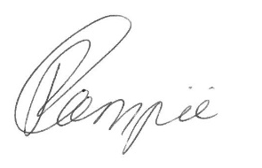

p.p.

Ian Jones

Public Protection Service Manager

