Arbour Cottage
Cadney Lane
Bettisfield
Whitchurch
Shropshire
SY13 2LW

Chief Planning Officer
Wrexham County Borough Council
16 Lord Street,
Wrexham,
LL11 1LG.

Tel: 01948 710575 / 07740814961
Email: peter-grayburn@btconnect.com

23rd October 2022

Dear Sir

Re: P2022/0869 – Cadney Lane, Bettisfield

I own and occupy Arbour Cottage, Cadney Lane, Bettisfield and have first-hand knowledge of the immediate area of the land in question as well as Bettisfield as a whole.

I am OBJECTING to this application on the following grounds:

General Points:

Throughout the application, the application refers to Bettisfield as a ‘rural Village’ (WCBC Tier 4 definition) but in fact is categorised by WCBC as a ‘Tier 5 Hamlet’ and as such is therefore deemed unfit for ‘sustainable’ development.

WCBC and Natural Resource Wales have already stated in the Development Plan (and previous refused planning applications in the village) that there should be no further development in Bettisfield due to (principally) the lack of mains drainage, very poor infrastructure and lack of amenities – a situation which remains the same to date.

The land is OUTSIDE WCBC’s development plan. (N.B. I am aware that the new Development Plan is not yet adopted and as confirmed by the Inspectorate in Cardiff, unless and until the new plan is adopted, the conditions of the existing Development Plan must still be enforced).

Application Form: Assessment of Flood Risk

The Applicant claims the site is not in an area of flood risk, yet the proposed site plan clearly shows at least one third of the site is in a high risk zone.

The Applicant claims the where is no water course with 20 metres of a water course yet there is such a water course only 10 metres from the site.

Page 1 of 3

Planning and Design Statement:

Section 3: The Applicant claims the proposed houses will be consistent with existing properties but quotes ridge heights of up to 9m which is indicative of three storey houses. No such properties exist in the Village, let alone on Cadney Lane, consequently this claim is simply not true.

Section 4: The Applicant refers to Wrexham Unitary Development Plan, notably Policy GDP1 (d) i.e. safety of vehicular and pedestrians - yet the proposed access to the site is directly off a narrow unlit lane with a (currently) 60 mph speed limit and no pavements (except a very short one in front of just two houses some way up the lane)

Section 2, 4 & 6.5 The Applicant appears to acknowledges that ‘infill’ sites should be ‘one and not more than two’ properties yet expects nine to be considered as ‘infill’

Section 4: The Applicant refers to various recent appeals in various area of Wales, none of which are local to Bettisfield or can be deemed as remotely similar to the factors affecting Bettisfield – these references are therefore irrelevant and should be ignored.

Section 6.3 The Applicant claims there is mains drainage on site. There is no mains drainage in or near the Village.

Sections 7 & 9 The Applicant claims residents would not have to rely on private cares or public transport. Given that there no facilities whatsoever in the Village, such a statement is simply onerous and totally misleading – residents are totally reliant on private cars or taxis.

Ecological Appraisal

This report is a so-called desk-top study and acknowledges that only one site visit has taken place which obviously an insufficient time period from which to draw wild life conclusions.

The ‘desk-top’ findings must also be read with a great deal of concern as it is clear that the research behind it is old and therefore not representative of the situation to-day. To illustrate – the author refers to the fact that only one sighting of a Great Crested Newt was recorded in 1999 about 1 km from the site. As WCBC are fully aware, Great Crested Newts featured heavily in the Nags Head Field situation almost up to present day and that field is less than 100 metres from this proposed development.

Foul Drainage Strategy

Section 2.1 States the access to the site is from the west of Cadney Lane yet the site is to the east. There is no explanation as to why there should be access to the side from the other side of the road within the needs of the Foul Drainage Stratagy

Section 3.1 states the drainage field should be at least 200m from other discharge to ground units. There is no scaling on the mapping, but it does appear that the proposed drainage ground is significantly closer than 200m to existing properties some (or all) of which have septic tank drainage.

The applicant acknowledges that a pump will be required – electricity supplies to Bettisfield can be somewhat ‘hit and miss’ and recent long term power outage has caused severe difficulty with other similar systems in Bettisfield. There is no reference to how such a power cut will be overcome with regards to the proposed system.

Page 2 of 3

Section 3.2 and 3.3 The proposed drainage system is based on an occupancy of 32 people (4 x 4 bedroom houses and 5 x 3 bedroom houses). There is no reference to the size of proposed houses in the application itself so it would appear this computation is pure speculation and therefore unreliable.

Appendix A Percolation Test: Some photographs are duplicated but given different headings thus not providing correct findings.

The above points are the principle factors behind my objection to this application. There are other incorrect or potentially misleading points which I have not listed but I trust the Planning Department will recognise and take into account and after due consideration, REFUSE this application.

Yours Sincerely
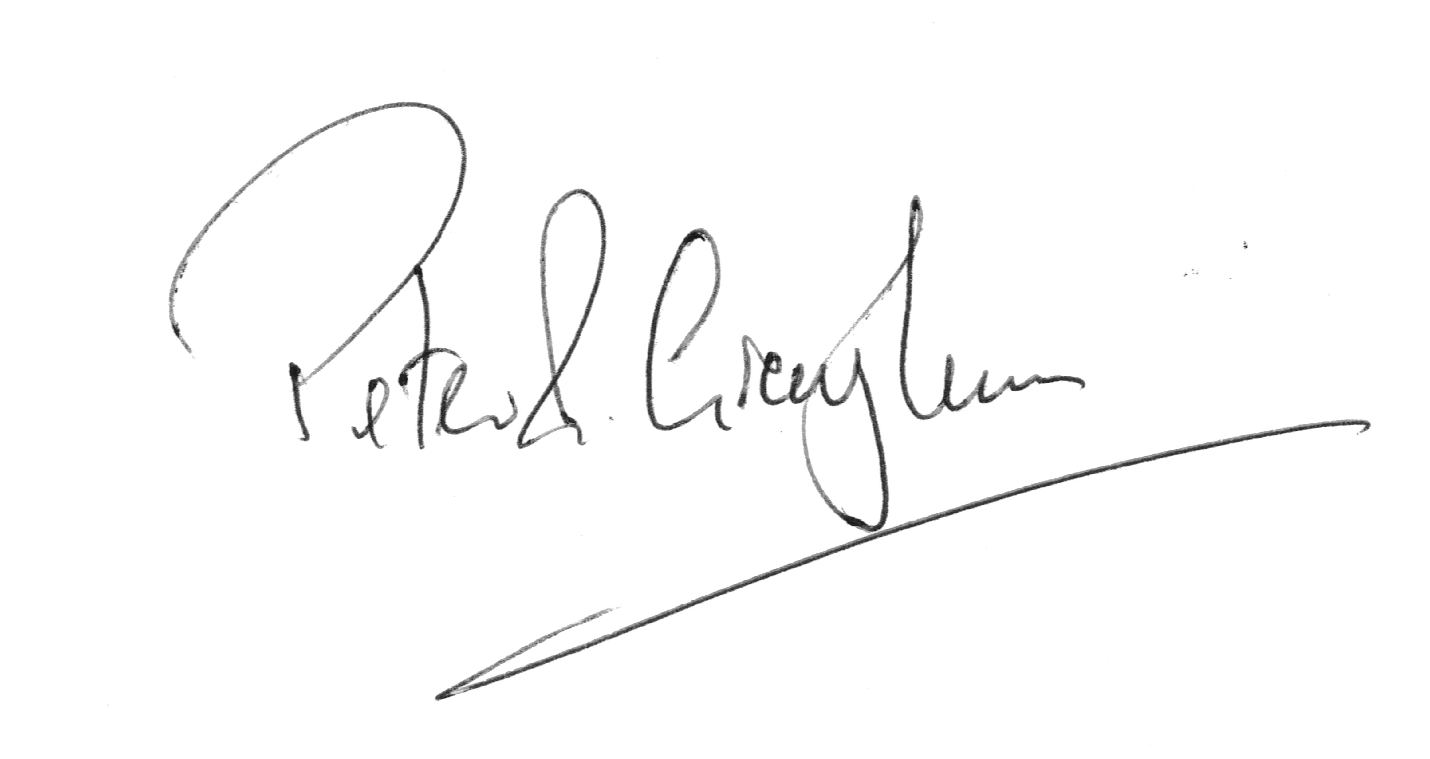
Peter R Grayburn

Page 3 of 3

