APPENDIX V

PHOTOGRAPHS OF THE INTERIOR OF THE FARMSHOP
BRYN-Y-PYS HOME FARM, WREXHAM ROAD, OVERTON, WREXHAM LL13 0HG
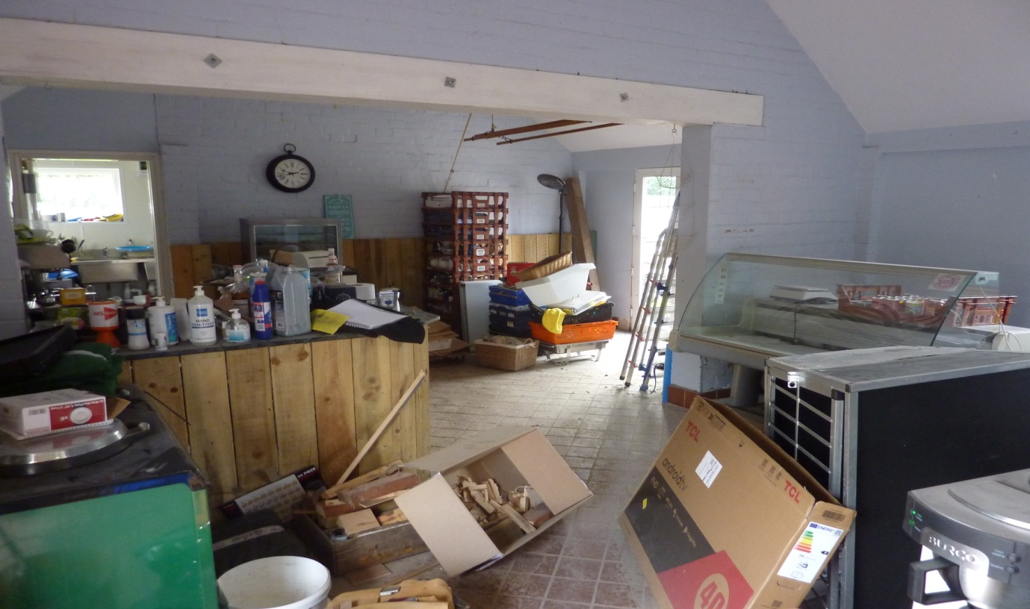
Picture of Farmshop Room
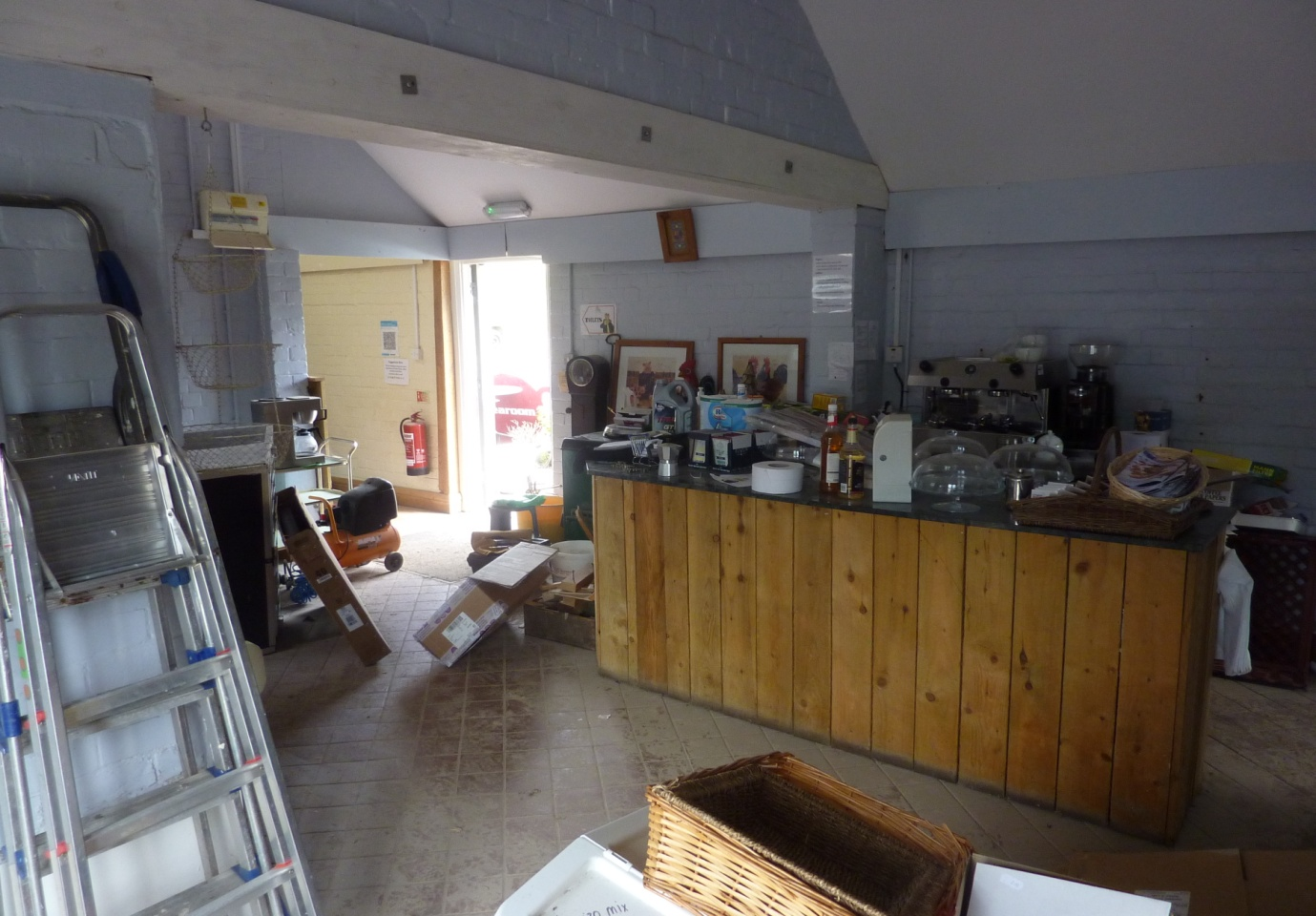
Picture of Farmshop Room
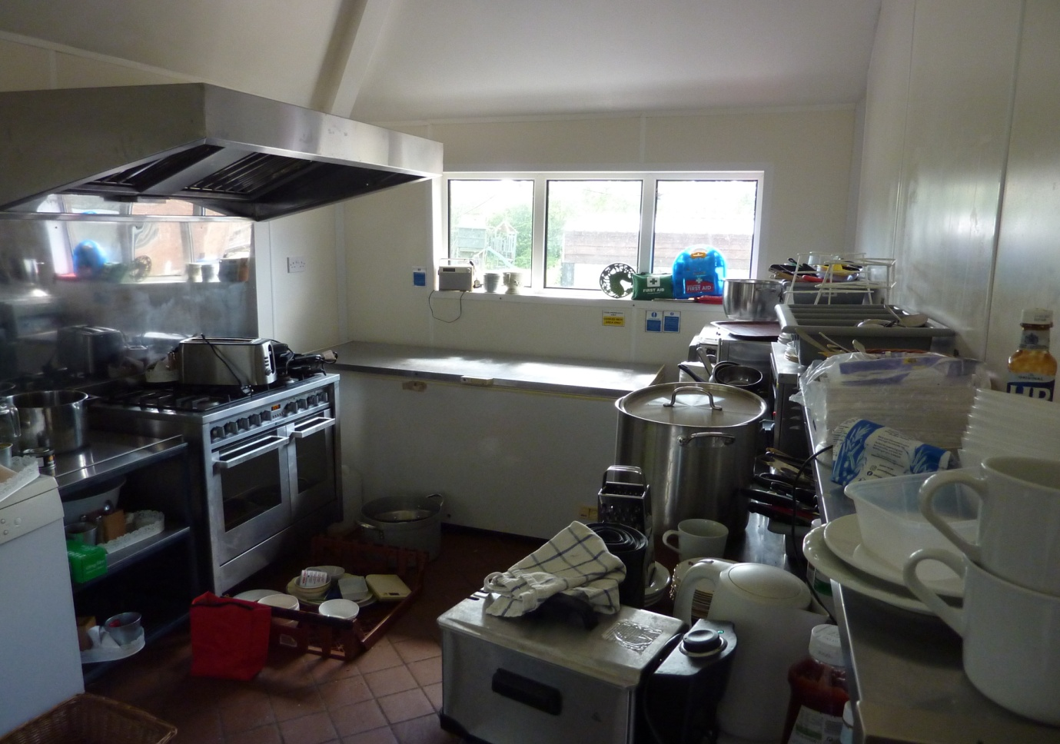
Photograph of Farmshop Kitchen.
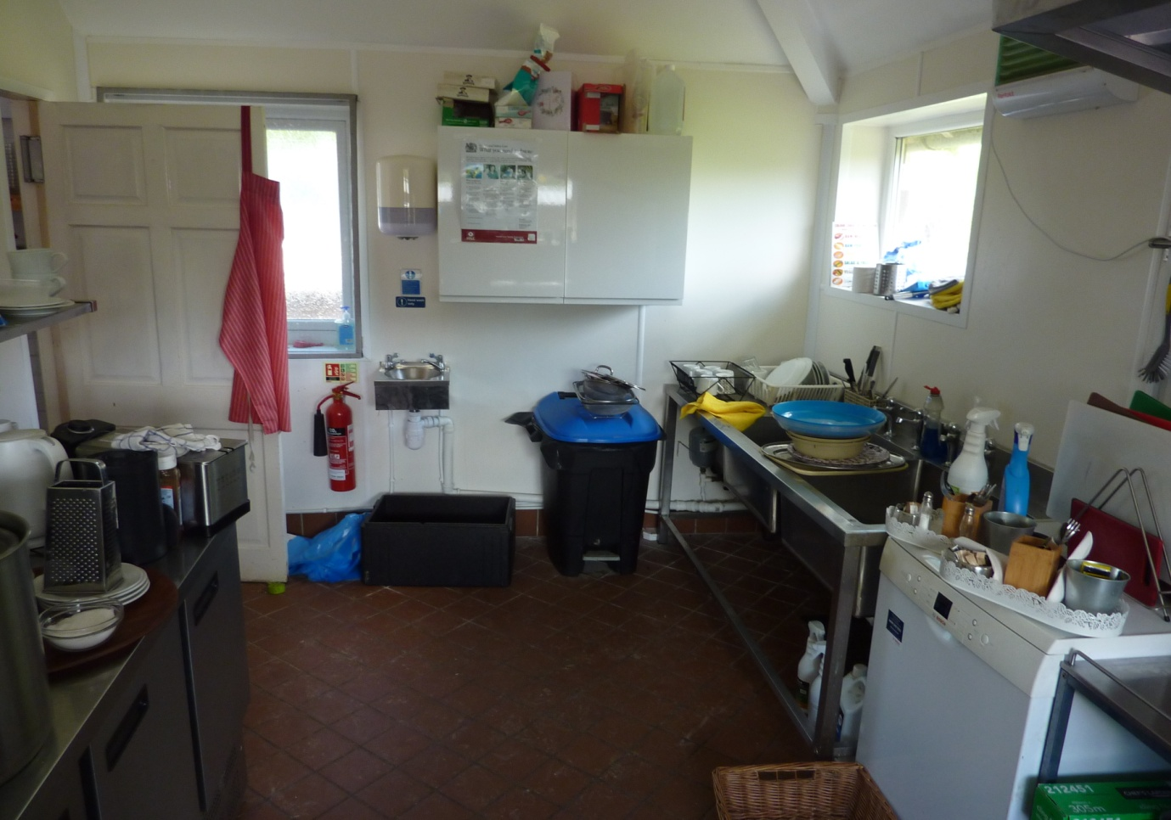
Photograph of Farmshop Kitchen.
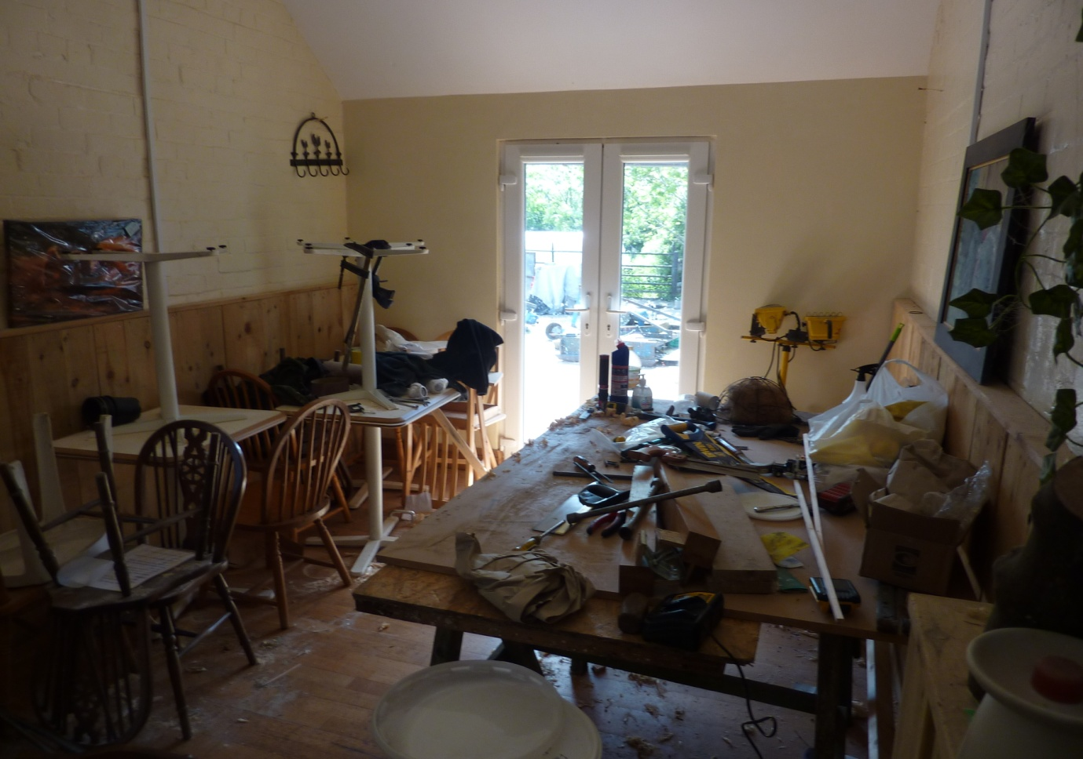
Photograph of Farmshop Tea Room.
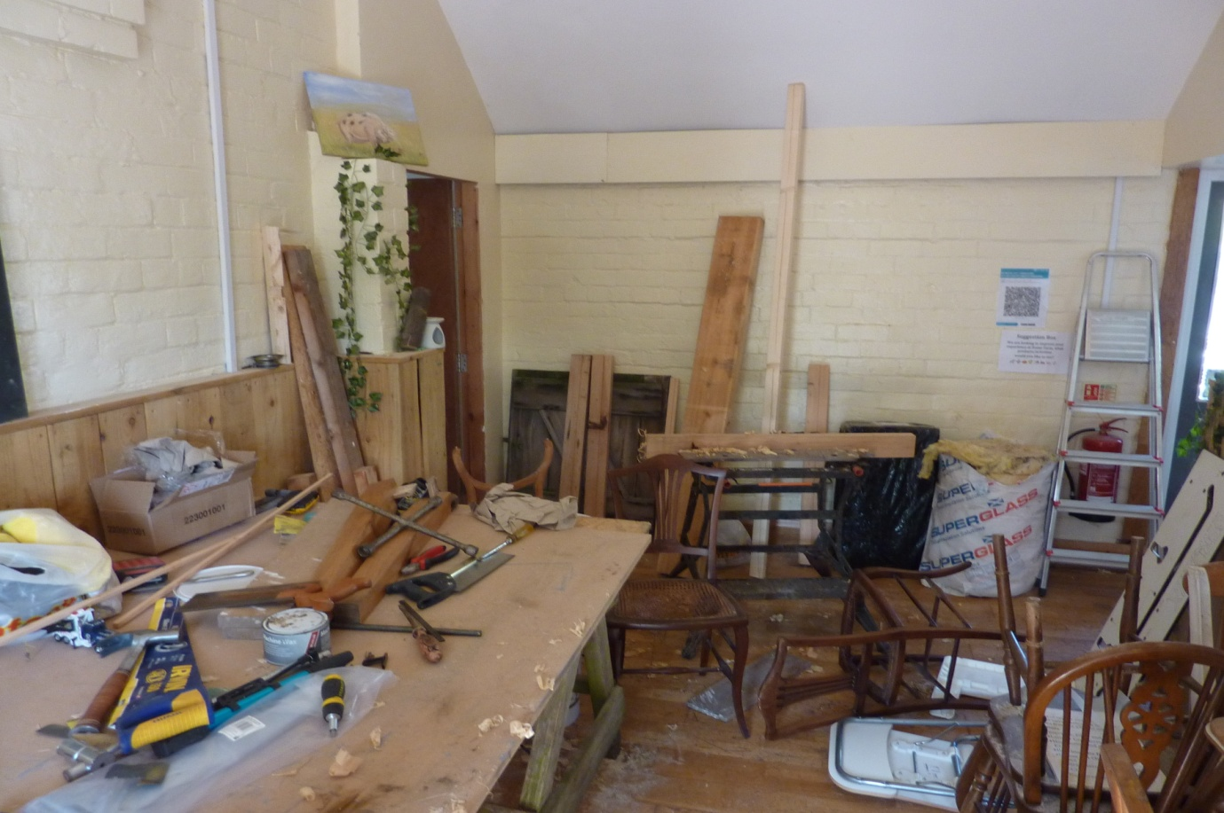
Photograph of Farmshop Tea Room.

