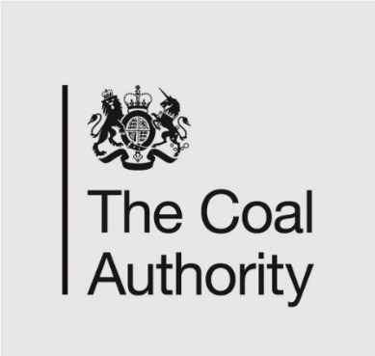 |  | 200 Lichfield Lane  Mansfield  Nottinghamshire  NG18 4RG  T: 01623 637 119 (Planning Enquiries)  E: planningconsultation@coal.gov.uk  W: www.gov.uk/coalauthority

For the attention of: Tyler Fox – Case Officer
Wrexham County Borough Council

[By email: planning@wrexham.gov.uk]

15th February 2024

Dear Mr Fox

Re: Planning Application P/2024/0026

Erection Of Storage/Workshop Unit; Coppi Industrial Estate, Unit 6 Rhosllanerchrugog, Wrexham

Thank you for your notification of 2 February 2024 seeking the views of the Coal Authority on the above.

The Coal Authority is a non-departmental public body sponsored by the Department for Energy Security and Net Zero. As a statutory consultee, the Coal Authority has a duty to respond to planning applications and development plans in order to protect the public and the environment in mining areas.

The Coal Authority Response: Further Information Required

I have reviewed the proposals and confirm that the application site falls within the defined Development High Risk Area; therefore within the application site and surrounding area there are coal mining features and hazards which need to be considered in relation to the determination of this planning application.

The Coal Authority records indicate that the site lies within an area of both recorded and probable shallow coal mining. Within 20m of the south western boundary is recorded mine entry (CA shaft ref: 328346-041). Our records indicate that: this entry had been filled and was drilled and grouted in 1976 by NKC Geotech Ltd. The specification for the treatments is unknown. Based on the historic source plans to plot the current position of the mine entry, this could vary by several metres from its recorded position.

We are aware that intrusive investigations were undertaken to the south of the current site for a very similar scheme of development, under planning application reference P/2021/1046. This application was supported by a Coal Mining Investigation Report, 27 September 2021 prepared by NKC Geotech Ltd and the author concludes the following: whilst shallow coal seams are present beneath the site, no evidence of these seams being worked (no voids / broken ground) were encountered. No remedial and / or mitigation measures were identified. The report author also informs that the mine entry (CA shaft ref: 328346-041) was treated to NCB specification and proved to lie 20m west of the site in 1976.

Whilst we note that the intrusive site investigations were carried for the footprint of the proposed unit under application reference P/2021/1046, geological conditions beneath the part of the site where the current scheme of development is proposed may be similar.

In light of the above we request that the applicant submits clarification from their technical consultants whether they are satisfied that the investigations previously carried out are sufficient to demonstrate that the site is safe and stable for the scheme of development currently under consideration, or whether further works are required in this regard.

The Coal Authority would be very pleased to receive for further consultation and comment any additional information submitted by the applicant.

Please do not hesitate to contact me if you would like to discuss this matter further.

Yours sincerely,

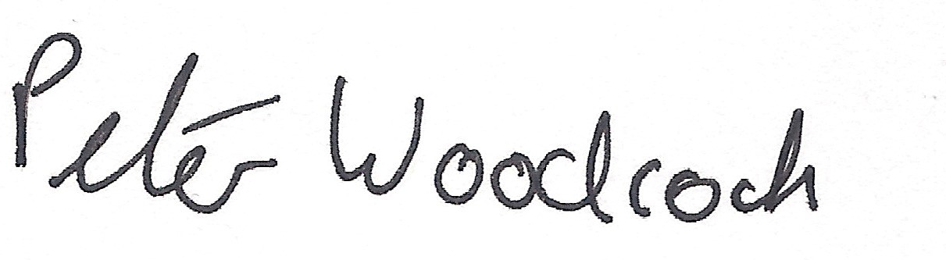
Peter Woodcock | BSc (Hons), AssocRTPI

Disclaimer

The above consultation response is provided by the Coal Authority as a statutory consultee and is based upon the latest available data and the electronic consultation records held by the Coal Authority since 1 April 2013. The comments made are also based on the information provided to the Coal Authority by the Local Planning Authority and/or information that has been published on the Council’s website for consultation purposed in relation to this specific planning application. The views and conclusions contained in this response may be subject to review and amendment by the Coal Authority if additional or new data/information (such as a revised Coal Mining Risk Assessment) is provided by the Local Planning Authority or the applicant for consultation purposes.

In formulating this response the Coal Authority has taken full account of the professional conclusions reached by the competent person who has prepared the Coal Mining Risk Assessment or other similar report. In the event that any future claim for liability arises in relation to this development the Coal Authority will take full account of the views, conclusions and mitigation previously expressed by the professional advisors for this development in relation to ground conditions and the acceptability of development.

