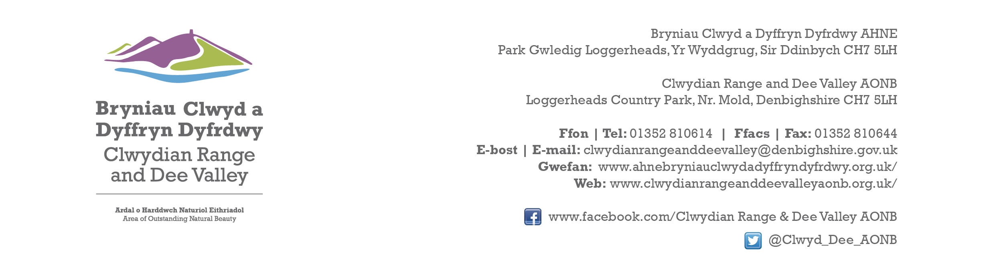

Ref P/2023/0826
Dyddiad | Date: 18th January 2024

Sarah Duckworth
Economy and Planning
Wrexham County Borough Council
Guildhall
Wrexham
LL11 1AY

Dear Sarah,

PROPOSAL: Single storey side and rear extension.

LOCATION: Bryn Cottage, Drefechan, Penycae, Wrexham

Thank you for consulting with the Joint Committee on this application. The following observations are submitted on behalf of the Joint Committee.

In policy terms the proposed extension exceeds your size threshold for domestic extensions in the open countryside. However, this is guidance and is not necessarily a justifiable reason to refuse permission, unless of course there is demonstrable harm. In this case proposed development will not have any adverse impact upon the character and appearance of the AONB. The Joint Committee raise no objections

I would be grateful if you could take account of the committee’s views when deciding this application.

Yours sincerely,

Dave Williams
AONB Planning Advisor
For the Clwydian Range and Dee Valley AONB Joint Committee

