STRUCTURAL APPRAISAL

ERBISTOCK VILLAGE HALL, ERBISTOCK
29/09/23

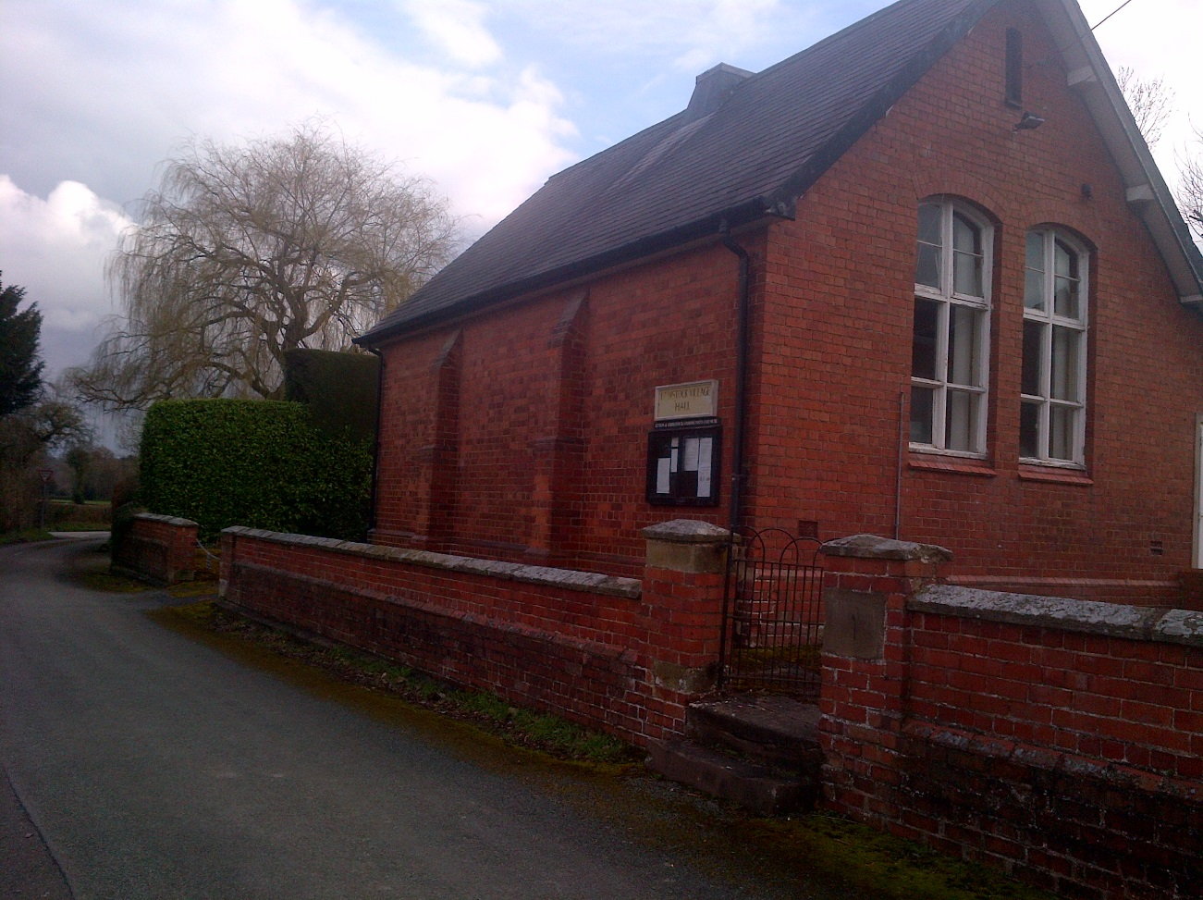
SURVEYOR

RICHARD M BROUGHTON MRICS, MCABE
Coedteg Farm,
Nant Y Glyn Rd,
Colwyn Bay,
LL29 6AB

INTRODUCTION

The property comprises a red facing brick structure with a slated roof of traditional construction believed to have been constructed in the early 1900’s

The original structure also includes a lean-to single storey structure to the rear south west elevation, which appears to be part of the original traditionally constructed structure

A further flat roofed extension has been constructed to the rear south west elevation to provide toilet and kitchen facilities and this extension is believed to have been constructed mid to late 1990’s

The property is sited in a generous plot in a small hamlet of residential properties

FINDINGS

walls
very limited evidence was noted of any structural movement in the walls
some cracking was noted to have occurred in the brickwork over the twinned windows on each gable elevation. The cracking has previously been pointed up in cement mortar and appears to be historic movement rather than progressive

wall thicknesses are substantial, plumb, free from distortion and not exhibiting any sign of distress

no evidence that could be attributed to foundation movement was noted

roof
the slated roof and its supporting structure appear to be in good structural order with no significant signs of dipping or distress

proposed alterations
the proposals are designed to have very limited implications to the existing structure and so would not cause any distress to the existing building

conclusions
from the above observations, as a chartered building surveyor with over 40 years experience in the building surveying discipline, I am satisfied that the existing building is capable of being converted in the proposed manner without causing any detriment to the existing structure

