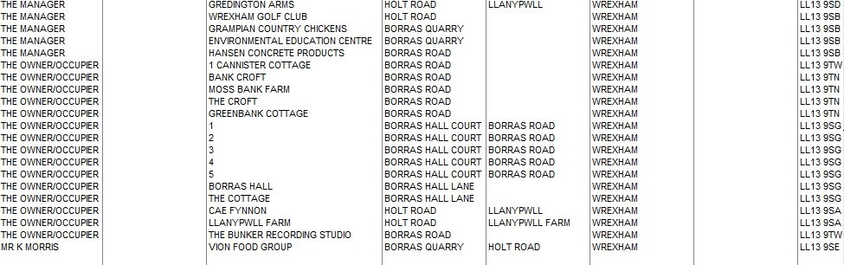

HEADTEACHER, MILENNIUM ECO CENTRE, HOLT ROAD, LLAN Y PWLL, WREXHAM LL13 9BZ
1 and 2- both- THE COCH HOUSE, BORRAS HALL LANE, WREXHAM LL13 9SG
GORTON HALL COTTAGE, BORRAS HALL LANE, WREXHAM LL13 9SG

