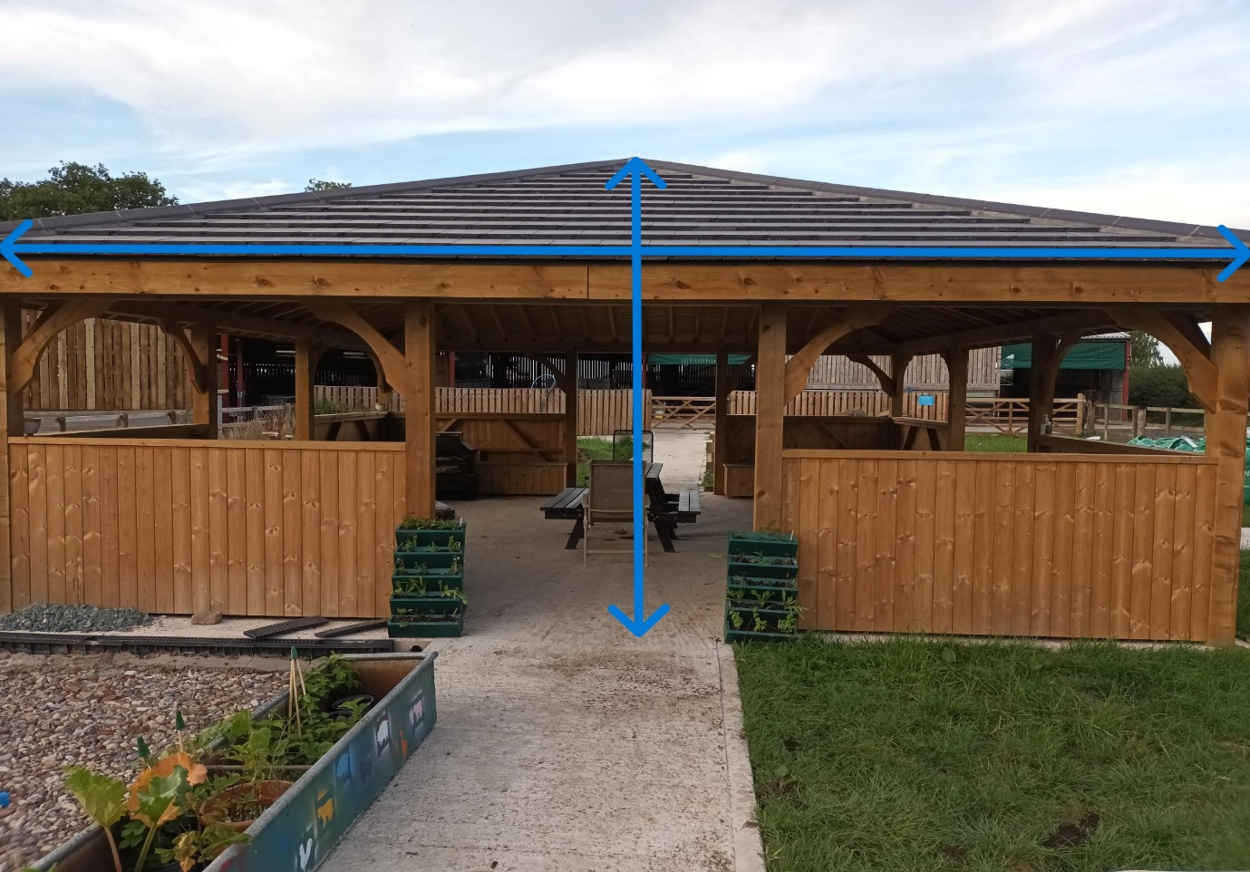
Position 1
Height 3.95m
Length 8m
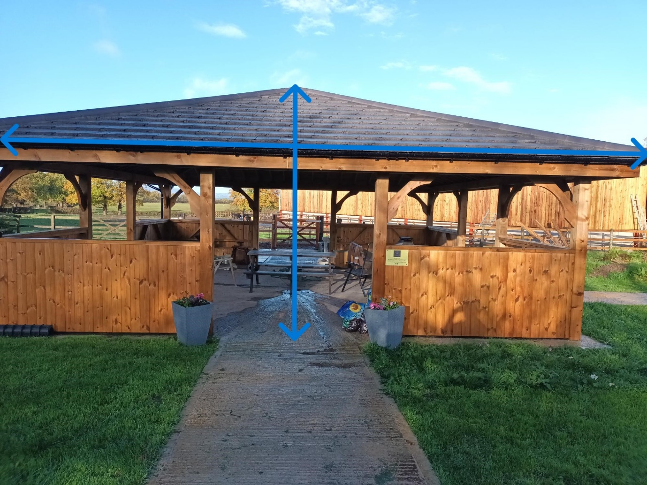
Position 2
Height 3.95m
Length 8m
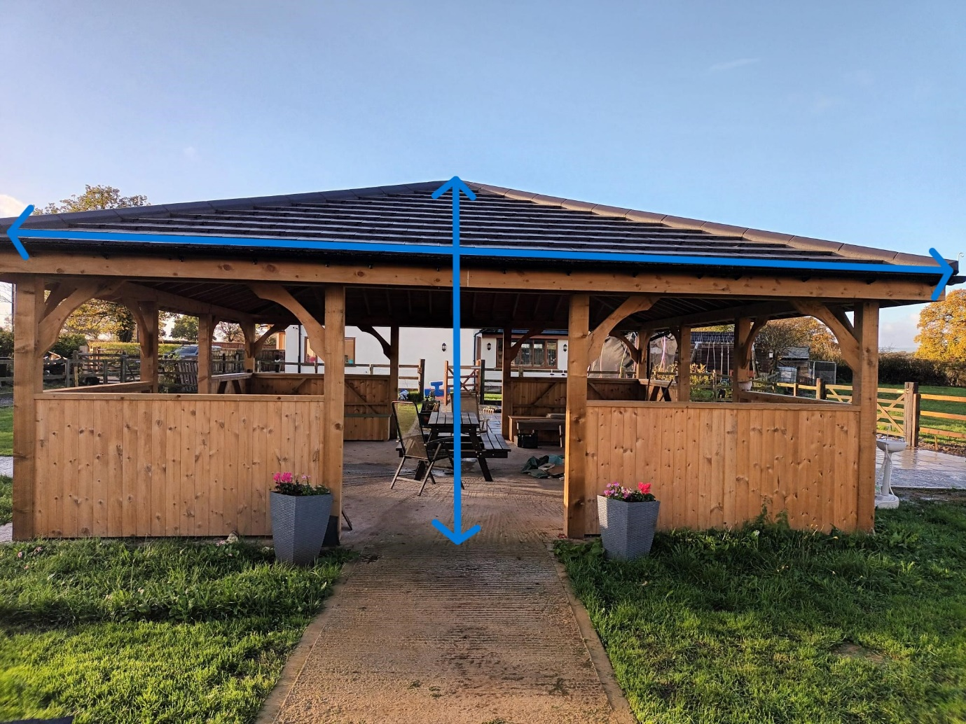
Position 3
Height 3.95m
Length 8m
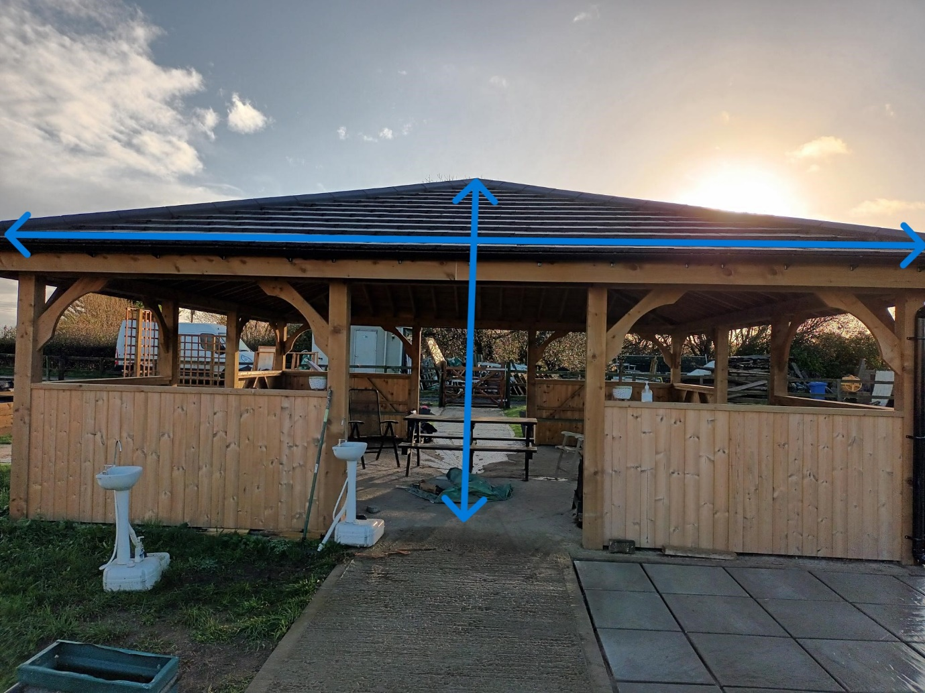

Position 4

Height 3.95m
Length 8m

