
Bob Dewey

PLANNING

GROUNDS OF APPEAL
Re: proposed garage
Lynwood, Maesyfynnon Road, Minera, Wrexham
Background:

The site is located immediately to the front of the dwelling known as Lynwood which was recently refurbished as a dwelling (see history below) and approval was given for extensions to link it to an adjoining building.

The Inspector should be aware that there are two properties named Lynwood in MInera.

Planning History

P/2022/0883 Single storey side extension Granted 17/07/2023
P/2013/0748 conversion of vacant storage building to dwelling Granted 03/022014

Planning decision:

Planning permission was refused on 19/07/2023 for the following reason:
“Due to the position of the proposed garage, the development will have
a detrimental impact upon the character and appearance of the area
and the openness of the countryside and therefore conflicts with GDP1
and PS2 of the Wrexham Unitary Development Plan.”

Planning Policy:

This is contained in the adopted Wrexham Maelor Local Plan. The refusal notice quotes: the two following policies:-

PS2 says: Development must not materially detrimentally affect countryside,
landscape/townscape character, open space, or the quality of the natural environment
GDP1 says: All new development should:-
a) Ensure that built development in its scale, design and layout, and in its use
of materials and landscaping, accords with the character of the site and makes
a positive contribution to the appearance of the nearby locality.
(……. we do not believe that any of the other criteria reflect the text of the refusal notice).

No reference is made to the draft LDP and it is unclear the status of that plan or therefore its relevance in this case.

However, the Council’s adopted LPG 14 does appear relevant: and it is very surprising that the decision makes no acknowledgment of that policy since relates to “Garden Extensions in the Countryside” and it includes the following:
The Council will also make reference to non-statutory Supplementary Planning Guidance in their consideration and determination of development proposals, as appropriate.

Analysis:

At the request of the Council the application was made into two items:

change of use to domestic curtilage
and
erection of garage.

The reason for refusal relates solely to the garage so we assume that the change of use is not objectionable to the Council.

The house is situated in an extremely secluded rural position which belies its previous history as at the centre of an industrial area associated with the large limestone quarry. It was on a railway track (the photos show the front to the property) running across and through the site now intended for a small carport/garage of rural appearance.

The owner lives in the property and needs proper accommodation for his car and the site is chosen to avoid conflict with footpaths crossing the site. The Council’s Guidance Notes says:
The Council recognises the interest of some rural householders in having larger gardens. Where these can be provided in such a way that the landscape and appearance of the area would not be harmed, a garden extension may be acceptable.
If a dwelling has ……….. or no off-road parking space, a garden extension which would enable a significant road safety risk to be removed may be permitted.

The site is very limited in size and to provide covered car parking in any other way could involve significant excavation and/or retaining walls and it is difficult to imagine any way in which this would have less impact upon the countryside. The LPG says:

however, where the area of an existing curtilage is severely restricted, an extension may be acceptable provided this is limited to the minimum amount of land appropriate for reasonable family enjoyment of the property

This small garage constructed predominantly using timber framing would appear ideal for a rural location and the suggestion that it would impinge on the rural setting seems extraordinary. The refusal reason seems to imply that it would impact upon “open countryside” whereas it will be substantially screened by woodland and by the topography which would make it very difficult to view from other than immediately adjacent viewpoints on the footpaths.

It is suggested that most people would find the screening afforded by a simply constructed building more acceptable than parked cars.

The Council report says:
Policy PS1 of the UDP states that new development for housing will be directed to
within defined settlement limits. Given the above, it is considered that there is an in
principal policy objection to the proposed change of use of the land for domestic
purposes.

Policy PS1 is a strategic level policy and it is suggested that it is not the right level of policy to react to a small domestic garage. It is an extraordinary statement given the fact that the vast majority of domestic extension (whether in countryside or not) will not need planning permission and the generous nature of the LPG advice is that extensions to facilitate the occupation of rural dwellings can be supported where justified. Objecting to a garage to provide a safe and convenient facility for the occupant cannot be (as suggested) objectionable in terms of “principal policy”.

Introducing domestic uses to land which was previously used for another purpose, can
result in significant visual impacts. The proposed three bay garage would introduce an
urban characteristic to an area which currently is open and contributes to the character
of the area and the setting of the AONB.

The land’s only previous “purpose” was a railway line. (see photo).

The proposed site would be detached from the main dwelling Lynwood on land that is
not part of the lawful curtilage of the dwelling. It is considered that this is inappropriate
and would result in encroachment of development into the countryside, breaking away
from the current grouping of building which are all located to the south of the Public Right of Way.

The wording of the officer’s discussion suggests that she is determined to object regardless. Moving the garage some 12 yards so as to be behind the house (and thus permitted development) and in what is assumed to be considered by the Council to be the “legal curtilage” would make minimal impact upon the alleged disturbance to the rural setting.

The siting would also allow natural surveillance from the front windows of the property which is not an unreasonable request. Siting the garage behind the house would leave it more vulnerable to vandalism given the extensive footpath network.

Conclusion:

The development would not materially detrimentally affect the countryside, or the character or the natural environment. It would accord with the character of the site and will make
a positive contribution to the locality.

The Inspector is requested to grant permission.

August 4 2023 rev4

Robert A Dewey BA (Hons) MBA Dipl Est Management, Dipl Town Planning,

he Gables, Llanfynydd WREXHAM. LL11 5HG tel: 01978 761315 (m) 07947 186 777

e mail bobdeweyplanning@gmail.com

Wrexham CBC
LPG 14 Garden Extensions in the Countryside

The Council recognises the interest of some rural householders in having larger gardens. Where these can be provided in such a way that the landscape and appearance of the area would not be harmed, a garden extension may be acceptable. Nevertheless, the Council’s guiding principle is the need to protect the rural environment. General Considerations (a) Size and Scale
The amount of land which the Council will consider appropriate for inclusion in a garden extension will vary depending upon the size of the existing residential curtilage. Where a dwelling already has the benefit of a substantial garden area, an extension is unlikely to be permitted: however, where the area of an existing curtilage is severely restricted, an extension may be acceptable provided this is limited to the minimum amount of land appropriate for reasonable family enjoyment of the property. In considering whether the size O the aspect and location of the site; O the presence of landscape features such as a break of slope, hedgerow, watercourse or woodland which could form a logical new boundary to the residential curtilage; O the extent to which high quality agricultural land would be taken out of productive use. (b) Essential Services Garden extensions to provide space for central heating fuel tanks, septic tanks or other services essential for domestic occupation are likely to be acceptable where there is insufficient space available for these services within the existing residential curtilage. However, the extension must be limited to the minimum area required to comply with installation requirements. In the case of above ground installations, structures and equipment will need to be coloured, screened or positioned in such a way that their effect upon the landscape would be kept to a minimum. (c) Vehicular Access and Parking If a dwelling has no vehicular access, an access with obstructed visibility or no off-road parking space, a garden extension which would enable a significant road safety risk to be removed may be permitted. In these circumstances, the extension will normally be limited to the minimum area required to comply with the Council’s highway and parking standards. of a proposed garden extension is appropriate, the Council will take particular account of :-

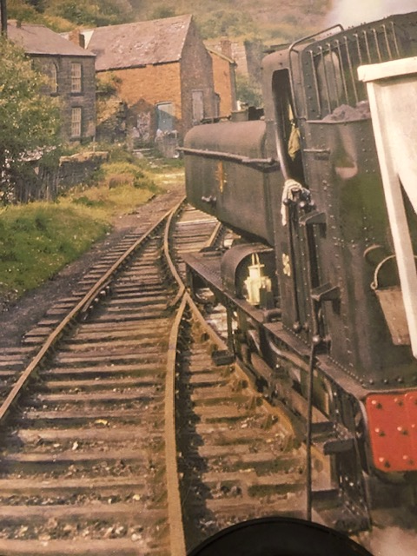
the site
Lynwood

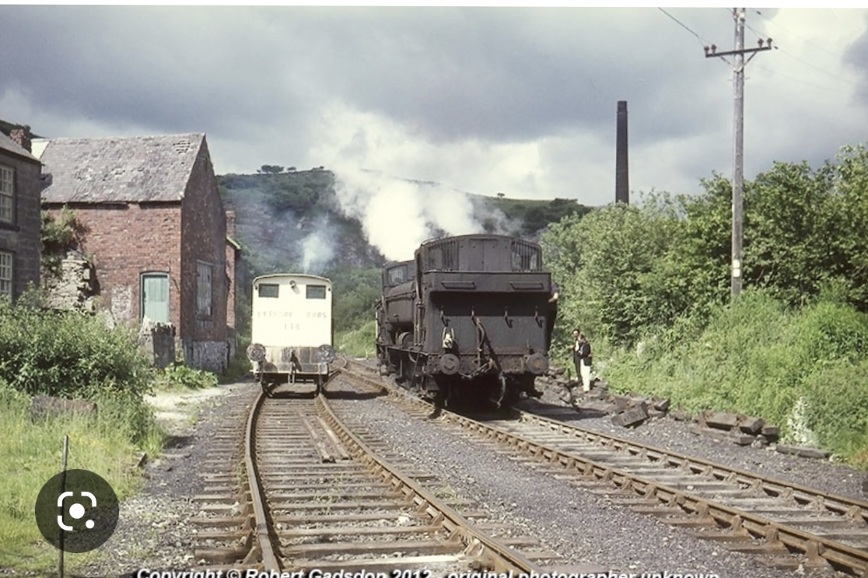
site

