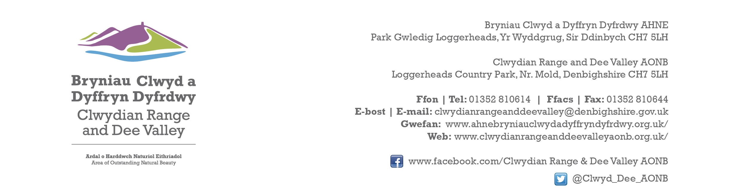

Ref P/2022/1080
Dyddiad | Date: 10th March 2023

Matthew Phillips
Economy and Planning
Wrexham County Borough Council
Guildhall
Wrexham
LL11 1AY

Dear Matthew,

PROPOSAL: Construction of New Access Road, Lorry Park, Weighbridge and Building, Car Park, Facilities block, Roundwood storage areas, 132 KV Substation and Ancillary works

LOCATION: Kronospan Ltd, Holyhead Road, Chirk, Wrexham

Thank you for consulting with the Joint Committee on this application. The following observations are submitted on behalf of the Joint Committee.

The Joint Committee object to this application. The proposed development involves a significant extension of the existing industrial curtilage of Kronospan into adjoining open countryside, a designated Green Barrier and Special Landscape Area. It is contrary to both existing UDP and emerging LDP policy.

The site lies within close proximity of the AONB boundary and within the buffer zone of the Pontcysyllte Aqueduct and Canal World Heritage site. It is visible from a number of locations within the designated area and would adversely affect its setting and compromise views out from the AONB. As acknowledged in the applicant’s Design & Access statement “the primary purpose of an AONB as set out in the Countryside and Rights of Way Act 2000 is to conserve and enhance natural beauty. The purpose of an AONB can be affected by change occurring outside of its boundary. As such, potential adverse changes in outward views from within the AONB and indeed changes in views towards the AONB from locations outside the boundary are important factors to be considered in the design process.” The Joint Committee consider this proposal significantly compromises both sets of views. Furthermore, despite the applicant’s acceptance that it is visible from the AONB, no specific measures are proposed to address visual effects from the designated area.

By the applicant’s own admission ( Planning Statement ) “the proposal is contrary to UDP/LDP policies in respect of land outside settlement limits/employment areas and Green Barrier/Green Belt.” Other than treating this as an “exceptional case” the only policy justification put forward by the applicants supporting their proposal is LDP Policy EM4. However, this policy requires it to be demonstrated that there are no alternatives and that the development forms a logical extension to the existing settlement limit. This application fails on both counts.

First of all, by its very nature, most of the land included within the application site is required for the parking of HGV’s ( 91 spaces ). The area is approximately 4 times greater in size than the existing lorry park. No explanation is provided as to why this increase is required, or why this number needs to be accommodated here at any one time. No evidence or consideration of other potential parking sites elsewhere have been provided. Similarly, insufficient information or justification has been provided as to why other more sustainable transport options available e.g. rail, have not been pursued further.

Secondly, the extended area does not form a logical extension to the existing settlement limit. It is not rounding off, neither does it follow a natural physical form/feature/boundary and constitutes an unnatural spur of development into the open countryside. It would be seen as incongruous and would establish an undesirable precedent, increasing the vulnerability of land to the west of Afon Bradley ( closer to the AONB & WHS ) to further industrial development in future. Whilst the existing Kronospan site is extremely large scale, it is nevertheless relatively well contained within the existing landscape setting. Approving this application would significantly compromise the existing relationship by adding an unnatural spur of development at the entrance to the village.

The applicants state that the principle objective is to provide an alternative access road to the north which will provide environmental benefits to the village. The benefits of removing HGV movements along Holyhead Road through Chirk, in terms of reducing noise and disturbance, dust, vibration and improving air quality are acknowledged and indeed welcomed. However, the extent of the incursion into open countryside is disproportionate and involves a lot more than an alternative access road. Had a scheme with minimal intervention been submitted for a new access road with accompanying landscaping, the Joint Committee may well have supported it. Unfortunately, this is not the case and what we have is an extremely large extension to the industrial curtilage. Once this change of use has occurred it will be extremely difficult to resist further built development and log storage in this area.

I would be grateful if you could take account of the committee’s views when deciding this application.

Yours sincerely,

Dave Williams
AONB Planning Advisor
For the Clwydian Range and Dee Valley AONB Joint Committee

