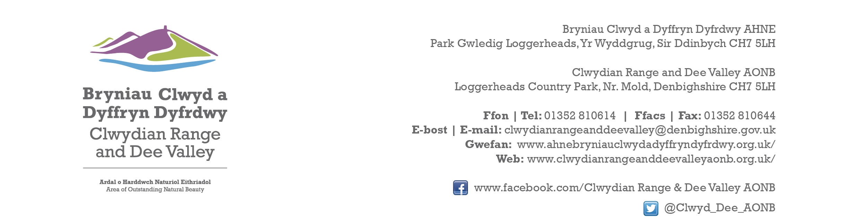

Ref P/2022/1080
Dyddiad | Date: 25th October 2023

Matthew Phillips
Economy and Planning
Wrexham County Borough Council
Guildhall
Wrexham
LL11 1AY

Dear Matthew,

PROPOSAL: Construction of New Access Road, Lorry Park, Weighbridge and Building, Car Park, Facilities block, Roundwood storage areas, 132 KV Substation and Ancillary works

LOCATION: Kronospan Ltd, Holyhead Road, Chirk, Wrexham

Thank you for re-consulting with the Joint Committee on this application. The following observations are submitted on behalf of the Joint Committee.

The Joint Committee’s objection to this application is unchanged. Despite the amendments, the proposed development remains a significant extension of the existing industrial curtilage of Kronospan into adjoining open countryside, a designated Green Barrier and Special Landscape Area. It is contrary to both existing UDP and emerging LDP policy.

The site lies within close proximity of the AONB boundary and within the buffer zone of the Pontcysyllte Aqueduct and Canal World Heritage site. It is visible from a number of locations within the designated area and would adversely affect its setting and compromise views out from the AONB. The primary purpose of an AONB as set out in the Countryside and Rights of Way Act 2000 is to conserve and enhance natural beauty. The purpose of an AONB can also be affected by change occurring outside of its boundary. As such, potential adverse changes in outward views from within the AONB and indeed changes in views towards the AONB from locations outside the boundary are important factors to be considered in the design process. Despite the amendments the Joint Committee consider this proposal significantly compromises both sets of views.

The proposal is contrary to UDP/LDP policies in respect of land outside settlement limits/employment areas and Green Barrier/Green Belt and should be refused. In this regard the Joint Committee have nothing further to add to our previous responses. Whilst the potential environmental benefits for Chirk residents of re-locating the lorry park are acknowledged, and indeed supported, the extended area does not form a logical extension to the existing settlement limit. It is not rounding off, neither does it follow a natural physical form/feature/boundary and constitutes an unnatural spur of development into the open countryside. It would be seen as incongruous and would establish an undesirable precedent, increasing the vulnerability of land to the west of Afon Bradley ( closer to the AONB & WHS ) to further industrial development in future.

Whilst the existing Kronospan site is extremely large scale, it is nevertheless relatively well contained within the existing landscape setting. Approving this application would significantly compromise the existing relationship by adding an unnatural spur of development at the entrance to the village.

Had a scheme with minimal intervention been submitted for a new access road/lorry park with accompanying landscaping, the Joint Committee may well have supported it. Despite the 50% reduction in the proposed size of the lorry park, the red outline of the application remains unchanged. The application site area needs to be reduced by re-positioning the new roundabout closer to the village, reducing the incursion into open countryside. This would result in a more proportionate extension, creating a more natural rounding off of the settlement, with more opportunities for planting and more natural mounding, helping to assimilate the development into the landscape.

Leaving the application boundary as proposed will only encourage further incremental encroachment of industrial/storage development beyond the proposed lorry park down as far as the roundabout as currently shown on the submitted plans.

I would be grateful if you could take account of the committee’s views when deciding this application.

Yours sincerely,

Dave Williams
AONB Planning Advisor
For the Clwydian Range and Dee Valley AONB Joint Committee

