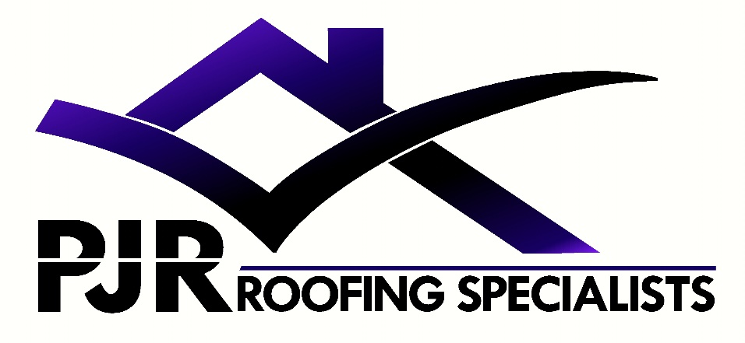
1 Grenville terrace
Station road
Ruabon
Wrexham
LL14 6DL

07719407902
Pjr-roofing@hotmail.com

Pre-Purchase Roof inspection

Address;
10 Park street
Ruabon
Wrexham
LL14 6LE

Date of inspection;

Friday 2nd December 2022
Roof condition;
We carried out a visual inspection and a drone inspection of the external roof areas at the above property.
There main roof has a large number of lead tags visible on both the front and back elevations. There is approximately 20+ on the front and similar amount on the rear.
The property benefits from recently fitted new fascias and gutters.
The lower roof of the property looks to be in good repair

Chimney;
There is 1 main chimney to the property, which is shared with the neighbour it is old but looks structurally sound from what is visible from the drone.
There is a second chimney to the rear lower roof, this has been capped off.

Recommendations
It’s our opinion there is signs that the main roof maybe suffering with nail rot, this is where the nails have rotted and would account for the very large amount of lead tags holding the slates in. The property would benefit from a re-roof asap re-using the existing slates and fixing them with new nails. A realistic budget for this work would be in the region of £5000.

