APPENDIX IV
PHOTOGRAPHS OF THE EXTERIOR OF THE FARMSHOP
BRYN-Y-PYS HOME FARM, WREXHAM ROAD, OVERTON, WREXHAM LL13 0HG

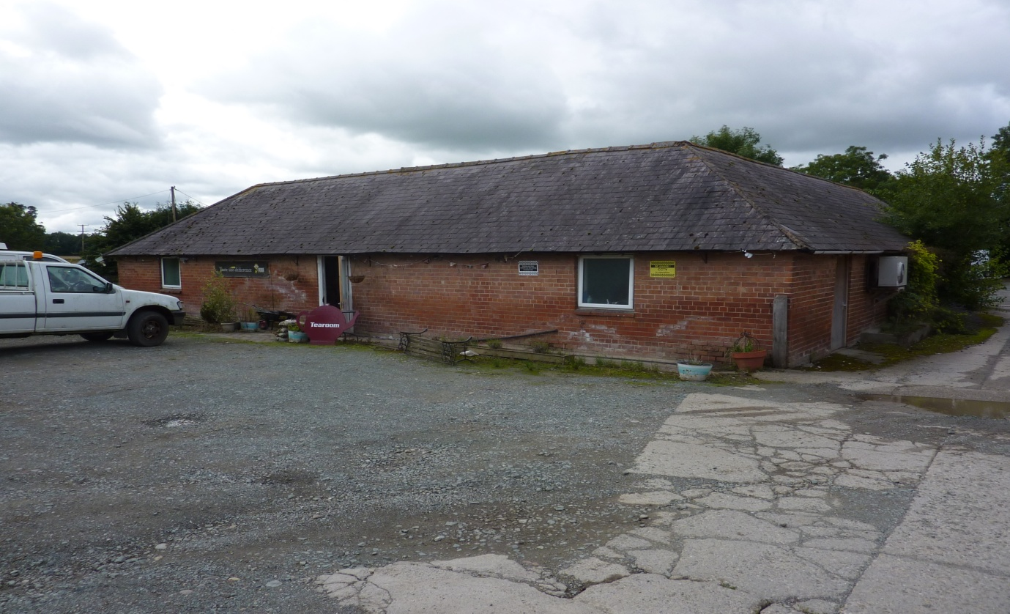
Front of the Farmshop (North-East Elevation) with Car Park
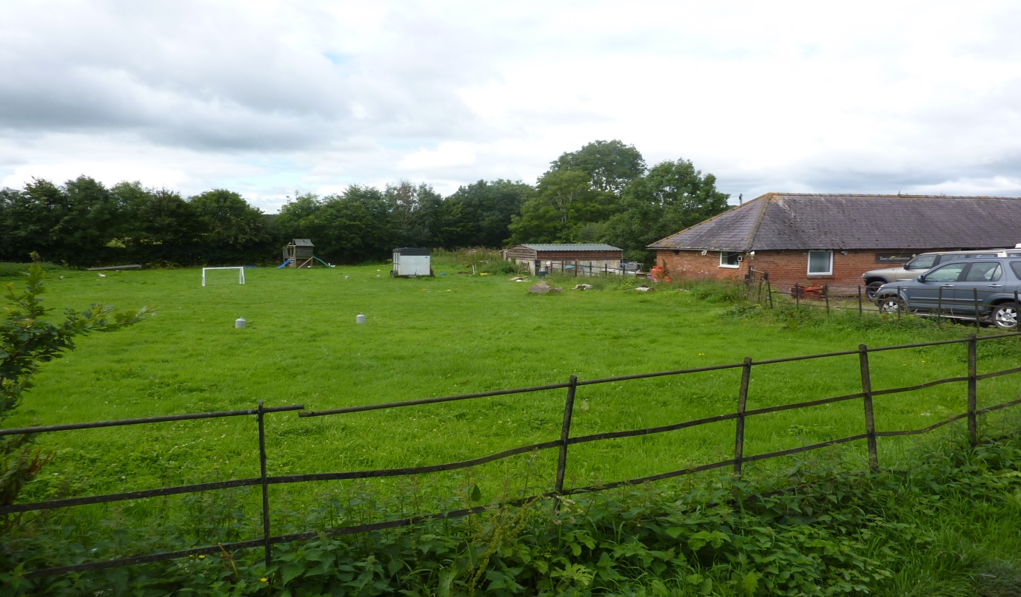
View of Gable End of Farmshop (South-East Elevation) from main drive with Tree Shelter Belt to the Rear.
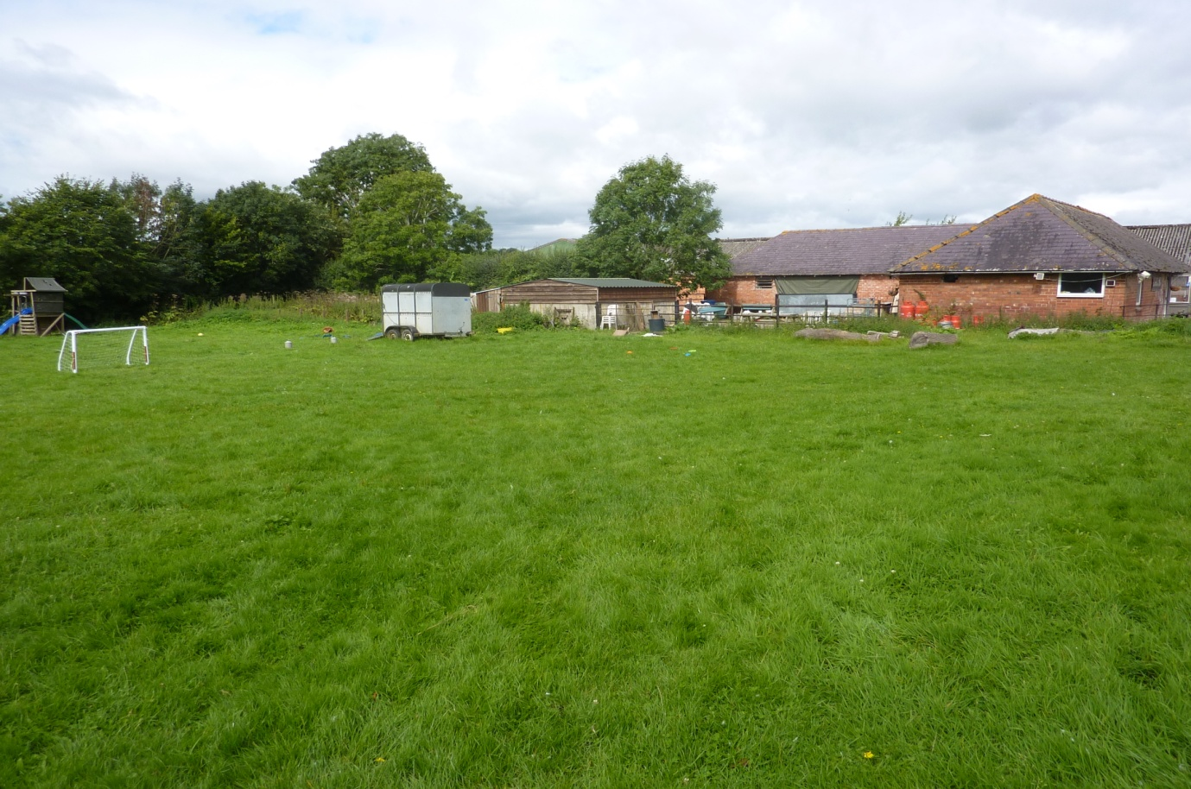
View of Gable End of Farmshop (South-East Elevation) from adjacent paddock.
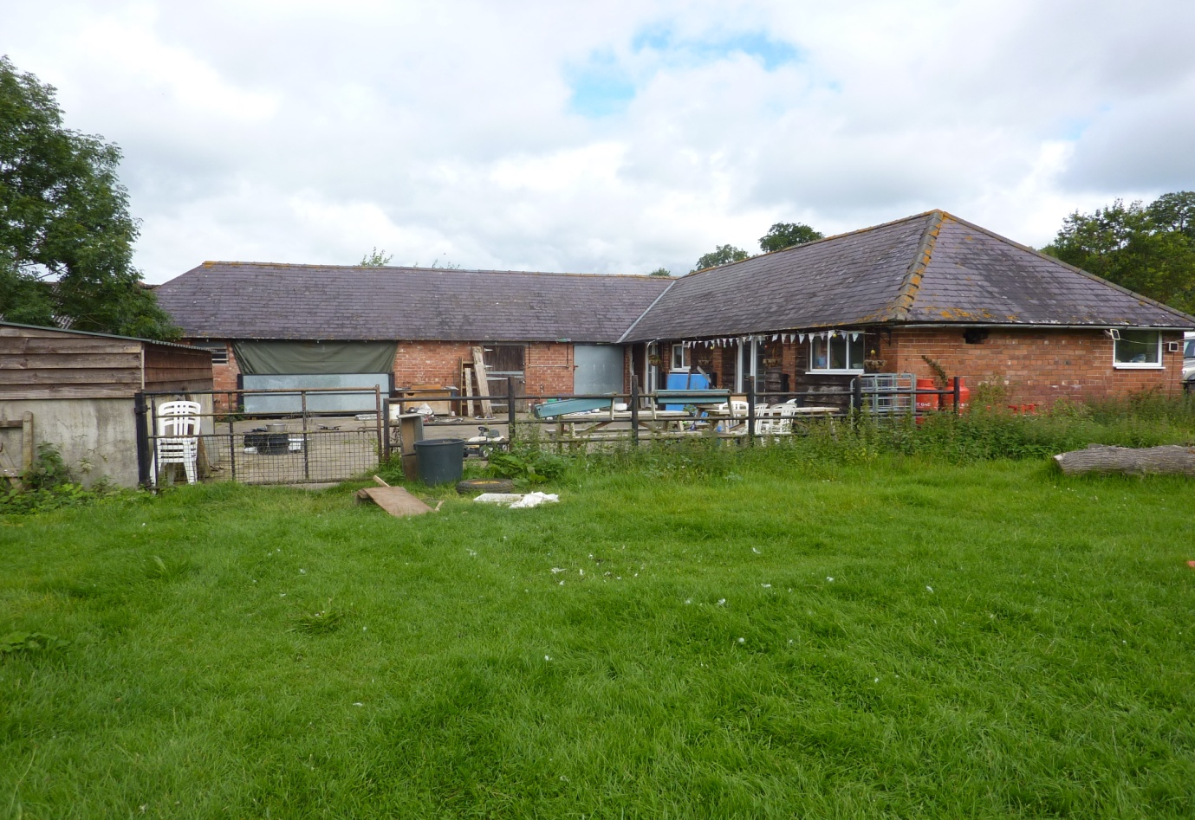
View of Rear of Farmshop (South-West Elevation)

