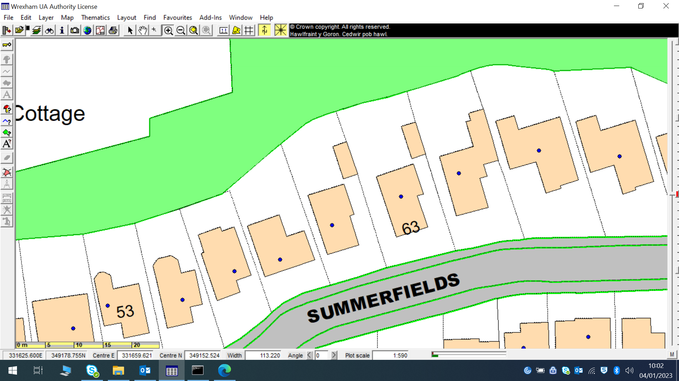
T2 - cherry
T1-oak

