
Mitie
Floor 12, The Shard, 32 London Bridge Street, London,
SE1 9SG, UK

T 0117 322 1322
E info@mitie.com
mitie.com
10th July 2023
FAO Building Conservation Officer
Heritage Impact Statement - Alteration to the internal lighting throughout the building, Halifax Bank Plc, 55 Hope St, Wrexham LL11 1AF

Proposed works
We have been instructed by Lloyds Banking Group Limited as part of their energy reduction programme (Zero Carbon) for their portfolio of properties to carry out an internal lighting upgrade to remove the current Tungsten & fluorescent lighting out of the property and replace with modern energy efficient LED lighting and emergency lighting to current BS5266 regulations. This will be carried out as a straight 1 for 1 replacement with no additional wiring needed in most areas as we are utilising the existing cabling which is already in place. The lighting will enhance the internal customer and colleague areas whilst improving the illumination of the unique internal areas of the building.
Due to the exposed vaulted ceiling the banking hall will have the greatest impact from the proposed lighting. To meet the clients lighting level specification, our design proposes to replace five of the current suspended pendent lighting with eight new LED pendants as detailed in appendix one of this document. The installation will involve new circuits and cable containment to the new lighting which is likely to be surface mounted to the ceiling due to access issues on the floor above. The existing lighting layout and proposed lighting is detailed in appendix two.
The remaining lighting installation in all other areas, enhances the customer and colleague areas and in our opinion does not negatively impact the internal walls, ceilings, floors and decorative details within the building.

This building is a Grade II listed building Bank. Built in 1876 by John Gibson, architect, for the National Provincial Bank, which had been established on this site in 1849. Rusticated ashlar faced. Interior of banking chamber modified by insertion of suspended ceilings and late C20 counters etc. The banking hall has unique corniche detail and exposed structural beams to support the ceiling.
Internally the building has been divided essentially into 2 areas back of house & front of house.
The front of house (Banking Hall) which is customer facing and is open to the public, has a traditional plaster ceiling and a modern suspended ceiling and partition walls The existing lighting in these areas is a mix of ceiling pendants, recessed down lights, wall lights and adjustable spot lighting as per the picture below. The customer meeting rooms have ceiling recessed panels, down lights and adjustable recessed spot lighting.

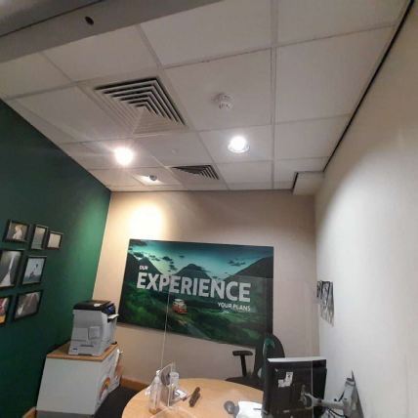

The back of house is the heart of the bank and is where the staff do their administration work, The back of house which is out of bounds to members of the public consists of meeting rooms, offices, corridors, toilets & plant rooms which all constitute the workings of the bank and have over time been modernised with suspended ceiling grid and with modular lighting installed. Some areas have a plaster board ceiling with a surface mounted lighting batten. None of these areas are customer facing and have already undergone changes over time including the installation of suspended ceilings as per the photo below.
With the use of modern LED lighting not only will energy consumption be reduced but also the total number of light fittings will also be reduced which will allow for the architecture to be seen with limited obstruction showing the building off to the public.

Summary
In summary, our design will improve the internal areas of the building and provide safe passage from the building in the result of an emergency through the upgrade of lighting and emergency lighting. The design in the banking hall to meet the clients specification will involve works to install new suspended lighting, cable and containment to the surface of the ceiling. All other areas will be a one for one replacement using existing lighting pointed and either surface mounted on installation into suspended ceiling tiles.

Yours sincerely

Machal Husain
macal.husain94@mitie.com

Appendix 1
Banking hall proposed pendants.
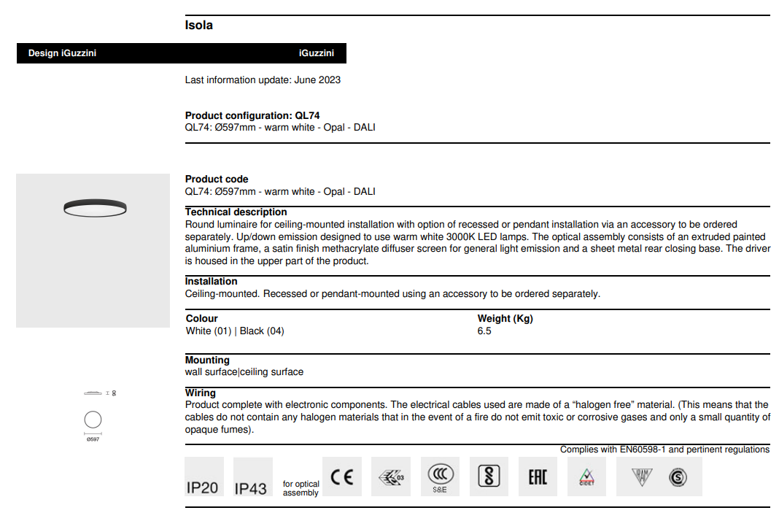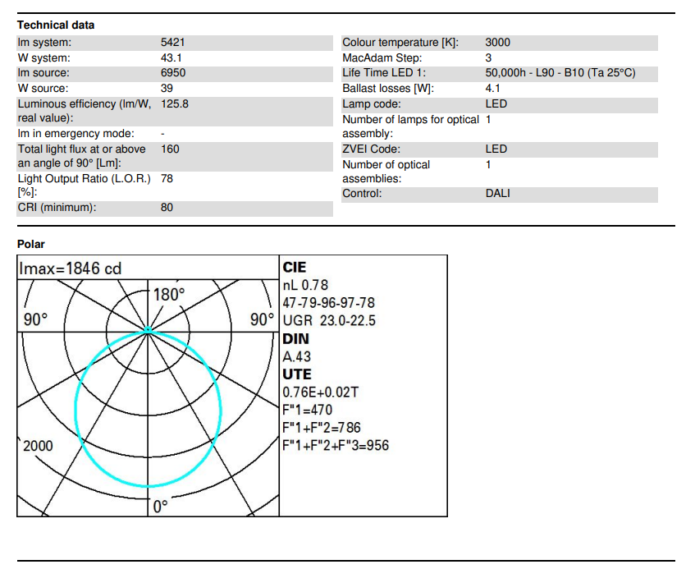
Appendix 2
Ground floor banking hall
Existing lighting
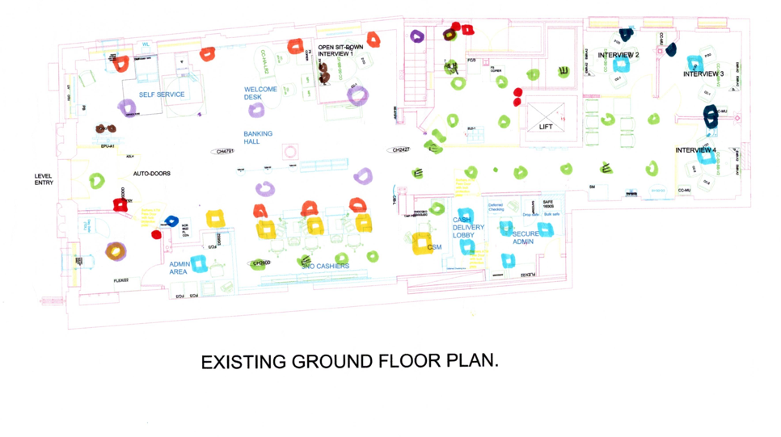
Proposed lighting
