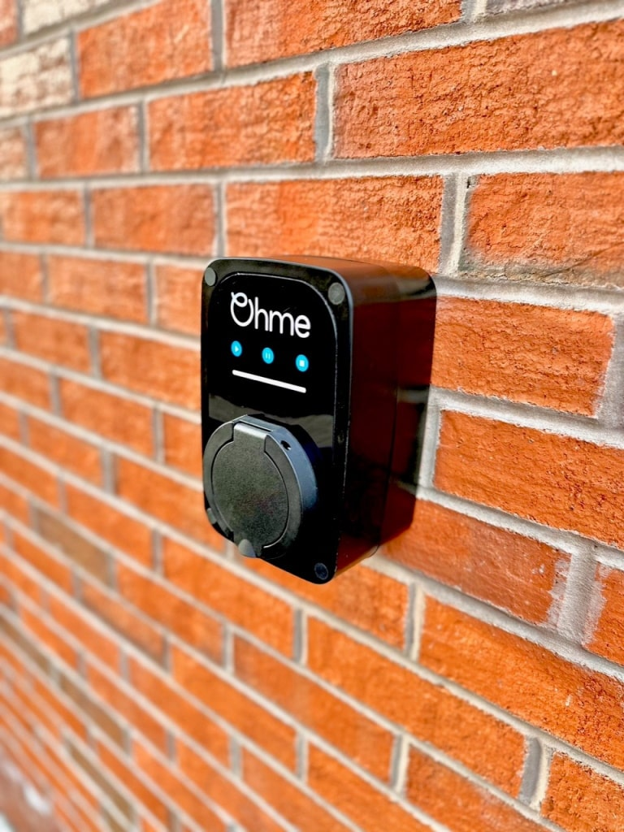

OHME pod point charger

H:W:D - 230 x 140 x 100mm

Cubic size : 0.003 cubic metres

